# Database Figures and Tables

## Tables

### Wear depths tables

Table 1: Wear severities dimensions from image processing for tooth 1.

|  |  |  |  |  |  |  |  |  |  |  |
| --- | --- | --- | --- | --- | --- | --- | --- | --- | --- | --- |
| **Case** | **Wear depth $$\text{[μm]}$$** |  | **Case** | **Wear depth $$\text{[μm]}$$** |  | **Case** | **Wear depth $$\text{[μm]}$$** |  | **Case** | **Wear depth $$\text{[μm]}$$** |
| Healthy | $$0$$ | W9 | $$285$$ | W18 | $$442$$ | W27 | $$686$$ |
| W1 | $$38$$ | W10 | $$300$$ | W19 | $$465$$ | W28 | $$721$$ |
| W2 | $$77$$ | W11 | $$314$$ | W20 | $$488$$ | W29 | $$757$$ |
| W3 | $$115$$ | W12 | $$330$$ | W21 | $$512$$ | W30 | $$795$$ |
| W4 | $$152$$ | W13 | $$347$$ | W22 | $$538$$ | W31 | $$834$$ |
| W5 | $$166$$ | W14 | $$364$$ | W23 | $$565$$ | W32 | $$876$$ |
| W6 | $$185$$ | W15 | $$382$$ | W24 | $$593$$ | W33 | $$920$$ |
| W7 | $$259$$ | W16 | $$401$$ | W25 | $$623$$ | W34 | $$966$$ |
| W8 | $$272$$ | W17 | $$421$$ | W26 | $$654$$ | W35 | $$1000$$ |

Table 2: Wear severities dimensions from image processing for tooth 2.

|  |  |  |  |  |  |  |  |  |  |  |
| --- | --- | --- | --- | --- | --- | --- | --- | --- | --- | --- |
| **Case** | **Wear depth $$\text{[μm]}$$** |  | **Case** | **Wear depth $$\text{[μm]}$$** |  | **Case** | **Wear depth $$\text{[μm]}$$** |  | **Case** | **Wear depth $$\text{[μm]}$$** |
| Healthy | $$0$$ | W9 | 306 | W18 | 448 | W27 | 718 |
| W1 | 41 | W10 | 306 | W19 | 465 | W28 | 736 |
| W2 | 74 | W11 | 329 | W20 | 465 | W29 | 736 |
| W3 | 121 | W12 | 340 | W21 | 543 | W30 | 802 |
| W4 | 152 | W13 | 354 | W22 | 543 | W31 | 847 |
| W5 | 166 | W14 | 394 | W23 | 575 | W32 | 847 |
| W6 | 176 | W15 | 405 | W24 | 644 | W33 | 907 |
| W7 | 253 | W16 | 405 | W25 | 644 | W34 | 949 |
| W8 | 306 | W17 | 441 | W26 | 644 | W35 | 1002 |

Table 3: Wear severities dimensions from image processing for tooth 3.

|  |  |  |  |  |  |  |  |  |  |  |
| --- | --- | --- | --- | --- | --- | --- | --- | --- | --- | --- |
| **Case** | **Wear depth $$\text{[μm]}$$** |  | **Case** | **Wear depth $$\text{[μm]}$$** |  | **Case** | **Wear depth $$\text{[μm]}$$** |  | **Case** | **Wear depth $$\text{[μm]}$$** |
| Healthy | $$0$$ | W9 | 300 | W18 | 455 | W27 | 729 |
| W1 | 36 | W10 | 300 | W19 | 459 | W28 | 729 |
| W2 | 76 | W11 | 320 | W20 | 459 | W29 | 752 |
| W3 | 110 | W12 | 335 | W21 | 493 | W30 | 845 |
| W4 | 155 | W13 | 346 | W22 | 552 | W31 | 910 |
| W5 | 166 | W14 | 377 | W23 | 552 | W32 | 910 |
| W6 | 206 | W15 | 399 | W24 | 645 | W33 | 956 |
| W7 | 253 | W16 | 399 | W25 | 656 | W34 | 956 |
| W8 | 265 | W17 | 455 | W26 | 656 | W35 | 999 |

Table 4: Wear severities dimensions from image processing for tooth 4.

|  |  |  |  |  |  |  |  |  |  |  |
| --- | --- | --- | --- | --- | --- | --- | --- | --- | --- | --- |
| **Case** | **Wear depth $$\text{[μm]}$$** |  | **Case** | **Wear depth $$\text{[μm]}$$** |  | **Case** | **Wear depth $$\text{[μm]}$$** |  | **Case** | **Wear depth $$\text{[μm]}$$** |
| Healthy | $$0$$ | W9 | 292 | W18 | 419 | W27 | 725 |
| W1 | 37 | W10 | 308 | W19 | 481 | W28 | 772 |
| W2 | 76 | W11 | 308 | W20 | 520 | W29 | 772 |
| W3 | 122 | W12 | 338 | W21 | 530 | W30 | 772 |
| W4 | 143 | W13 | 343 | W22 | 543 | W31 | 802 |
| W5 | 161 | W14 | 380 | W23 | 572 | W32 | 851 |
| W6 | 177 | W15 | 380 | W24 | 642 | W33 | 916 |
| W7 | 262 | W16 | 405 | W25 | 642 | W34 | 959 |
| W8 | 262 | W17 | 419 | W26 | 725 | W35 | 978 |

Table 5: Wear severities dimensions from image processing for tooth 5.

|  |  |  |  |  |  |  |  |  |  |  |
| --- | --- | --- | --- | --- | --- | --- | --- | --- | --- | --- |
| **Case** | **Wear depth $$\text{[μm]}$$** |  | **Case** | **Wear depth $$\text{[μm]}$$** |  | **Case** | **Wear depth $$\text{[μm]}$$** |  | **Case** | **Wear depth $$\text{[μm]}$$** |
| Healthy | $$0$$ | W9 | 288 | W18 | 435 | W27 | 697 |
| W1 | 38 | W10 | 291 | W19 | 439 | W28 | 705 |
| W2 | 77 | W11 | 291 | W20 | 500 | W29 | 713 |
| W3 | 116 | W12 | 318 | W21 | 502 | W30 | 768 |
| W4 | 144 | W13 | 322 | W22 | 502 | W31 | 861 |
| W5 | 162 | W14 | 331 | W23 | 540 | W32 | 861 |
| W6 | 185 | W15 | 356 | W24 | 557 | W33 | 943 |
| W7 | 269 | W16 | 407 | W25 | 665 | W34 | 956 |
| W8 | 273 | W17 | 415 | W26 | 690 | W35 | 1040 |

Table 6: Wear severities dimensions from image processing for tooth 6.

|  |  |  |  |  |  |  |  |  |  |  |
| --- | --- | --- | --- | --- | --- | --- | --- | --- | --- | --- |
| **Case** | **Wear depth $$\text{[μm]}$$** |  | **Case** | **Wear depth $$\text{[μm]}$$** |  | **Case** | **Wear depth $$\text{[μm]}$$** |  | **Case** | **Wear depth $$\text{[μm]}$$** |
| Healthy | $$0$$ | W9 | 305 | W18 | 439 | W27 | 659 |
| W1 | 42 | W10 | 305 | W19 | 491 | W28 | 735 |
| W2 | 75 | W11 | 360 | W20 | 491 | W29 | 830 |
| W3 | 114 | W12 | 360 | W21 | 549 | W30 | 830 |
| W4 | 153 | W13 | 360 | W22 | 590 | W31 | 830 |
| W5 | 162 | W14 | 361 | W23 | 590 | W32 | 917 |
| W6 | 192 | W15 | 364 | W24 | 590 | W33 | 955 |
| W7 | 228 | W16 | 400 | W25 | 659 | W34 | 955 |
| W8 | 279 | W17 | 439 | W26 | 659 | W35 | 974 |

Table 7: Wear severities dimensions from image processing for tooth 7.

|  |  |  |  |  |  |  |  |  |  |  |
| --- | --- | --- | --- | --- | --- | --- | --- | --- | --- | --- |
| **Case** | **Wear depth $$\text{[μm]}$$** |  | **Case** | **Wear depth $$\text{[μm]}$$** |  | **Case** | **Wear depth $$\text{[μm]}$$** |  | **Case** | **Wear depth $$\text{[μm]}$$** |
| Healthy | $$0$$ | W9 | 283 | W18 | 424 | W27 | 729 |
| W1 | 39 | W10 | 321 | W19 | 495 | W28 | 846 |
| W2 | 68 | W11 | 332 | W20 | 495 | W29 | 846 |
| W3 | 110 | W12 | 341 | W21 | 536 | W30 | 849 |
| W4 | 152 | W13 | 348 | W22 | 543 | W31 | 899 |
| W5 | 162 | W14 | 416 | W23 | 549 | W32 | 927 |
| W6 | 183 | W15 | 416 | W24 | 592 | W33 | 1031 |
| W7 | 253 | W16 | 416 | W25 | 592 | W34 | 1031 |
| W8 | 268 | W17 | 424 | W26 | 696 | W35 | 729 |

Table 8: Wear severities dimensions from image processing for tooth 8.

|  |  |  |  |  |  |  |  |  |  |  |
| --- | --- | --- | --- | --- | --- | --- | --- | --- | --- | --- |
| **Case** | **Wear depth $$\text{[μm]}$$** |  | **Case** | **Wear depth $$\text{[μm]}$$** |  | **Case** | **Wear depth $$\text{[μm]}$$** |  | **Case** | **Wear depth $$\text{[μm]}$$** |
| Healthy | $$0$$ | W9 | 299 | W18 | 452 | W27 | 724 |
| W1 | 36 | W10 | 309 | W19 | 489 | W28 | 724 |
| W2 | 77 | W11 | 320 | W20 | 489 | W29 | 810 |
| W3 | 119 | W12 | 344 | W21 | 558 | W30 | 810 |
| W4 | 162 | W13 | 356 | W22 | 593 | W31 | 817 |
| W5 | 172 | W14 | 372 | W23 | 593 | W32 | 871 |
| W6 | 176 | W15 | 372 | W24 | 593 | W33 | 871 |
| W7 | 253 | W16 | 422 | W25 | 634 | W34 | 998 |
| W8 | 273 | W17 | 422 | W26 | 665 | W35 | 998 |

Table 9: Wear severities dimensions from image processing for tooth 9.

|  |  |  |  |  |  |  |  |  |  |  |
| --- | --- | --- | --- | --- | --- | --- | --- | --- | --- | --- |
| **Case** | **Wear depth $$\text{[μm]}$$** |  | **Case** | **Wear depth $$\text{[μm]}$$** |  | **Case** | **Wear depth $$\text{[μm]}$$** |  | **Case** | **Wear depth $$\text{[μm]}$$** |
| Healthy | $$0$$ | W9 | 274 | W18 | 449 | W27 | 731 |
| W1 | 38 | W10 | 283 | W19 | 450 | W28 | 731 |
| W2 | 75 | W11 | 301 | W20 | 498 | W29 | 745 |
| W3 | 118 | W12 | 336 | W21 | 529 | W30 | 751 |
| W4 | 154 | W13 | 340 | W22 | 529 | W31 | 830 |
| W5 | 159 | W14 | 340 | W23 | 558 | W32 | 876 |
| W6 | 181 | W15 | 380 | W24 | 571 | W33 | 939 |
| W7 | 262 | W16 | 414 | W25 | 633 | W34 | 1046 |
| W8 | 272 | W17 | 414 | W26 | 731 | W35 | 1046 |

Table 10: Wear severities dimensions from image processing for tooth 10.

|  |  |  |  |  |  |  |  |  |  |  |
| --- | --- | --- | --- | --- | --- | --- | --- | --- | --- | --- |
| **Case** | **Wear depth $$\text{[μm]}$$** |  | **Case** | **Wear depth $$\text{[μm]}$$** |  | **Case** | **Wear depth $$\text{[μm]}$$** |  | **Case** | **Wear depth $$\text{[μm]}$$** |
| Healthy | $$0$$ | W9 | 298 | W18 | 421 | W27 | 713 |
| W1 | 39 | W10 | 298 | W19 | 452 | W28 | 713 |
| W2 | 76 | W11 | 316 | W20 | 485 | W29 | 732 |
| W3 | 118 | W12 | 348 | W21 | 559 | W30 | 781 |
| W4 | 154 | W13 | 356 | W22 | 559 | W31 | 892 |
| W5 | 160 | W14 | 383 | W23 | 559 | W32 | 892 |
| W6 | 179 | W15 | 383 | W24 | 588 | W33 | 892 |
| W7 | 265 | W16 | 416 | W25 | 588 | W34 | 910 |
| W8 | 273 | W17 | 416 | W26 | 632 | W35 | 991 |

Table 11: Wear severities dimensions from image processing for tooth 11.

|  |  |  |  |  |  |  |  |  |  |  |
| --- | --- | --- | --- | --- | --- | --- | --- | --- | --- | --- |
| **Case** | **Wear depth $$\text{[μm]}$$** |  | **Case** | **Wear depth $$\text{[μm]}$$** |  | **Case** | **Wear depth $$\text{[μm]}$$** |  | **Case** | **Wear depth $$\text{[μm]}$$** |
| Healthy | $$0$$ | W9 | 284 | W18 | 496 | W27 | 677 |
| W1 | 36 | W10 | 284 | W19 | 496 | W28 | 744 |
| W2 | 80 | W11 | 294 | W20 | 496 | W29 | 744 |
| W3 | 102 | W12 | 350 | W21 | 518 | W30 | 821 |
| W4 | 155 | W13 | 350 | W22 | 556 | W31 | 830 |
| W5 | 173 | W14 | 354 | W23 | 590 | W32 | 830 |
| W6 | 179 | W15 | 354 | W24 | 590 | W33 | 889 |
| W7 | 284 | W16 | 377 | W25 | 617 | W34 | 951 |
| W8 | 284 | W17 | 448 | W26 | 677 | W35 | 1044 |

Table 12: Wear severities dimensions from image processing for tooth 12.

|  |  |  |  |  |  |  |  |  |  |  |
| --- | --- | --- | --- | --- | --- | --- | --- | --- | --- | --- |
| **Case** | **Wear depth $$\text{[μm]}$$** |  | **Case** | **Wear depth $$\text{[μm]}$$** |  | **Case** | **Wear depth $$\text{[μm]}$$** |  | **Case** | **Wear depth $$\text{[μm]}$$** |
| Healthy | $$0$$ | W9 | 305 | W18 | 435 | W27 | 693 |
| W1 | 41 | W10 | 311 | W19 | 530 | W28 | 707 |
| W2 | 78 | W11 | 328 | W20 | 530 | W29 | 801 |
| W3 | 113 | W12 | 342 | W21 | 565 | W30 | 801 |
| W4 | 153 | W13 | 361 | W22 | 565 | W31 | 853 |
| W5 | 164 | W14 | 370 | W23 | 594 | W32 | 937 |
| W6 | 185 | W15 | 398 | W24 | 597 | W33 | 1034 |
| W7 | 249 | W16 | 403 | W25 | 616 | W34 | 1034 |
| W8 | 305 | W17 | 425 | W26 | 652 | W35 | 1034 |

Table 13: Wear severities dimensions from image processing for tooth 13.

|  |  |  |  |  |  |  |  |  |  |  |
| --- | --- | --- | --- | --- | --- | --- | --- | --- | --- | --- |
| **Case** | **Wear depth $$\text{[μm]}$$** |  | **Case** | **Wear depth $$\text{[μm]}$$** |  | **Case** | **Wear depth $$\text{[μm]}$$** |  | **Case** | **Wear depth $$\text{[μm]}$$** |
| Healthy | $$0$$ | W9 | 295 | W18 | 437 | W27 | 689 |
| W1 | 38 | W10 | 295 | W19 | 437 | W28 | 728 |
| W2 | 78 | W11 | 299 | W20 | 495 | W29 | 752 |
| W3 | 116 | W12 | 339 | W21 | 495 | W30 | 752 |
| W4 | 143 | W13 | 347 | W22 | 529 | W31 | 809 |
| W5 | 160 | W14 | 347 | W23 | 608 | W32 | 837 |
| W6 | 190 | W15 | 380 | W24 | 627 | W33 | 949 |
| W7 | 281 | W16 | 408 | W25 | 627 | W34 | 958 |
| W8 | 295 | W17 | 408 | W26 | 689 | W35 | 1054 |

Table 14: Wear severities dimensions from image processing for tooth 14.

|  |  |  |  |  |  |  |  |  |  |  |
| --- | --- | --- | --- | --- | --- | --- | --- | --- | --- | --- |
| **Case** | **Wear depth $$\text{[μm]}$$** |  | **Case** | **Wear depth $$\text{[μm]}$$** |  | **Case** | **Wear depth $$\text{[μm]}$$** |  | **Case** | **Wear depth $$\text{[μm]}$$** |
| Healthy | $$0$$ | W9 | 300 | W18 | 472 | W27 | 677 |
| W1 | 38 | W10 | 311 | W19 | 472 | W28 | 677 |
| W2 | 77 | W11 | 311 | W20 | 474 | W29 | 744 |
| W3 | 116 | W12 | 311 | W21 | 510 | W30 | 761 |
| W4 | 153 | W13 | 361 | W22 | 559 | W31 | 845 |
| W5 | 171 | W14 | 361 | W23 | 569 | W32 | 873 |
| W6 | 188 | W15 | 382 | W24 | 586 | W33 | 893 |
| W7 | 231 | W16 | 409 | W25 | 586 | W34 | 932 |
| W8 | 279 | W17 | 427 | W26 | 591 | W35 | 1007 |

Table 15: Wear severities dimensions from image processing for tooth 15.

|  |  |  |  |  |  |  |  |  |  |  |
| --- | --- | --- | --- | --- | --- | --- | --- | --- | --- | --- |
| **Case** | **Wear depth $$\text{[μm]}$$** |  | **Case** | **Wear depth $$\text{[μm]}$$** |  | **Case** | **Wear depth $$\text{[μm]}$$** |  | **Case** | **Wear depth $$\text{[μm]}$$** |
| Healthy | $$0$$ | W9 | 294 | W18 | 435 | W27 | 652 |
| W1 | 39 | W10 | 294 | W19 | 435 | W28 | 681 |
| W2 | 77 | W11 | 341 | W20 | 491 | W29 | 771 |
| W3 | 107 | W12 | 341 | W21 | 548 | W30 | 804 |
| W4 | 149 | W13 | 354 | W22 | 566 | W31 | 832 |
| W5 | 192 | W14 | 356 | W23 | 566 | W32 | 832 |
| W6 | 192 | W15 | 383 | W24 | 577 | W33 | 927 |
| W7 | 238 | W16 | 383 | W25 | 632 | W34 | 1064 |
| W8 | 277 | W17 | 435 | W26 | 652 | W35 | 1064 |

Table 16: Wear severities dimensions from image processing for tooth 16.

|  |  |  |  |  |  |  |  |  |  |  |
| --- | --- | --- | --- | --- | --- | --- | --- | --- | --- | --- |
| **Case** | **Wear depth $$\text{[μm]}$$** |  | **Case** | **Wear depth $$\text{[μm]}$$** |  | **Case** | **Wear depth $$\text{[μm]}$$** |  | **Case** | **Wear depth $$\text{[μm]}$$** |
| Healthy | $$0$$ | W9 | 293 | W18 | 431 | W27 | 751 |
| W1 | 35 | W10 | 307 | W19 | 455 | W28 | 751 |
| W2 | 73 | W11 | 308 | W20 | 495 | W29 | 808 |
| W3 | 118 | W12 | 356 | W21 | 495 | W30 | 808 |
| W4 | 142 | W13 | 356 | W22 | 501 | W31 | 830 |
| W5 | 171 | W14 | 363 | W23 | 566 | W32 | 887 |
| W6 | 187 | W15 | 399 | W24 | 596 | W33 | 887 |
| W7 | 242 | W16 | 399 | W25 | 682 | W34 | 887 |
| W8 | 261 | W17 | 426 | W26 | 682 | W35 | 1052 |

Table 17: Wear severities dimensions from image processing for tooth 17.

|  |  |  |  |  |  |  |  |  |  |  |
| --- | --- | --- | --- | --- | --- | --- | --- | --- | --- | --- |
| **Case** | **Wear depth $$\text{[μm]}$$** |  | **Case** | **Wear depth $$\text{[μm]}$$** |  | **Case** | **Wear depth $$\text{[μm]}$$** |  | **Case** | **Wear depth $$\text{[μm]}$$** |
| Healthy | $$0$$ | W9 | 285 | W18 | 452 | W27 | 663 |
| W1 | 35 | W10 | 331 | W19 | 455 | W28 | 711 |
| W2 | 78 | W11 | 331 | W20 | 463 | W29 | 756 |
| W3 | 121 | W12 | 333 | W21 | 500 | W30 | 847 |
| W4 | 153 | W13 | 335 | W22 | 572 | W31 | 949 |
| W5 | 164 | W14 | 365 | W23 | 572 | W32 | 949 |
| W6 | 177 | W15 | 385 | W24 | 572 | W33 | 949 |
| W7 | 275 | W16 | 444 | W25 | 659 | W34 | 949 |
| W8 | 275 | W17 | 444 | W26 | 659 | W35 | 1070 |

Table 18: Wear severities dimensions from image processing for tooth 18.

|  |  |  |  |  |  |  |  |  |  |  |
| --- | --- | --- | --- | --- | --- | --- | --- | --- | --- | --- |
| **Case** | **Wear depth $$\text{[μm]}$$** |  | **Case** | **Wear depth $$\text{[μm]}$$** |  | **Case** | **Wear depth $$\text{[μm]}$$** |  | **Case** | **Wear depth $$\text{[μm]}$$** |
| Healthy | $$0$$ | W9 | 290 | W18 | 458 | W27 | 746 |
| W1 | 38 | W10 | 298 | W19 | 458 | W28 | 746 |
| W2 | 74 | W11 | 304 | W20 | 481 | W29 | 762 |
| W3 | 105 | W12 | 347 | W21 | 540 | W30 | 767 |
| W4 | 144 | W13 | 349 | W22 | 547 | W31 | 874 |
| W5 | 173 | W14 | 371 | W23 | 589 | W32 | 874 |
| W6 | 195 | W15 | 389 | W24 | 631 | W33 | 880 |
| W7 | 264 | W16 | 389 | W25 | 631 | W34 | 953 |
| W8 | 279 | W17 | 415 | W26 | 631 | W35 | 1010 |

Table 19: Wear severities dimensions from image processing for tooth 19.

|  |  |  |  |  |  |  |  |  |  |  |
| --- | --- | --- | --- | --- | --- | --- | --- | --- | --- | --- |
| **Case** | **Wear depth $$\text{[μm]}$$** |  | **Case** | **Wear depth $$\text{[μm]}$$** |  | **Case** | **Wear depth $$\text{[μm]}$$** |  | **Case** | **Wear depth $$\text{[μm]}$$** |
| Healthy | $$0$$ | W9 | 281 | W18 | 452 | W27 | 728 |
| W1 | 38 | W10 | 288 | W19 | 477 | W28 | 738 |
| W2 | 75 | W11 | 311 | W20 | 483 | W29 | 750 |
| W3 | 116 | W12 | 360 | W21 | 517 | W30 | 896 |
| W4 | 159 | W13 | 360 | W22 | 537 | W31 | 896 |
| W5 | 179 | W14 | 360 | W23 | 563 | W32 | 896 |
| W6 | 190 | W15 | 389 | W24 | 623 | W33 | 897 |
| W7 | 275 | W16 | 389 | W25 | 652 | W34 | 919 |
| W8 | 281 | W17 | 452 | W26 | 652 | W35 | 963 |

Table 20: Wear severities dimensions from image processing for tooth 20.

|  |  |  |  |  |  |  |  |  |  |  |
| --- | --- | --- | --- | --- | --- | --- | --- | --- | --- | --- |
| **Case** | **Wear depth $$\text{[μm]}$$** |  | **Case** | **Wear depth $$\text{[μm]}$$** |  | **Case** | **Wear depth $$\text{[μm]}$$** |  | **Case** | **Wear depth $$\text{[μm]}$$** |
| Healthy | $$0$$ | W9 | 294 | W18 | 446 | W27 | 708 |
| W1 | 38 | W10 | 294 | W19 | 446 | W28 | 708 |
| W2 | 72 | W11 | 299 | W20 | 446 | W29 | 754 |
| W3 | 109 | W12 | 330 | W21 | 484 | W30 | 793 |
| W4 | 148 | W13 | 354 | W22 | 495 | W31 | 824 |
| W5 | 154 | W14 | 359 | W23 | 562 | W32 | 852 |
| W6 | 189 | W15 | 401 | W24 | 607 | W33 | 871 |
| W7 | 280 | W16 | 428 | W25 | 656 | W34 | 1006 |
| W8 | 280 | W17 | 446 | W26 | 708 | W35 | 1006 |

Table 21: Wear severities dimensions from image processing for tooth 21.

|  |  |  |  |  |  |  |  |  |  |  |
| --- | --- | --- | --- | --- | --- | --- | --- | --- | --- | --- |
| **Case** | **Wear depth $$\text{[μm]}$$** |  | **Case** | **Wear depth $$\text{[μm]}$$** |  | **Case** | **Wear depth $$\text{[μm]}$$** |  | **Case** | **Wear depth $$\text{[μm]}$$** |
| Healthy | $$0$$ | W9 | 287 | W18 | 462 | W27 | 692 |
| W1 | 38 | W10 | 310 | W19 | 483 | W28 | 693 |
| W2 | 79 | W11 | 354 | W20 | 524 | W29 | 770 |
| W3 | 116 | W12 | 354 | W21 | 539 | W30 | 773 |
| W4 | 160 | W13 | 354 | W22 | 539 | W31 | 807 |
| W5 | 171 | W14 | 354 | W23 | 610 | W32 | 837 |
| W6 | 176 | W15 | 354 | W24 | 610 | W33 | 937 |
| W7 | 257 | W16 | 407 | W25 | 610 | W34 | 962 |
| W8 | 257 | W17 | 431 | W26 | 637 | W35 | 962 |

Table 22: Wear severities dimensions from image processing for tooth 22.

|  |  |  |  |  |  |  |  |  |  |  |
| --- | --- | --- | --- | --- | --- | --- | --- | --- | --- | --- |
| **Case** | **Wear depth $$\text{[μm]}$$** |  | **Case** | **Wear depth $$\text{[μm]}$$** |  | **Case** | **Wear depth $$\text{[μm]}$$** |  | **Case** | **Wear depth $$\text{[μm]}$$** |
| Healthy | $$0$$ | W9 | 266 | W18 | 438 | W27 | 676 |
| W1 | 39 | W10 | 284 | W19 | 453 | W28 | 687 |
| W2 | 85 | W11 | 298 | W20 | 488 | W29 | 739 |
| W3 | 109 | W12 | 327 | W21 | 488 | W30 | 799 |
| W4 | 147 | W13 | 356 | W22 | 513 | W31 | 915 |
| W5 | 169 | W14 | 391 | W23 | 555 | W32 | 935 |
| W6 | 193 | W15 | 391 | W24 | 565 | W33 | 935 |
| W7 | 259 | W16 | 391 | W25 | 648 | W34 | 962 |
| W8 | 263 | W17 | 438 | W26 | 676 | W35 | 995 |

Table 23: Wear severities dimensions from image processing for tooth 23.

|  |  |  |  |  |  |  |  |  |  |  |
| --- | --- | --- | --- | --- | --- | --- | --- | --- | --- | --- |
| **Case** | **Wear depth $$\text{[μm]}$$** |  | **Case** | **Wear depth $$\text{[μm]}$$** |  | **Case** | **Wear depth $$\text{[μm]}$$** |  | **Case** | **Wear depth $$\text{[μm]}$$** |
| Healthy | $$0$$ | W9 | 273 | W18 | 424 | W27 | 688 |
| W1 | 36 | W10 | 303 | W19 | 424 | W28 | 724 |
| W2 | 79 | W11 | 322 | W20 | 505 | W29 | 796 |
| W3 | 115 | W12 | 322 | W21 | 530 | W30 | 796 |
| W4 | 154 | W13 | 336 | W22 | 577 | W31 | 799 |
| W5 | 174 | W14 | 358 | W23 | 577 | W32 | 895 |
| W6 | 194 | W15 | 407 | W24 | 596 | W33 | 1039 |
| W7 | 258 | W16 | 407 | W25 | 601 | W34 | 1039 |
| W8 | 273 | W17 | 407 | W26 | 656 | W35 | 1039 |

Table 24: Wear severities dimensions from image processing for tooth 24.

|  |  |  |  |  |  |  |  |  |  |  |
| --- | --- | --- | --- | --- | --- | --- | --- | --- | --- | --- |
| **Case** | **Wear depth $$\text{[μm]}$$** |  | **Case** | **Wear depth $$\text{[μm]}$$** |  | **Case** | **Wear depth $$\text{[μm]}$$** |  | **Case** | **Wear depth $$\text{[μm]}$$** |
| Healthy | $$0$$ | W9 | 313 | W18 | 465 | W27 | 660 |
| W1 | 39 | W10 | 331 | W19 | 494 | W28 | 715 |
| W2 | 67 | W11 | 331 | W20 | 529 | W29 | 803 |
| W3 | 115 | W12 | 342 | W21 | 529 | W30 | 803 |
| W4 | 151 | W13 | 342 | W22 | 529 | W31 | 845 |
| W5 | 154 | W14 | 361 | W23 | 613 | W32 | 845 |
| W6 | 180 | W15 | 379 | W24 | 613 | W33 | 944 |
| W7 | 263 | W16 | 379 | W25 | 613 | W34 | 984 |
| W8 | 263 | W17 | 410 | W26 | 640 | W35 | 1019 |

Table 25: Wear severities dimensions from image processing for tooth 25.

|  |  |  |  |  |  |  |  |  |  |  |
| --- | --- | --- | --- | --- | --- | --- | --- | --- | --- | --- |
| **Case** | **Wear depth $$\text{[μm]}$$** |  | **Case** | **Wear depth $$\text{[μm]}$$** |  | **Case** | **Wear depth $$\text{[μm]}$$** |  | **Case** | **Wear depth $$\text{[μm]}$$** |
| Healthy | $$0$$ | W9 | 296 | W18 | 438 | W27 | 670 |
| W1 | 37 | W10 | 324 | W19 | 484 | W28 | 697 |
| W2 | 78 | W11 | 324 | W20 | 486 | W29 | 763 |
| W3 | 126 | W12 | 353 | W21 | 524 | W30 | 765 |
| W4 | 146 | W13 | 353 | W22 | 524 | W31 | 830 |
| W5 | 161 | W14 | 353 | W23 | 547 | W32 | 881 |
| W6 | 178 | W15 | 391 | W24 | 605 | W33 | 941 |
| W7 | 272 | W16 | 411 | W25 | 623 | W34 | 941 |
| W8 | 284 | W17 | 411 | W26 | 656 | W35 | 1017 |

Table 26: Wear severities dimensions from image processing for tooth 26.

|  |  |  |  |  |  |  |  |  |  |  |
| --- | --- | --- | --- | --- | --- | --- | --- | --- | --- | --- |
| **Case** | **Wear depth $$\text{[μm]}$$** |  | **Case** | **Wear depth $$\text{[μm]}$$** |  | **Case** | **Wear depth $$\text{[μm]}$$** |  | **Case** | **Wear depth $$\text{[μm]}$$** |
| Healthy | $$0$$ | W9 | 292 | W18 | 433 | W27 | 738 |
| W1 | 37 | W10 | 315 | W19 | 449 | W28 | 738 |
| W2 | 76 | W11 | 315 | W20 | 477 | W29 | 799 |
| W3 | 122 | W12 | 356 | W21 | 547 | W30 | 799 |
| W4 | 150 | W13 | 356 | W22 | 565 | W31 | 839 |
| W5 | 166 | W14 | 366 | W23 | 586 | W32 | 892 |
| W6 | 185 | W15 | 378 | W24 | 601 | W33 | 922 |
| W7 | 257 | W16 | 408 | W25 | 601 | W34 | 983 |
| W8 | 272 | W17 | 433 | W26 | 634 | W35 | 1014 |

Table 27: Wear severities dimensions from image processing for tooth 27.

|  |  |  |  |  |  |  |  |  |  |  |
| --- | --- | --- | --- | --- | --- | --- | --- | --- | --- | --- |
| **Case** | **Wear depth $$\text{[μm]}$$** |  | **Case** | **Wear depth $$\text{[μm]}$$** |  | **Case** | **Wear depth $$\text{[μm]}$$** |  | **Case** | **Wear depth $$\text{[μm]}$$** |
| Healthy | $$0$$ | W9 | 271 | W18 | 432 | W27 | 673 |
| W1 | 37 | W10 | 303 | W19 | 514 | W28 | 741 |
| W2 | 78 | W11 | 316 | W20 | 514 | W29 | 770 |
| W3 | 125 | W12 | 335 | W21 | 514 | W30 | 794 |
| W4 | 152 | W13 | 380 | W22 | 554 | W31 | 876 |
| W5 | 170 | W14 | 380 | W23 | 554 | W32 | 876 |
| W6 | 181 | W15 | 406 | W24 | 624 | W33 | 912 |
| W7 | 270 | W16 | 418 | W25 | 624 | W34 | 972 |
| W8 | 270 | W17 | 418 | W26 | 634 | W35 | 980 |

Table 28: Wear severities dimensions from image processing for tooth 28.

|  |  |  |  |  |  |  |  |  |  |  |
| --- | --- | --- | --- | --- | --- | --- | --- | --- | --- | --- |
| **Case** | **Wear depth $$\text{[μm]}$$** |  | **Case** | **Wear depth $$\text{[μm]}$$** |  | **Case** | **Wear depth $$\text{[μm]}$$** |  | **Case** | **Wear depth $$\text{[μm]}$$** |
| Healthy | $$0$$ | W9 | 309 | W18 | 434 | W27 | 667 |
| W1 | 37 | W10 | 309 | W19 | 449 | W28 | 680 |
| W2 | 82 | W11 | 326 | W20 | 460 | W29 | 731 |
| W3 | 110 | W12 | 326 | W21 | 480 | W30 | 777 |
| W4 | 154 | W13 | 350 | W22 | 538 | W31 | 789 |
| W5 | 158 | W14 | 350 | W23 | 538 | W32 | 892 |
| W6 | 186 | W15 | 381 | W24 | 538 | W33 | 938 |
| W7 | 263 | W16 | 410 | W25 | 660 | W34 | 938 |
| W8 | 263 | W17 | 410 | W26 | 660 | W35 | 938 |

Table 29: Wear severities dimensions from image processing for tooth 29.

|  |  |  |  |  |  |  |  |  |  |  |
| --- | --- | --- | --- | --- | --- | --- | --- | --- | --- | --- |
| **Case** | **Wear depth $$\text{[μm]}$$** |  | **Case** | **Wear depth $$\text{[μm]}$$** |  | **Case** | **Wear depth $$\text{[μm]}$$** |  | **Case** | **Wear depth $$\text{[μm]}$$** |
| Healthy | $$0$$ | W9 | 277 | W18 | 470 | W27 | 688 |
| W1 | 35 | W10 | 298 | W19 | 470 | W28 | 688 |
| W2 | 78 | W11 | 298 | W20 | 478 | W29 | 785 |
| W3 | 104 | W12 | 316 | W21 | 480 | W30 | 806 |
| W4 | 141 | W13 | 345 | W22 | 558 | W31 | 806 |
| W5 | 171 | W14 | 356 | W23 | 558 | W32 | 898 |
| W6 | 181 | W15 | 374 | W24 | 587 | W33 | 898 |
| W7 | 277 | W16 | 402 | W25 | 591 | W34 | 1000 |
| W8 | 277 | W17 | 407 | W26 | 688 | W35 | 1000 |

Table 30: Wear severities dimensions from image processing for tooth 30.

|  |  |  |  |  |  |  |  |  |  |  |
| --- | --- | --- | --- | --- | --- | --- | --- | --- | --- | --- |
| **Case** | **Wear depth $$\text{[μm]}$$** |  | **Case** | **Wear depth $$\text{[μm]}$$** |  | **Case** | **Wear depth $$\text{[μm]}$$** |  | **Case** | **Wear depth $$\text{[μm]}$$** |
| Healthy | $$0$$ | W9 | 286 | W18 | 452 | W27 | 695 |
| W1 | 37 | W10 | 286 | W19 | 452 | W28 | 725 |
| W2 | 80 | W11 | 291 | W20 | 522 | W29 | 776 |
| W3 | 107 | W12 | 317 | W21 | 527 | W30 | 789 |
| W4 | 156 | W13 | 334 | W22 | 527 | W31 | 843 |
| W5 | 164 | W14 | 347 | W23 | 571 | W32 | 879 |
| W6 | 185 | W15 | 404 | W24 | 572 | W33 | 953 |
| W7 | 245 | W16 | 404 | W25 | 679 | W34 | 953 |
| W8 | 278 | W17 | 452 | W26 | 679 | W35 | 1076 |

Table 31: Wear severities dimensions from image processing for tooth 31.

|  |  |  |  |  |  |  |  |  |  |  |
| --- | --- | --- | --- | --- | --- | --- | --- | --- | --- | --- |
| **Case** | **Wear depth $$\text{[μm]}$$** |  | **Case** | **Wear depth $$\text{[μm]}$$** |  | **Case** | **Wear depth $$\text{[μm]}$$** |  | **Case** | **Wear depth $$\text{[μm]}$$** |
| Healthy | $$0$$ | W9 | 287 | W18 | 430 | W27 | 661 |
| W1 | 39 | W10 | 287 | W19 | 512 | W28 | 767 |
| W2 | 79 | W11 | 305 | W20 | 525 | W29 | 767 |
| W3 | 110 | W12 | 337 | W21 | 525 | W30 | 814 |
| W4 | 152 | W13 | 346 | W22 | 525 | W31 | 849 |
| W5 | 157 | W14 | 352 | W23 | 579 | W32 | 879 |
| W6 | 172 | W15 | 408 | W24 | 609 | W33 | 885 |
| W7 | 266 | W16 | 408 | W25 | 609 | W34 | 907 |
| W8 | 266 | W17 | 408 | W26 | 648 | W35 | 1015 |

Table 32: Wear severities dimensions from image processing for tooth 32.

|  |  |  |  |  |  |  |  |  |  |  |
| --- | --- | --- | --- | --- | --- | --- | --- | --- | --- | --- |
| **Case** | **Wear depth $$\text{[μm]}$$** |  | **Case** | **Wear depth $$\text{[μm]}$$** |  | **Case** | **Wear depth $$\text{[μm]}$$** |  | **Case** | **Wear depth $$\text{[μm]}$$** |
| Healthy | $$0$$ | W9 | 266 | W18 | 441 | W27 | 696 |
| W1 | 37 | W10 | 324 | W19 | 441 | W28 | 707 |
| W2 | 73 | W11 | 324 | W20 | 511 | W29 | 707 |
| W3 | 116 | W12 | 382 | W21 | 511 | W30 | 741 |
| W4 | 153 | W13 | 382 | W22 | 511 | W31 | 842 |
| W5 | 179 | W14 | 382 | W23 | 517 | W32 | 898 |
| W6 | 183 | W15 | 382 | W24 | 565 | W33 | 1013 |
| W7 | 234 | W16 | 422 | W25 | 640 | W34 | 1013 |
| W8 | 266 | W17 | 422 | W26 | 644 | W35 | 1013 |

Table 33: Wear severities dimensions from image processing for tooth 33.

|  |  |  |  |  |  |  |  |  |  |  |
| --- | --- | --- | --- | --- | --- | --- | --- | --- | --- | --- |
| **Case** | **Wear depth $$\text{[μm]}$$** |  | **Case** | **Wear depth $$\text{[μm]}$$** |  | **Case** | **Wear depth $$\text{[μm]}$$** |  | **Case** | **Wear depth $$\text{[μm]}$$** |
| Healthy | $$0$$ | W9 | 280 | W18 | 442 | W27 | 714 |
| W1 | 36 | W10 | 339 | W19 | 462 | W28 | 728 |
| W2 | 80 | W11 | 339 | W20 | 497 | W29 | 820 |
| W3 | 125 | W12 | 340 | W21 | 514 | W30 | 820 |
| W4 | 146 | W13 | 368 | W22 | 525 | W31 | 860 |
| W5 | 168 | W14 | 368 | W23 | 592 | W32 | 947 |
| W6 | 180 | W15 | 375 | W24 | 592 | W33 | 947 |
| W7 | 247 | W16 | 442 | W25 | 638 | W34 | 947 |
| W8 | 277 | W17 | 442 | W26 | 668 | W35 | 1036 |

Table 34: Wear severities dimensions from image processing for tooth 34.

|  |  |  |  |  |  |  |  |  |  |  |
| --- | --- | --- | --- | --- | --- | --- | --- | --- | --- | --- |
| **Case** | **Wear depth $$\text{[μm]}$$** |  | **Case** | **Wear depth $$\text{[μm]}$$** |  | **Case** | **Wear depth $$\text{[μm]}$$** |  | **Case** | **Wear depth $$\text{[μm]}$$** |
| Healthy | $$0$$ | W9 | 296 | W18 | 451 | W27 | 671 |
| W1 | 38 | W10 | 297 | W19 | 451 | W28 | 671 |
| W2 | 80 | W11 | 314 | W20 | 487 | W29 | 825 |
| W3 | 115 | W12 | 338 | W21 | 499 | W30 | 825 |
| W4 | 142 | W13 | 362 | W22 | 621 | W31 | 825 |
| W5 | 171 | W14 | 362 | W23 | 621 | W32 | 881 |
| W6 | 182 | W15 | 376 | W24 | 621 | W33 | 901 |
| W7 | 250 | W16 | 376 | W25 | 621 | W34 | 917 |
| W8 | 255 | W17 | 429 | W26 | 671 | W35 | 1081 |

Table 35: Wear severities dimensions from image processing for tooth 35.

|  |  |  |  |  |  |  |  |  |  |  |
| --- | --- | --- | --- | --- | --- | --- | --- | --- | --- | --- |
| **Case** | **Wear depth $$\text{[μm]}$$** |  | **Case** | **Wear depth $$\text{[μm]}$$** |  | **Case** | **Wear depth $$\text{[μm]}$$** |  | **Case** | **Wear depth $$\text{[μm]}$$** |
| Healthy | $$0$$ | W9 | 294 | W18 | 427 | W27 | 682 |
| W1 | 36 | W10 | 294 | W19 | 427 | W28 | 747 |
| W2 | 77 | W11 | 310 | W20 | 496 | W29 | 754 |
| W3 | 118 | W12 | 342 | W21 | 522 | W30 | 754 |
| W4 | 145 | W13 | 342 | W22 | 524 | W31 | 797 |
| W5 | 177 | W14 | 350 | W23 | 524 | W32 | 958 |
| W6 | 189 | W15 | 355 | W24 | 610 | W33 | 958 |
| W7 | 258 | W16 | 364 | W25 | 645 | W34 | 958 |
| W8 | 284 | W17 | 427 | W26 | 671 | W35 | 994 |

### Records tables

Table 36: Vibration signals recording - Format YYYYMMDDHHMM.

|  |  |  |  |
| --- | --- | --- | --- |
| **Record number** | **Record at 45 [RPS]** | **Record at 15 [RPS]** | **Status** |
| 1 | 202302131332 | 202302131613 | Healthy |
| 2 | 202302131333 | 202302131614 | Healthy |
| 3 | 202302131334 | 202302131616 | Healthy |
| 4 | 202302131335 | 202302131617 | Healthy |
| 5 | 202302131337 | 202302131619 | Healthy |
| 6 | 202302131338 | 202302131620 | Healthy |
| 7 | 202302131339 | 202302131621 | Healthy |
| 8 | 202302131340 | 202302131629 | Healthy |
| 9 | 202302131349 | 202302131630 | Healthy |
| 10 | 202302131350 | 202302131631 | Healthy |
| 11 | 202302131353 | 202302131632 | Healthy |
| 12 | 202302131354 | 202302131633 | Healthy |
| 13 | 202302131355 | 202302131634 | Healthy |
| 14 | 202302131356 | 202302131636 | Healthy |
| 15 | 202302131357 | 202302131637 | Healthy |
| 16 | 202302131406 | 202302131638 | Healthy |
| 17 | 202302131407 | 202302131653 | Healthy |
| 18 | 202302131408 | 202302131654 | Healthy |
| 19 | 202302131410 | 202302131655 | Healthy |
| 20 | 202302131412 | 202302131656 | Healthy |
| 21 | 202302131413 | 202302131657 | Healthy |
| 22 | 202302131414 | 202302131658 | Healthy |
| 23 | 202302131415 | 202302131700 | Healthy |
| 24 | 202302131416 | 202302131701 | Healthy |
| 25 | 202302131442 | 202302131707 | Healthy |
| 26 | 202302131444 | 202302131708 | Healthy |
| 27 | 202302131445 | 202302131709 | Healthy |
| 28 | 202302131446 | 202302131710 | Healthy |
| 29 | 202302131447 | 202302131711 | Healthy |
| 30 | 202302131448 | 202302131712 | Healthy |
| 31 | 202302131449 | 202302131713 | Healthy |
| 32 | 202302131450 | 202302131715 | Healthy |
| 33 | 202302131502 | 202302131722 | Healthy |
| 34 | 202302131504 | 202302131724 | Healthy |
| 35 | 202302131505 | 202302131725 | Healthy |
| 36 | 202302131506 | 202302131726 | Healthy |
| 37 | 202302131507 | 202302131728 | Healthy |
| 38 | 202302131508 | 202302131729 | Healthy |
| 39 | 202302131509 | 202302131730 | Healthy |
| 40 | 202302131510 | 202302131737 | Healthy |
| 41 | 202302131520 | 202302131738 | Healthy |
| 42 | 202302131521 | 202302131739 | Healthy |
| 43 | 202302131522 | 202302131740 | Healthy |
| 44 | 202302131523 | 202302131741 | Healthy |
| 45 | 202302131525 | 202302131743 | Healthy |
| 46 | 202302131527 | 202302131744 | Healthy |
| 47 | 202302131528 | 202302131745 | Healthy |
| 48 | 202302131537 | 202302131746 | Healthy |
| 49 | 202302131538 | 202302131754 | Healthy |
| 50 | 202302131539 | 202302131755 | Healthy |
| 51 | 202302131540 | 202302131756 | Healthy |
| 52 | 202302131541 | 202302131757 | Healthy |
| 53 | 202302131542 | 202302131758 | Healthy |
| 54 | 202302131544 | 202302131759 | Healthy |
| 55 | 202302131545 | 202302131801 | Healthy |
| 56 | 202302131546 | 202302131802 | Healthy |
| 57 | 202302151433 | 202302151547 | Healthy |
| 58 | 202302151434 | 202302151549 | Healthy |
| 59 | 202302151435 | 202302151550 | Healthy |
| 60 | 202302151436 | 202302151551 | Healthy |
| 61 | 202302151437 | 202302151552 | Healthy |
| 62 | 202302151438 | 202302151553 | Healthy |
| 63 | 202302151439 | 202302151554 | Healthy |
| 64 | 202302151441 | 202302151613 | Healthy |
| 65 | 202302151501 | 202302151614 | Healthy |
| 66 | 202302151502 | 202302151615 | Healthy |
| 67 | 202302151503 | 202302151616 | Healthy |
| 68 | 202302151504 | 202302151618 | Healthy |
| 69 | 202302151505 | 202302151619 | Healthy |
| 70 | 202302151506 | 202302151620 | Healthy |
| 71 | 202302151508 | 202302151621 | Healthy |
| 72 | 202302151509 | 202302151622 | Healthy |
| 73 | 202302151516 | 202302151630 | Healthy |
| 74 | 202302151517 | 202302151631 | Healthy |
| 75 | 202302151518 | 202302151632 | Healthy |
| 76 | 202302151519 | 202302151633 | Healthy |
| 77 | 202302151520 | 202302151635 | Healthy |
| 78 | 202302151522 | 202302151636 | Healthy |
| 79 | 202302151523 | 202302151637 | Healthy |
| 80 | 202302151524 | 202302151638 | Healthy |
| 81 | 202302160928 | 202302161045 | Healthy |
| 82 | 202302160929 | 202302161046 | Healthy |
| 83 | 202302160930 | 202302161047 | Healthy |
| 84 | 202302160931 | 202302161048 | Healthy |
| 85 | 202302160932 | 202302161049 | Healthy |
| 86 | 202302160933 | 202302161051 | Healthy |
| 87 | 202302160934 | 202302161052 | Healthy |
| 88 | 202302160935 | 202302161053 | Healthy |
| 89 | 202302160952 | 202302161117 | Healthy |
| 90 | 202302160953 | 202302161120 | Healthy |
| 91 | 202302160954 | 202302161121 | Healthy |
| 92 | 202302160955 | 202302161122 | Healthy |
| 93 | 202302160956 | 202302161123 | Healthy |
| 94 | 202302160957 | 202302161124 | Healthy |
| 95 | 202302160958 | 202302161125 | Healthy |
| 96 | 202302161000 | 202302161133 | Healthy |
| 97 | 202302161007 | 202302161134 | Healthy |
| 98 | 202302161008 | 202302161136 | Healthy |
| 99 | 202302161010 | 202302161137 | Healthy |
| 100 | 202302161012 | 202302161138 | Healthy |
| 101 | 202302161013 | 202302161139 | Healthy |
| 102 | 202302161014 | 202302161140 | Healthy |
| 103 | 202302161015 | 202302161141 | Healthy |
| 104 | 202302161022 | 202302161143 | Healthy |
| 105 | 202302161023 | 202302161149 | Healthy |
| 106 | 202302161025 | 202302161150 | Healthy |
| 107 | 202302161026 | 202302161151 | Healthy |
| 108 | 202302161027 | 202302161154 | Healthy |
| 109 | 202302161028 | 202302161155 | Healthy |
| 110 | 202302161029 | 202302161156 | Healthy |
| 111 | 202302161030 | 202302161157 | Healthy |
| 112 | 202302161031 | 202302161158 | Healthy |
| 113 | 202302231422 | 202302231540 | Healthy |
| 114 | 202302231424 | 202302231542 | Healthy |
| 115 | 202302231425 | 202302231543 | Healthy |
| 116 | 202302231427 | 202302231544 | Healthy |
| 117 | 202302231428 | 202302231545 | Healthy |
| 118 | 202302231429 | 202302231547 | Healthy |
| 119 | 202302231430 | 202302231548 | Healthy |
| 120 | 202302231431 | 202302231554 | Healthy |
| 121 | 202302231451 | 202302231555 | Healthy |
| 122 | 202302231452 | 202302231556 | Healthy |
| 123 | 202302231453 | 202302231559 | Healthy |
| 124 | 202302231454 | 202302231600 | Healthy |
| 125 | 202302231455 | 202302231601 | Healthy |
| 126 | 202302231456 | 202302231602 | Healthy |
| 127 | 202302231458 | 202302231603 | Healthy |
| 128 | 202302231459 | 202302231609 | Healthy |
| 129 | 202302231514 | 202302231611 | Healthy |
| 130 | 202302231515 | 202302231612 | Healthy |
| 131 | 202302231516 | 202302231613 | Healthy |
| 132 | 202302231518 | 202302231614 | Healthy |
| 133 | 202302231519 | 202302231615 | Healthy |
| 134 | 202302231520 | 202302231617 | Healthy |
| 135 | 202302231521 | 202302231618 | Healthy |
| 136 | 202302231522 | 202302231619 | Healthy |
| 137 | 202302271553 | 202302271829 | Healthy |
| 138 | 202302271554 | 202302271830 | Healthy |
| 139 | 202302271556 | 202302271832 | Healthy |
| 140 | 202302271557 | 202302271833 | Healthy |
| 141 | 202302271559 | 202302271834 | Healthy |
| 142 | 202302271600 | 202302271835 | Healthy |
| 143 | 202302271601 | 202302271836 | Healthy |
| 144 | 202302271609 | 202302271837 | Healthy |
| 145 | 202302271610 | 202302271842 | Healthy |
| 146 | 202302271611 | 202302271843 | Healthy |
| 147 | 202302271613 | 202302271844 | Healthy |
| 148 | 202302271614 | 202302271845 | Healthy |
| 149 | 202302271615 | 202302271846 | Healthy |
| 150 | 202302271616 | 202302271847 | Healthy |
| 151 | 202302271617 | 202302271849 | Healthy |
| 152 | 202302271618 | 202302271850 | Healthy |
| 153 | 202302271624 | 202302271855 | Healthy |
| 154 | 202302271625 | 202302271856 | Healthy |
| 155 | 202302271627 | 202302271857 | Healthy |
| 156 | 202302271631 | 202302271859 | Healthy |
| 157 | 202302271632 | 202302271900 | Healthy |
| 158 | 202302271633 | 202302271901 | Healthy |
| 159 | 202302271634 | 202302271902 | Healthy |
| 160 | 202302271636 | 202302281543 | Healthy |
| 161 | 202302281222 | 202302281544 | Healthy |
| 162 | 202302281224 | 202302281546 | Healthy |
| 163 | 202302281225 | 202302281547 | Healthy |
| 164 | 202302281226 | 202302281548 | Healthy |
| 165 | 202302281227 | 202302281549 | Healthy |
| 166 | 202302281228 | 202302281550 | Healthy |
| 167 | 202302281229 | 202302281551 | Healthy |
| 168 | 202302281230 | 202302281552 | Healthy |
| 169 | 202302281231 | 202302281554 | Healthy |
| 170 | 202302281234 | 202302281555 | Healthy |
| 171 | 202302281235 | 202302281601 | Healthy |
| 172 | 202302281236 | 202302281602 | Healthy |
| 173 | 202302281237 | 202302281603 | Healthy |
| 174 | 202302281238 | 202302281604 | Healthy |
| 175 | 202302281239 | 202302281605 | Healthy |
| 176 | 202302281240 | 202302281607 | Healthy |
| 177 | 202302281241 | 202302281608 | Healthy |
| 178 | 202302281242 | 202302281609 | Healthy |
| 179 | 202302281244 | 202302281610 | Healthy |
| 180 | 202302281245 | 202302281611 | Healthy |
| 181 | 202302281247 | 202302281620 | Healthy |
| 182 | 202302281248 | 202302281621 | Healthy |
| 183 | 202302281250 | 202302281622 | Healthy |
| 184 | 202302281251 | 202302281623 | Healthy |
| 185 | 202302281252 | 202302281624 | Healthy |
| 186 | 202302281253 | 202302281625 | Healthy |
| 187 | 202302281254 | 202302281626 | Healthy |
| 188 | 202302281255 | 202302281627 | Healthy |
| 189 | 202302281257 | 202302281628 | Healthy |
| 190 | 202302281258 | 202302281630 | Healthy |
| 191 | 202302281300 | 202302281635 | Healthy |
| 192 | 202302281301 | 202302281636 | Healthy |
| 193 | 202302281302 | 202302281637 | Healthy |
| 194 | 202302281303 | 202302281638 | Healthy |
| 195 | 202302281304 | 202302281640 | Healthy |
| 196 | 202302281306 | 202302281641 | Healthy |
| 197 | 202302281307 | 202302281642 | Healthy |
| 198 | 202302281308 | 202302281643 | Healthy |
| 199 | 202302281309 | 202302281644 | Healthy |
| 200 | 202302281310 | 202302281645 | Healthy |
| 201 | 202302281330 | 202302281654 | Healthy |
| 202 | 202302281331 | 202302281655 | Healthy |
| 203 | 202302281332 | 202302281656 | Healthy |
| 204 | 202302281333 | 202302281657 | Healthy |
| 205 | 202302281334 | 202302281658 | Healthy |
| 206 | 202302281335 | 202302281659 | Healthy |
| 207 | 202302281336 | 202302281700 | Healthy |
| 208 | 202302281338 | 202302281702 | Healthy |
| 209 | 202302281339 | 202302281703 | Healthy |
| 210 | 202302281340 | 202302281704 | Healthy |
| 211 | 202302281344 | 202302281709 | Healthy |
| 212 | 202302281345 | 202302281710 | Healthy |
| 213 | 202302281346 | 202302281711 | Healthy |
| 214 | 202302281347 | 202302281712 | Healthy |
| 215 | 202302281348 | 202302281713 | Healthy |
| 216 | 202302281349 | 202302281714 | Healthy |
| 217 | 202302281350 | 202302281716 | Healthy |
| 218 | 202302281352 | 202302281717 | Healthy |
| 219 | 202302281353 | 202302281718 | Healthy |
| 220 | 202302281354 | 202302281719 | Healthy |
| 221 | 202302281358 | 202302281723 | Healthy |
| 222 | 202302281359 | 202302281725 | Healthy |
| 223 | 202302281400 | 202302281726 | Healthy |
| 224 | 202302281401 | 202302281727 | Healthy |
| 225 | 202302281402 | 202302281728 | Healthy |
| 226 | 202302281403 | 202302281729 | Healthy |
| 227 | 202302281405 | 202302281730 | Healthy |
| 228 | 202302281406 | 202302281731 | Healthy |
| 229 | 202302281407 | 202302281732 | Healthy |
| 230 | 202302281408 | 202302281733 | Healthy |
| 231 | 202302281412 | 202302281739 | Healthy |
| 232 | 202302281413 | 202302281741 | Healthy |
| 233 | 202302281414 | 202302281742 | Healthy |
| 234 | 202302281415 | 202302281743 | Healthy |
| 235 | 202302281416 | 202302281744 | Healthy |
| 236 | 202302281418 | 202302281745 | Healthy |
| 237 | 202302281419 | 202302281746 | Healthy |
| 238 | 202302281420 | 202302281747 | Healthy |
| 239 | 202302281421 | 202302281748 | Healthy |
| 240 | 202302281427 | 202302281749 | Healthy |
| 241 | 202302281428 | 202302281754 | Healthy |
| 242 | 202302281429 | 202302281755 | Healthy |
| 243 | 202302281431 | 202302281756 | Healthy |
| 244 | 202302281432 | 202302281757 | Healthy |
| 245 | 202302281433 | 202302281758 | Healthy |
| 246 | 202302281434 | 202302281759 | Healthy |
| 247 | 202302281436 | 202302281800 | Healthy |
| 248 | 202302281437 | 202302281801 | Healthy |
| 249 | 202302281438 | 202302281803 | Healthy |
| 250 | 202302281451 | 202302281804 | Healthy |
| 251 | 202304091222 | 202304091345 | W1 |
| 252 | 202304091252 | 202304091346 | W1 |
| 253 | 202304091253 | 202304091355 | W1 |
| 254 | 202304091254 | 202304091356 | W1 |
| 255 | 202304091301 | 202304091408 | W1 |
| 256 | 202304091307 | 202304091409 | W1 |
| 257 | 202304091308 | 202304091415 | W1 |
| 258 | 202304091309 | 202304091416 | W1 |
| 259 | 202304091747 | 202304091851 | W2 |
| 260 | 202304091748 | 202304091853 | W2 |
| 261 | 202304091757 | 202304091900 | W2 |
| 262 | 202304091805 | 202304091902 | W2 |
| 263 | 202304091806 | 202304091907 | W2 |
| 264 | 202304091807 | 202304091909 | W2 |
| 265 | 202304091814 | 202304091914 | W2 |
| 266 | 202304091820 | 202304091915 | W2 |
| 267 | 202304101054 | 202304101231 | W3 |
| 268 | 202304101055 | 202304101232 | W3 |
| 269 | 202304101107 | 202304101239 | W3 |
| 270 | 202304101109 | 202304101241 | W3 |
| 271 | 202304101117 | 202304101246 | W3 |
| 272 | 202304101119 | 202304101247 | W3 |
| 273 | 202304101126 | 202304101253 | W3 |
| 274 | 202304101127 | 202304101254 | W3 |
| 275 | 202304101549 | 202304101700 | W4 |
| 276 | 202304101550 | 202304101701 | W4 |
| 277 | 202304101610 | 202304101705 | W4 |
| 278 | 202304101611 | 202304101707 | W4 |
| 279 | 202304101618 | 202304101712 | W4 |
| 280 | 202304101619 | 202304101713 | W4 |
| 281 | 202304101625 | 202304101718 | W4 |
| 282 | 202304101626 | 202304101719 | W4 |
| 283 | 202304101913 | 202304102044 | W5 |
| 284 | 202304101915 | 202304102045 | W5 |
| 285 | 202304101924 | 202304102050 | W5 |
| 286 | 202304101925 | 202304102051 | W5 |
| 287 | 202304101931 | 202304102056 | W5 |
| 288 | 202304101933 | 202304102057 | W5 |
| 289 | 202304101939 | 202304102102 | W5 |
| 290 | 202304101940 | 202304102103 | W5 |
| 291 | 202304131741 | 202304131934 | W6 |
| 292 | 202304131742 | 202304131942 | W6 |
| 293 | 202304131755 | 202304131943 | W6 |
| 294 | 202304131756 | 202304131945 | W6 |
| 295 | 202304131802 | 202304131951 | W6 |
| 296 | 202304131803 | 202304131952 | W6 |
| 297 | 202304131810 | 202304131958 | W6 |
| 298 | 202304131812 | 202304131959 | W6 |
| 299 | 202304161132 | 202304161240 | W7 |
| 300 | 202304161133 | 202304161241 | W7 |
| 301 | 202304161147 | 202304161251 | W7 |
| 302 | 202304161148 | 202304161252 | W7 |
| 303 | 202304161155 | 202304161258 | W7 |
| 304 | 202304161156 | 202304161259 | W7 |
| 305 | 202304161203 | 202304161304 | W7 |
| 306 | 202304161204 | 202304161305 | W7 |
| 307 | 202304161701 | 202304161810 | W8 |
| 308 | 202304161702 | 202304161811 | W8 |
| 309 | 202304161714 | 202304161816 | W8 |
| 310 | 202304161715 | 202304161818 | W8 |
| 311 | 202304161721 | 202304161823 | W8 |
| 312 | 202304161722 | 202304161824 | W8 |
| 313 | 202304161728 | 202304161829 | W8 |
| 314 | 202304161729 | 202304161830 | W8 |
| 315 | 202304181308 | 202304181405 | W9 |
| 316 | 202304181319 | 202304181417 | W9 |
| 317 | 202304181320 | 202304181418 | W9 |
| 318 | 202304181321 | 202304181419 | W9 |
| 319 | 202304181327 | 202304181425 | W9 |
| 320 | 202304181328 | 202304181426 | W9 |
| 321 | 202304181334 | 202304181431 | W9 |
| 322 | 202304181335 | 202304181432 | W9 |
| 323 | 202304191311 | 202304191411 | W10 |
| 324 | 202304191312 | 202304191412 | W10 |
| 325 | 202304191323 | 202304191421 | W10 |
| 326 | 202304191324 | 202304191422 | W10 |
| 327 | 202304191331 | 202304191427 | W10 |
| 328 | 202304191337 | 202304191428 | W10 |
| 329 | 202304191338 | 202304191434 | W10 |
| 330 | 202304191339 | 202304191435 | W10 |
| 331 | 202304191913 | 202304192014 | W11 |
| 332 | 202304191914 | 202304192015 | W11 |
| 333 | 202304191925 | 202304192023 | W11 |
| 334 | 202304191926 | 202304192024 | W11 |
| 335 | 202304191932 | 202304192029 | W11 |
| 336 | 202304191933 | 202304192030 | W11 |
| 337 | 202304191941 | 202304192034 | W11 |
| 338 | 202304191942 | 202304192035 | W11 |
| 339 | 202304201209 | 202304201316 | W12 |
| 340 | 202304201220 | 202304201318 | W12 |
| 341 | 202304201221 | 202304201324 | W12 |
| 342 | 202304201222 | 202304201325 | W12 |
| 343 | 202304201229 | 202304201330 | W12 |
| 344 | 202304201230 | 202304201331 | W12 |
| 345 | 202304201236 | 202304201336 | W12 |
| 346 | 202304201237 | 202304201337 | W12 |
| 347 | 202304231225 | 202304231320 | W13 |
| 348 | 202304231226 | 202304231321 | W13 |
| 349 | 202304231236 | 202304231328 | W13 |
| 350 | 202304231237 | 202304231330 | W13 |
| 351 | 202304231243 | 202304231336 | W13 |
| 352 | 202304231244 | 202304231337 | W13 |
| 353 | 202304231249 | 202304231342 | W13 |
| 354 | 202304231250 | 202304231343 | W13 |
| 355 | 202304231715 | 202304231807 | W14 |
| 356 | 202304231716 | 202304231808 | W14 |
| 357 | 202304231724 | 202304231815 | W14 |
| 358 | 202304231725 | 202304231816 | W14 |
| 359 | 202304231730 | 202304231821 | W14 |
| 360 | 202304231731 | 202304231822 | W14 |
| 361 | 202304231737 | 202304231827 | W14 |
| 362 | 202304231738 | 202304231828 | W14 |
| 363 | 202304232100 | 202304232150 | W15 |
| 364 | 202304232101 | 202304232151 | W15 |
| 365 | 202304232108 | 202304232156 | W15 |
| 366 | 202304232109 | 202304232158 | W15 |
| 367 | 202304232115 | 202304232203 | W15 |
| 368 | 202304232116 | 202304232204 | W15 |
| 369 | 202304232121 | 202304232208 | W15 |
| 370 | 202304232122 | 202304232209 | W15 |
| 371 | 202305011224 | 202305011320 | W16 |
| 372 | 202305011225 | 202305011321 | W16 |
| 373 | 202305011234 | 202305011328 | W16 |
| 374 | 202305011235 | 202305011329 | W16 |
| 375 | 202305011241 | 202305011335 | W16 |
| 376 | 202305011242 | 202305011336 | W16 |
| 377 | 202305011248 | 202305011341 | W16 |
| 378 | 202305011249 | 202305011342 | W16 |
| 379 | 202305012001 | 202305012051 | W17 |
| 380 | 202305012002 | 202305012052 | W17 |
| 381 | 202305012009 | 202305012058 | W17 |
| 382 | 202305012010 | 202305012059 | W17 |
| 383 | 202305012015 | 202305012104 | W17 |
| 384 | 202305012016 | 202305012105 | W17 |
| 385 | 202305012022 | 202305012111 | W17 |
| 386 | 202305012023 | 202305012112 | W17 |
| 387 | 202305021319 | 202305021420 | W18 |
| 388 | 202305021320 | 202305021421 | W18 |
| 389 | 202305021328 | 202305021428 | W18 |
| 390 | 202305021329 | 202305021429 | W18 |
| 391 | 202305021335 | 202305021434 | W18 |
| 392 | 202305021336 | 202305021435 | W18 |
| 393 | 202305021342 | 202305021441 | W18 |
| 394 | 202305021343 | 202305021442 | W18 |
| 395 | 202305031351 | 202305031456 | W19 |
| 396 | 202305031352 | 202305031504 | W19 |
| 397 | 202305031401 | 202305031505 | W19 |
| 398 | 202305031402 | 202305031506 | W19 |
| 399 | 202305031409 | 202305031511 | W19 |
| 400 | 202305031410 | 202305031512 | W19 |
| 401 | 202305031416 | 202305031517 | W19 |
| 402 | 202305031417 | 202305031518 | W19 |
| 403 | 202305071129 | 202305071230 | W20 |
| 404 | 202305071130 | 202305071231 | W20 |
| 405 | 202305071142 | 202305071238 | W20 |
| 406 | 202305071143 | 202305071239 | W20 |
| 407 | 202305071152 | 202305071245 | W20 |
| 408 | 202305071153 | 202305071246 | W20 |
| 409 | 202305071158 | 202305071304 | W20 |
| 410 | 202305071159 | 202305071305 | W20 |
| 411 | 202305071650 | 202305071748 | W21 |
| 412 | 202305071651 | 202305071749 | W21 |
| 413 | 202305071658 | 202305071756 | W21 |
| 414 | 202305071700 | 202305071757 | W21 |
| 415 | 202305071707 | 202305071803 | W21 |
| 416 | 202305071708 | 202305071804 | W21 |
| 417 | 202305071714 | 202305071809 | W21 |
| 418 | 202305071715 | 202305071810 | W21 |
| 419 | 202305101851 | 202305140943 | W22 |
| 420 | 202305101852 | 202305140953 | W22 |
| 421 | 202305101902 | 202305140955 | W22 |
| 422 | 202305101904 | 202305140956 | W22 |
| 423 | 202305101910 | 202305141002 | W22 |
| 424 | 202305101911 | 202305141004 | W22 |
| 425 | 202305101917 | 202305141009 | W22 |
| 426 | 202305101918 | 202305141010 | W22 |
| 427 | 202305141639 | 202305141754 | W23 |
| 428 | 202305141640 | 202305141755 | W23 |
| 429 | 202305141649 | 202305141800 | W23 |
| 430 | 202305141650 | 202305141801 | W23 |
| 431 | 202305141731 | 202305141808 | W23 |
| 432 | 202305141732 | 202305141809 | W23 |
| 433 | 202305141738 | 202305141815 | W23 |
| 434 | 202305141739 | 202305141816 | W23 |
| 435 | 202305231736 | 202305231831 | W24 |
| 436 | 202305231737 | 202305231833 | W24 |
| 437 | 202305231744 | 202305231837 | W24 |
| 438 | 202305231745 | 202305231839 | W24 |
| 439 | 202305231751 | 202305231845 | W24 |
| 440 | 202305231752 | 202305231846 | W24 |
| 441 | 202305231758 | 202305231851 | W24 |
| 442 | 202305231759 | 202305231852 | W24 |
| 443 | 202305241852 | 202305241945 | W25 |
| 444 | 202305241853 | 202305241946 | W25 |
| 445 | 202305241900 | 202305241952 | W25 |
| 446 | 202305241907 | 202305241953 | W25 |
| 447 | 202305241908 | 202305241958 | W25 |
| 448 | 202305241909 | 202305241959 | W25 |
| 449 | 202305241915 | 202305242004 | W25 |
| 450 | 202305241916 | 202305242006 | W25 |
| 451 | 202305301727 | 202305301825 | W26 |
| 452 | 202305301728 | 202305301826 | W26 |
| 453 | 202305301737 | 202305301832 | W26 |
| 454 | 202305301742 | 202305301833 | W26 |
| 455 | 202305301743 | 202305301838 | W26 |
| 456 | 202305301745 | 202305301839 | W26 |
| 457 | 202305301753 | 202305301846 | W26 |
| 458 | 202305301754 | 202305301847 | W26 |
| 459 | 202305311922 | 202305312017 | W27 |
| 460 | 202305311923 | 202305312019 | W27 |
| 461 | 202305311931 | 202305312024 | W27 |
| 462 | 202305311932 | 202305312025 | W27 |
| 463 | 202305311939 | 202305312030 | W27 |
| 464 | 202305311940 | 202305312032 | W27 |
| 465 | 202305311946 | 202305312038 | W27 |
| 466 | 202305311947 | 202305312039 | W27 |
| 467 | 202306011145 | 202306040953 | W28 |
| 468 | 202306011146 | 202306040958 | W28 |
| 469 | 202306011153 | 202306040959 | W28 |
| 470 | 202306011154 | 202306041000 | W28 |
| 471 | 202306011159 | 202306041006 | W28 |
| 472 | 202306011209 | 202306041007 | W28 |
| 473 | 202306040919 | 202306041011 | W28 |
| 474 | 202306040920 | 202306041012 | W28 |
| 475 | 202306041825 | 202306041916 | W29 |
| 476 | 202306041832 | 202306041917 | W29 |
| 477 | 202306041833 | 202306041922 | W29 |
| 478 | 202306041834 | 202306041928 | W29 |
| 479 | 202306041840 | 202306041929 | W29 |
| 480 | 202306041846 | 202306041930 | W29 |
| 481 | 202306041847 | 202306041935 | W29 |
| 482 | 202306041848 | 202306041936 | W29 |
| 483 | 202306071522 | 202306071615 | W30 |
| 484 | 202306071523 | 202306071620 | W30 |
| 485 | 202306071529 | 202306071621 | W30 |
| 486 | 202306071530 | 202306071622 | W30 |
| 487 | 202306071536 | 202306071627 | W30 |
| 488 | 202306071537 | 202306071628 | W30 |
| 489 | 202306071543 | 202306071633 | W30 |
| 490 | 202306071544 | 202306071634 | W30 |
| 491 | 202306081211 | 202306081301 | W31 |
| 492 | 202306081212 | 202306081303 | W31 |
| 493 | 202306081218 | 202306081308 | W31 |
| 494 | 202306081224 | 202306081309 | W31 |
| 495 | 202306081226 | 202306081314 | W31 |
| 496 | 202306081231 | 202306081315 | W31 |
| 497 | 202306081232 | 202306081320 | W31 |
| 498 | 202306081233 | 202306081321 | W31 |
| 499 | 202306091644 | 202306091741 | W32 |
| 500 | 202306091645 | 202306091745 | W32 |
| 501 | 202306091652 | 202306091746 | W32 |
| 502 | 202306091657 | 202306091748 | W32 |
| 503 | 202306091658 | 202306091752 | W32 |
| 504 | 202306091704 | 202306091753 | W32 |
| 505 | 202306091711 | 202306091758 | W32 |
| 506 | 202306091715 | 202306091759 | W32 |
| 507 | 202306111416 | 202306111505 | W33 |
| 508 | 202306111417 | 202306111506 | W33 |
| 509 | 202306111423 | 202306111511 | W33 |
| 510 | 202306111424 | 202306111512 | W33 |
| 511 | 202306111430 | 202306111517 | W33 |
| 512 | 202306111431 | 202306111518 | W33 |
| 513 | 202306111438 | 202306111523 | W33 |
| 514 | 202306111441 | 202306111524 | W33 |
| 515 | 202306131432 | 202306131525 | W34 |
| 516 | 202306131437 | 202306131526 | W34 |
| 517 | 202306131439 | 202306131533 | W34 |
| 518 | 202306131445 | 202306131538 | W34 |
| 519 | 202306131446 | 202306131539 | W34 |
| 520 | 202306131447 | 202306131540 | W34 |
| 521 | 202306131452 | 202306131545 | W34 |
| 522 | 202306131453 | 202306131547 | W34 |
| 523 | 202306151019 | 202306151112 | W35 |
| 524 | 202306151020 | 202306151113 | W35 |
| 525 | 202306151026 | 202306151120 | W35 |
| 526 | 202306151034 | 202306151122 | W35 |
| 527 | 202306151036 | 202306151127 | W35 |
| 528 | 202306151037 | 202306151128 | W35 |
| 529 | 202306151043 | 202306151133 | W35 |
| 530 | 202306151044 | 202306151134 | W35 |

Table 37: Recordings examples at Figure 39 and Figure 40 - Format YYYYMMDDHHMM.

|  |  |  |  |
| --- | --- | --- | --- |
| **Record number** | **45 [RPS]** | **15 [RPS]** | **Status** |
| 1 | 202302281451 | 202302281804 | Healthy |
| 2 | 202304091309 | 202304091416 | W1 |
| 3 | 202304091820 | 202304091915 | W2 |
| 4 | 202304101127 | 202304101254 | W3 |
| 5 | 202304101626 | 202304101719 | W4 |
| 6 | 202304101940 | 202304102103 | W5 |
| 7 | 202304131812 | 202304131959 | W6 |
| 8 | 202304161204 | 202304161305 | W7 |
| 9 | 202304161729 | 202304161830 | W8 |
| 10 | 202304181335 | 202304181419 | W9 |
| 11 | 202304191339 | 202304191435 | W10 |
| 12 | 202304191942 | 202304192035 | W11 |
| 13 | 202304201237 | 202304201337 | W12 |
| 14 | 202304231250 | 202304231343 | W13 |
| 15 | 202304231738 | 202304231828 | W14 |
| 16 | 202304232122 | 202304232209 | W15 |
| 17 | 202305011249 | 202305011342 | W16 |
| 18 | 202305012023 | 202305012112 | W17 |
| 19 | 202305021343 | 202305021442 | W18 |
| 20 | 202305031417 | 202305031518 | W19 |
| 21 | 202305071159 | 202305071305 | W20 |
| 22 | 202305071715 | 202305071810 | W21 |
| 23 | 202305101918 | 202305141010 | W22 |
| 24 | 202305141739 | 202305141816 | W23 |
| 25 | 202305231759 | 202305231852 | W24 |
| 26 | 202305241916 | 202305242006 | W25 |
| 27 | 202305301754 | 202305301847 | W26 |
| 28 | 202305311947 | 202305312039 | W27 |
| 29 | 202306040920 | 202306041012 | W28 |
| 30 | 202306041848 | 202306041936 | W29 |
| 31 | 202306071544 | 202306071634 | W30 |
| 32 | 202306081233 | 202306081321 | W31 |
| 33 | 202306091715 | 202306091759 | W32 |
| 34 | 202306111441 | 202306111524 | W33 |
| 35 | 202306131453 | 202306131547 | W34 |
| 36 | 202306151044 | 202306151134 | W35 |

### Values tables

Table 38: RMS values from the vibration signals.

|  |  |  |  |
| --- | --- | --- | --- |
| **Record number** | **RMS at high speed [g]** | **RMS at low speed [g]** | **Status** |
| 1 | $$1.05$$ | $$0.19$$ | Healthy |
| 2 | $$1.04$$ | $$0.19$$ | Healthy |
| 3 | $$1.02$$ | $$0.18$$ | Healthy |
| 4 | $$1.06$$ | $$0.18$$ | Healthy |
| 5 | $$1.04$$ | $$0.18$$ | Healthy |
| 6 | $$1.02$$ | $$0.18$$ | Healthy |
| 7 | $$1.02$$ | $$0.19$$ | Healthy |
| 8 | $$1.04$$ | $$0.28$$ | Healthy |
| 9 | $$0.87$$ | $$0.28$$ | Healthy |
| 10 | $$0.87$$ | $$0.28$$ | Healthy |
| 11 | $$0.86$$ | $$0.28$$ | Healthy |
| 12 |  |  | Healthy |
| 13 |  |  | Healthy |
| 14 |  |  | Healthy |
| 15 |  |  | Healthy |
| 16 |  |  | Healthy |
| 17 |  |  | Healthy |
| 18 |  |  | Healthy |
| 19 |  |  | Healthy |
| 20 |  |  | Healthy |
| 21 |  |  | Healthy |
| 22 |  |  | Healthy |
| 23 |  |  | Healthy |
| 24 |  |  | Healthy |
| 25 |  |  | Healthy |
| 26 |  |  | Healthy |
| 27 |  |  | Healthy |
| 28 |  |  | Healthy |
| 29 |  |  | Healthy |
| 30 |  |  | Healthy |
| 31 |  |  | Healthy |
| 32 |  |  | Healthy |
| 33 |  |  | Healthy |
| 34 |  |  | Healthy |
| 35 |  |  | Healthy |
| 36 |  |  | Healthy |
| 37 |  |  | Healthy |
| 38 |  |  | Healthy |
| 39 |  |  | Healthy |
| 40 |  |  | Healthy |
| 41 |  |  | Healthy |
| 42 |  |  | Healthy |
| 43 |  |  | Healthy |
| 44 |  |  | Healthy |
| 45 |  |  | Healthy |
| 46 |  |  | Healthy |
| 47 |  |  | Healthy |
| 48 |  |  | Healthy |
| 49 |  |  | Healthy |
| 50 |  |  | Healthy |
| 51 |  |  | Healthy |
| 52 |  |  | Healthy |
| 53 |  |  | Healthy |
| 54 |  |  | Healthy |
| 55 |  |  | Healthy |
| 56 |  |  | Healthy |
| 57 |  |  | Healthy |
| 58 |  |  | Healthy |
| 59 |  |  | Healthy |
| 60 |  |  | Healthy |
| 61 |  |  | Healthy |
| 62 |  |  | Healthy |
| 63 |  |  | Healthy |
| 64 |  |  | Healthy |
| 65 |  |  | Healthy |
| 66 |  |  | Healthy |
| 67 |  |  | Healthy |
| 68 |  |  | Healthy |
| 69 |  |  | Healthy |
| 70 |  |  | Healthy |
| 71 |  |  | Healthy |
| 72 |  |  | Healthy |
| 73 |  |  | Healthy |
| 74 |  |  | Healthy |
| 75 |  |  | Healthy |
| 76 |  |  | Healthy |
| 77 |  |  | Healthy |
| 78 |  |  | Healthy |
| 79 |  |  | Healthy |
| 80 |  |  | Healthy |
| 81 |  |  | Healthy |
| 82 |  |  | Healthy |
| 83 |  |  | Healthy |
| 84 |  |  | Healthy |
| 85 |  |  | Healthy |
| 86 |  |  | Healthy |
| 87 |  |  | Healthy |
| 88 |  |  | Healthy |
| 89 |  |  | Healthy |
| 90 |  |  | Healthy |
| 91 |  |  | Healthy |
| 92 |  |  | Healthy |
| 93 |  |  | Healthy |
| 94 |  |  | Healthy |
| 95 |  |  | Healthy |
| 96 |  |  | Healthy |
| 97 |  |  | Healthy |
| 98 |  |  | Healthy |
| 99 |  |  | Healthy |
| 100 |  |  | Healthy |
| 101 |  |  | Healthy |
| 102 |  |  | Healthy |
| 103 |  |  | Healthy |
| 104 |  |  | Healthy |
| 105 |  |  | Healthy |
| 106 |  |  | Healthy |
| 107 |  |  | Healthy |
| 108 |  |  | Healthy |
| 109 |  |  | Healthy |
| 110 |  |  | Healthy |
| 111 |  |  | Healthy |
| 112 |  |  | Healthy |
| 113 |  |  | Healthy |
| 114 |  |  | Healthy |
| 115 |  |  | Healthy |
| 116 |  |  | Healthy |
| 117 |  |  | Healthy |
| 118 |  |  | Healthy |
| 119 |  |  | Healthy |
| 120 |  |  | Healthy |
| 121 |  |  | Healthy |
| 122 |  |  | Healthy |
| 123 |  |  | Healthy |
| 124 |  |  | Healthy |
| 125 |  |  | Healthy |
| 126 |  |  | Healthy |
| 127 |  |  | Healthy |
| 128 |  |  | Healthy |
| 129 |  |  | Healthy |
| 130 |  |  | Healthy |
| 131 |  |  | Healthy |
| 132 |  |  | Healthy |
| 133 |  |  | Healthy |
| 134 |  |  | Healthy |
| 135 |  |  | Healthy |
| 136 |  |  | Healthy |
| 137 |  |  | Healthy |
| 138 |  |  | Healthy |
| 139 |  |  | Healthy |
| 140 |  |  | Healthy |
| 141 |  |  | Healthy |
| 142 |  |  | Healthy |
| 143 |  |  | Healthy |
| 144 |  |  | Healthy |
| 145 |  |  | Healthy |
| 146 |  |  | Healthy |
| 147 |  |  | Healthy |
| 148 |  |  | Healthy |
| 149 |  |  | Healthy |
| 150 |  |  | Healthy |
| 151 |  |  | Healthy |
| 152 |  |  | Healthy |
| 153 |  |  | Healthy |
| 154 |  |  | Healthy |
| 155 |  |  | Healthy |
| 156 |  |  | Healthy |
| 157 |  |  | Healthy |
| 158 |  |  | Healthy |
| 159 |  |  | Healthy |
| 160 |  |  | Healthy |
| 161 |  |  | Healthy |
| 162 |  |  | Healthy |
| 163 |  |  | Healthy |
| 164 |  |  | Healthy |
| 165 |  |  | Healthy |
| 166 |  |  | Healthy |
| 167 |  |  | Healthy |
| 168 |  |  | Healthy |
| 169 |  |  | Healthy |
| 170 |  |  | Healthy |
| 171 |  |  | Healthy |
| 172 |  |  | Healthy |
| 173 |  |  | Healthy |
| 174 |  |  | Healthy |
| 175 |  |  | Healthy |
| 176 |  |  | Healthy |
| 177 |  |  | Healthy |
| 178 |  |  | Healthy |
| 179 |  |  | Healthy |
| 180 |  |  | Healthy |
| 181 |  |  | Healthy |
| 182 |  |  | Healthy |
| 183 |  |  | Healthy |
| 184 |  |  | Healthy |
| 185 |  |  | Healthy |
| 186 |  |  | Healthy |
| 187 |  |  | Healthy |
| 188 |  |  | Healthy |
| 189 |  |  | Healthy |
| 190 |  |  | Healthy |
| 191 |  |  | Healthy |
| 192 |  |  | Healthy |
| 193 |  |  | Healthy |
| 194 |  |  | Healthy |
| 195 |  |  | Healthy |
| 196 |  |  | Healthy |
| 197 |  |  | Healthy |
| 198 |  |  | Healthy |
| 199 |  |  | Healthy |
| 200 |  |  | Healthy |
| 201 |  |  | Healthy |
| 202 |  |  | Healthy |
| 203 |  |  | Healthy |
| 204 |  |  | Healthy |
| 205 |  |  | Healthy |
| 206 |  |  | Healthy |
| 207 |  |  | Healthy |
| 208 |  |  | Healthy |
| 209 |  |  | Healthy |
| 210 |  |  | Healthy |
| 211 |  |  | Healthy |
| 212 |  |  | Healthy |
| 213 |  |  | Healthy |
| 214 |  |  | Healthy |
| 215 |  |  | Healthy |
| 216 |  |  | Healthy |
| 217 |  |  | Healthy |
| 218 |  |  | Healthy |
| 219 |  |  | Healthy |
| 220 |  |  | Healthy |
| 221 |  |  | Healthy |
| 222 |  |  | Healthy |
| 223 |  |  | Healthy |
| 224 |  |  | Healthy |
| 225 |  |  | Healthy |
| 226 |  |  | Healthy |
| 227 |  |  | Healthy |
| 228 |  |  | Healthy |
| 229 |  |  | Healthy |
| 230 |  |  | Healthy |
| 231 |  |  | Healthy |
| 232 |  |  | Healthy |
| 233 |  |  | Healthy |
| 234 |  |  | Healthy |
| 235 |  |  | Healthy |
| 236 |  |  | Healthy |
| 237 |  |  | Healthy |
| 238 |  |  | Healthy |
| 239 |  |  | Healthy |
| 240 |  |  | Healthy |
| 241 |  |  | Healthy |
| 242 |  |  | Healthy |
| 243 |  |  | Healthy |
| 244 |  |  | Healthy |
| 245 |  |  | Healthy |
| 246 |  |  | Healthy |
| 247 |  |  | Healthy |
| 248 |  |  | Healthy |
| 249 |  |  | Healthy |
| 250 |  |  | Healthy |
| 251 |  |  | W1 |
| 252 |  |  | W1 |
| 253 |  |  | W1 |
| 254 |  |  | W1 |
| 255 |  |  | W1 |
| 256 |  |  | W1 |
| 257 |  |  | W1 |
| 258 |  |  | W1 |
| 259 |  |  | W2 |
| 260 |  |  | W2 |
| 261 |  |  | W2 |
| 262 |  |  | W2 |
| 263 |  |  | W2 |
| 264 |  |  | W2 |
| 265 |  |  | W2 |
| 266 |  |  | W2 |
| 267 |  |  | W3 |
| 268 |  |  | W3 |
| 269 |  |  | W3 |
| 270 |  |  | W3 |
| 271 |  |  | W3 |
| 272 |  |  | W3 |
| 273 |  |  | W3 |
| 274 |  |  | W3 |
| 275 |  |  | W4 |
| 276 |  |  | W4 |
| 277 |  |  | W4 |
| 278 |  |  | W4 |
| 279 |  |  | W4 |
| 280 |  |  | W4 |
| 281 |  |  | W4 |
| 282 |  |  | W4 |
| 283 |  |  | W5 |
| 284 |  |  | W5 |
| 285 |  |  | W5 |
| 286 |  |  | W5 |
| 287 |  |  | W5 |
| 288 |  |  | W5 |
| 289 |  |  | W5 |
| 290 |  |  | W5 |
| 291 |  |  | W6 |
| 292 |  |  | W6 |
| 293 |  |  | W6 |
| 294 |  |  | W6 |
| 295 |  |  | W6 |
| 296 |  |  | W6 |
| 297 |  |  | W6 |
| 298 |  |  | W6 |
| 299 |  |  | W7 |
| 300 |  |  | W7 |
| 301 |  |  | W7 |
| 302 |  |  | W7 |
| 303 |  |  | W7 |
| 304 |  |  | W7 |
| 305 |  |  | W7 |
| 306 |  |  | W7 |
| 307 |  |  | W8 |
| 308 |  |  | W8 |
| 309 |  |  | W8 |
| 310 |  |  | W8 |
| 311 |  |  | W8 |
| 312 |  |  | W8 |
| 313 |  |  | W8 |
| 314 |  |  | W8 |
| 315 |  |  | W9 |
| 316 |  |  | W9 |
| 317 |  |  | W9 |
| 318 |  |  | W9 |
| 319 |  |  | W9 |
| 320 |  |  | W9 |
| 321 |  |  | W9 |
| 322 |  |  | W9 |
| 323 |  |  | W10 |
| 324 |  |  | W10 |
| 325 |  |  | W10 |
| 326 |  |  | W10 |
| 327 |  |  | W10 |
| 328 |  |  | W10 |
| 329 |  |  | W10 |
| 330 |  |  | W10 |
| 331 |  |  | W11 |
| 332 |  |  | W11 |
| 333 |  |  | W11 |
| 334 |  |  | W11 |
| 335 |  |  | W11 |
| 336 |  |  | W11 |
| 337 |  |  | W11 |
| 338 |  |  | W11 |
| 339 |  |  | W12 |
| 340 |  |  | W12 |
| 341 |  |  | W12 |
| 342 |  |  | W12 |
| 343 |  |  | W12 |
| 344 |  |  | W12 |
| 345 |  |  | W12 |
| 346 |  |  | W12 |
| 347 |  |  | W13 |
| 348 |  |  | W13 |
| 349 |  |  | W13 |
| 350 |  |  | W13 |
| 351 |  |  | W13 |
| 352 |  |  | W13 |
| 353 |  |  | W13 |
| 354 |  |  | W13 |
| 355 |  |  | W14 |
| 356 |  |  | W14 |
| 357 |  |  | W14 |
| 358 |  |  | W14 |
| 359 |  |  | W14 |
| 360 |  |  | W14 |
| 361 |  |  | W14 |
| 362 |  |  | W14 |
| 363 |  |  | W15 |
| 364 |  |  | W15 |
| 365 |  |  | W15 |
| 366 |  |  | W15 |
| 367 |  |  | W15 |
| 368 |  |  | W15 |
| 369 |  |  | W15 |
| 370 |  |  | W15 |
| 371 |  |  | W16 |
| 372 |  |  | W16 |
| 373 |  |  | W16 |
| 374 |  |  | W16 |
| 375 |  |  | W16 |
| 376 |  |  | W16 |
| 377 |  |  | W16 |
| 378 |  |  | W16 |
| 379 |  |  | W17 |
| 380 |  |  | W17 |
| 381 |  |  | W17 |
| 382 |  |  | W17 |
| 383 |  |  | W17 |
| 384 |  |  | W17 |
| 385 |  |  | W17 |
| 386 |  |  | W17 |
| 387 |  |  | W18 |
| 388 |  |  | W18 |
| 389 |  |  | W18 |
| 390 |  |  | W18 |
| 391 |  |  | W18 |
| 392 |  |  | W18 |
| 393 |  |  | W18 |
| 394 |  |  | W18 |
| 395 |  |  | W19 |
| 396 |  |  | W19 |
| 397 |  |  | W19 |
| 398 |  |  | W19 |
| 399 |  |  | W19 |
| 400 |  |  | W19 |
| 401 |  |  | W19 |
| 402 |  |  | W19 |
| 403 |  |  | W20 |
| 404 |  |  | W20 |
| 405 |  |  | W20 |
| 406 |  |  | W20 |
| 407 |  |  | W20 |
| 408 |  |  | W20 |
| 409 |  |  | W20 |
| 410 |  |  | W20 |
| 411 |  |  | W21 |
| 412 |  |  | W21 |
| 413 |  |  | W21 |
| 414 |  |  | W21 |
| 415 |  |  | W21 |
| 416 |  |  | W21 |
| 417 |  |  | W21 |
| 418 |  |  | W21 |
| 419 |  |  | W22 |
| 420 |  |  | W22 |
| 421 |  |  | W22 |
| 422 |  |  | W22 |
| 423 |  |  | W22 |
| 424 |  |  | W22 |
| 425 |  |  | W22 |
| 426 |  |  | W22 |
| 427 |  |  | W23 |
| 428 |  |  | W23 |
| 429 |  |  | W23 |
| 430 |  |  | W23 |
| 431 |  |  | W23 |
| 432 |  |  | W23 |
| 433 |  |  | W23 |
| 434 |  |  | W23 |
| 435 |  |  | W24 |
| 436 |  |  | W24 |
| 437 |  |  | W24 |
| 438 |  |  | W24 |
| 439 |  |  | W24 |
| 440 |  |  | W24 |
| 441 |  |  | W24 |
| 442 |  |  | W24 |
| 443 |  |  | W25 |
| 444 |  |  | W25 |
| 445 |  |  | W25 |
| 446 |  |  | W25 |
| 447 |  |  | W25 |
| 448 |  |  | W25 |
| 449 |  |  | W25 |
| 450 |  |  | W25 |
| 451 |  |  | W26 |
| 452 |  |  | W26 |
| 453 |  |  | W26 |
| 454 |  |  | W26 |
| 455 |  |  | W26 |
| 456 |  |  | W26 |
| 457 |  |  | W26 |
| 458 |  |  | W26 |
| 459 |  |  | W27 |
| 460 |  |  | W27 |
| 461 |  |  | W27 |
| 462 |  |  | W27 |
| 463 |  |  | W27 |
| 464 |  |  | W27 |
| 465 |  |  | W27 |
| 466 |  |  | W27 |
| 467 |  |  | W28 |
| 468 |  |  | W28 |
| 469 |  |  | W28 |
| 470 |  |  | W28 |
| 471 |  |  | W28 |
| 472 |  |  | W28 |
| 473 |  |  | W28 |
| 474 |  |  | W28 |
| 475 |  |  | W29 |
| 476 |  |  | W29 |
| 477 |  |  | W29 |
| 478 |  |  | W29 |
| 479 |  |  | W29 |
| 480 |  |  | W29 |
| 481 |  |  | W29 |
| 482 |  |  | W29 |
| 483 |  |  | W30 |
| 484 |  |  | W30 |
| 485 |  |  | W30 |
| 486 |  |  | W30 |
| 487 |  |  | W30 |
| 488 |  |  | W30 |
| 489 |  |  | W30 |
| 490 |  |  | W30 |
| 491 |  |  | W31 |
| 492 |  |  | W31 |
| 493 |  |  | W31 |
| 494 |  |  | W31 |
| 495 |  |  | W31 |
| 496 |  |  | W31 |
| 497 |  |  | W31 |
| 498 |  |  | W31 |
| 499 |  |  | W32 |
| 500 |  |  | W32 |
| 501 |  |  | W32 |
| 502 |  |  | W32 |
| 503 |  |  | W32 |
| 504 |  |  | W32 |
| 505 |  |  | W32 |
| 506 |  |  | W32 |
| 507 |  |  | W33 |
| 508 |  |  | W33 |
| 509 |  |  | W33 |
| 510 |  |  | W33 |
| 511 |  |  | W33 |
| 512 |  |  | W33 |
| 513 |  |  | W33 |
| 514 |  |  | W33 |
| 515 | $$1.88$$ | $$0.86$$ | W34 |
| 516 | $$1.73$$ | $$0.86$$ | W34 |
| 517 | $$1.74$$ | $$0.89$$ | W34 |
| 518 | $$1.71$$ | $$0.83$$ | W34 |
| 519 | $$1.72$$ | $$0.83$$ | W34 |
| 520 | $$1.71$$ | $$0.83$$ | W34 |
| 521 | $$1.79$$ | $$0.86$$ | W34 |
| 522 | $$1.79$$ | $$0.86$$ | W34 |
| 523 | $$1.55$$ | $$0.77$$ | W35 |
| 524 | $$1.58$$ | $$0.77$$ | W35 |
| 525 | $$1.48$$ | $$0.75$$ | W35 |
| 526 | $$1.48$$ | $$0.75$$ | W35 |
| 527 | $$1.49$$ | $$0.74$$ | W35 |
| 528 | $$1.47$$ | $$0.75$$ | W35 |
| 529 | $$1.45$$ | $$0.74$$ | W35 |
| 530 | $$1.48$$ | $$0.74$$ | W35 |

Table 39: Normalized Frequency Modulation Energy (FME) from the vibration spectrum.

|  |  |  |  |
| --- | --- | --- | --- |
| **Record number** | **Normalized FME at high speed** | **Normalized FME at low speed** | **Status** |
| 1 | $$33.2$$ | $$62.0$$ | Healthy |
| 2 | $$33.8$$ | $$64.6$$ | Healthy |
| 3 | $$33.0$$ | $$61.1$$ | Healthy |
| 4 | $$37.6$$ | $$59.2$$ | Healthy |
| 5 | $$35.0$$ | $$58.6$$ | Healthy |
| 6 | $$33.9$$ | $$57.8$$ | Healthy |
| 7 | $$35.8$$ | $$55.7$$ | Healthy |
| 8 | $$35.3$$ | $$29.5$$ | Healthy |
| 9 | $$20.0$$ | $$28.3$$ | Healthy |
| 10 | $$20.5$$ | $$29.5$$ | Healthy |
| 11 | $$23.0$$ | $$29.3$$ | Healthy |
| 12 |  |  | Healthy |
| 13 |  |  | Healthy |
| 14 |  |  | Healthy |
| 15 |  |  | Healthy |
| 16 |  |  | Healthy |
| 17 |  |  | Healthy |
| 18 |  |  | Healthy |
| 19 |  |  | Healthy |
| 20 |  |  | Healthy |
| 21 |  |  | Healthy |
| 22 |  |  | Healthy |
| 23 |  |  | Healthy |
| 24 |  |  | Healthy |
| 25 |  |  | Healthy |
| 26 |  |  | Healthy |
| 27 |  |  | Healthy |
| 28 |  |  | Healthy |
| 29 |  |  | Healthy |
| 30 |  |  | Healthy |
| 31 |  |  | Healthy |
| 32 |  |  | Healthy |
| 33 |  |  | Healthy |
| 34 |  |  | Healthy |
| 35 |  |  | Healthy |
| 36 |  |  | Healthy |
| 37 |  |  | Healthy |
| 38 |  |  | Healthy |
| 39 |  |  | Healthy |
| 40 |  |  | Healthy |
| 41 |  |  | Healthy |
| 42 |  |  | Healthy |
| 43 |  |  | Healthy |
| 44 |  |  | Healthy |
| 45 |  |  | Healthy |
| 46 |  |  | Healthy |
| 47 |  |  | Healthy |
| 48 |  |  | Healthy |
| 49 |  |  | Healthy |
| 50 |  |  | Healthy |
| 51 |  |  | Healthy |
| 52 |  |  | Healthy |
| 53 |  |  | Healthy |
| 54 |  |  | Healthy |
| 55 |  |  | Healthy |
| 56 |  |  | Healthy |
| 57 |  |  | Healthy |
| 58 |  |  | Healthy |
| 59 |  |  | Healthy |
| 60 |  |  | Healthy |
| 61 |  |  | Healthy |
| 62 |  |  | Healthy |
| 63 |  |  | Healthy |
| 64 |  |  | Healthy |
| 65 |  |  | Healthy |
| 66 |  |  | Healthy |
| 67 |  |  | Healthy |
| 68 |  |  | Healthy |
| 69 |  |  | Healthy |
| 70 |  |  | Healthy |
| 71 |  |  | Healthy |
| 72 |  |  | Healthy |
| 73 |  |  | Healthy |
| 74 |  |  | Healthy |
| 75 |  |  | Healthy |
| 76 |  |  | Healthy |
| 77 |  |  | Healthy |
| 78 |  |  | Healthy |
| 79 |  |  | Healthy |
| 80 |  |  | Healthy |
| 81 |  |  | Healthy |
| 82 |  |  | Healthy |
| 83 |  |  | Healthy |
| 84 |  |  | Healthy |
| 85 |  |  | Healthy |
| 86 |  |  | Healthy |
| 87 |  |  | Healthy |
| 88 |  |  | Healthy |
| 89 |  |  | Healthy |
| 90 |  |  | Healthy |
| 91 |  |  | Healthy |
| 92 |  |  | Healthy |
| 93 |  |  | Healthy |
| 94 |  |  | Healthy |
| 95 |  |  | Healthy |
| 96 |  |  | Healthy |
| 97 |  |  | Healthy |
| 98 |  |  | Healthy |
| 99 |  |  | Healthy |
| 100 |  |  | Healthy |
| 101 |  |  | Healthy |
| 102 |  |  | Healthy |
| 103 |  |  | Healthy |
| 104 |  |  | Healthy |
| 105 |  |  | Healthy |
| 106 |  |  | Healthy |
| 107 |  |  | Healthy |
| 108 |  |  | Healthy |
| 109 |  |  | Healthy |
| 110 |  |  | Healthy |
| 111 |  |  | Healthy |
| 112 |  |  | Healthy |
| 113 |  |  | Healthy |
| 114 |  |  | Healthy |
| 115 |  |  | Healthy |
| 116 |  |  | Healthy |
| 117 |  |  | Healthy |
| 118 |  |  | Healthy |
| 119 |  |  | Healthy |
| 120 |  |  | Healthy |
| 121 |  |  | Healthy |
| 122 |  |  | Healthy |
| 123 |  |  | Healthy |
| 124 |  |  | Healthy |
| 125 |  |  | Healthy |
| 126 |  |  | Healthy |
| 127 |  |  | Healthy |
| 128 |  |  | Healthy |
| 129 |  |  | Healthy |
| 130 |  |  | Healthy |
| 131 |  |  | Healthy |
| 132 |  |  | Healthy |
| 133 |  |  | Healthy |
| 134 |  |  | Healthy |
| 135 |  |  | Healthy |
| 136 |  |  | Healthy |
| 137 |  |  | Healthy |
| 138 |  |  | Healthy |
| 139 |  |  | Healthy |
| 140 |  |  | Healthy |
| 141 |  |  | Healthy |
| 142 |  |  | Healthy |
| 143 |  |  | Healthy |
| 144 |  |  | Healthy |
| 145 |  |  | Healthy |
| 146 |  |  | Healthy |
| 147 |  |  | Healthy |
| 148 |  |  | Healthy |
| 149 |  |  | Healthy |
| 150 |  |  | Healthy |
| 151 |  |  | Healthy |
| 152 |  |  | Healthy |
| 153 |  |  | Healthy |
| 154 |  |  | Healthy |
| 155 |  |  | Healthy |
| 156 |  |  | Healthy |
| 157 |  |  | Healthy |
| 158 |  |  | Healthy |
| 159 |  |  | Healthy |
| 160 |  |  | Healthy |
| 161 |  |  | Healthy |
| 162 |  |  | Healthy |
| 163 |  |  | Healthy |
| 164 |  |  | Healthy |
| 165 |  |  | Healthy |
| 166 |  |  | Healthy |
| 167 |  |  | Healthy |
| 168 |  |  | Healthy |
| 169 |  |  | Healthy |
| 170 |  |  | Healthy |
| 171 |  |  | Healthy |
| 172 |  |  | Healthy |
| 173 |  |  | Healthy |
| 174 |  |  | Healthy |
| 175 |  |  | Healthy |
| 176 |  |  | Healthy |
| 177 |  |  | Healthy |
| 178 |  |  | Healthy |
| 179 |  |  | Healthy |
| 180 |  |  | Healthy |
| 181 |  |  | Healthy |
| 182 |  |  | Healthy |
| 183 |  |  | Healthy |
| 184 |  |  | Healthy |
| 185 |  |  | Healthy |
| 186 |  |  | Healthy |
| 187 |  |  | Healthy |
| 188 |  |  | Healthy |
| 189 |  |  | Healthy |
| 190 |  |  | Healthy |
| 191 |  |  | Healthy |
| 192 |  |  | Healthy |
| 193 |  |  | Healthy |
| 194 |  |  | Healthy |
| 195 |  |  | Healthy |
| 196 |  |  | Healthy |
| 197 |  |  | Healthy |
| 198 |  |  | Healthy |
| 199 |  |  | Healthy |
| 200 |  |  | Healthy |
| 201 |  |  | Healthy |
| 202 |  |  | Healthy |
| 203 |  |  | Healthy |
| 204 |  |  | Healthy |
| 205 |  |  | Healthy |
| 206 |  |  | Healthy |
| 207 |  |  | Healthy |
| 208 |  |  | Healthy |
| 209 |  |  | Healthy |
| 210 |  |  | Healthy |
| 211 |  |  | Healthy |
| 212 |  |  | Healthy |
| 213 |  |  | Healthy |
| 214 |  |  | Healthy |
| 215 |  |  | Healthy |
| 216 |  |  | Healthy |
| 217 |  |  | Healthy |
| 218 |  |  | Healthy |
| 219 |  |  | Healthy |
| 220 |  |  | Healthy |
| 221 |  |  | Healthy |
| 222 |  |  | Healthy |
| 223 |  |  | Healthy |
| 224 |  |  | Healthy |
| 225 |  |  | Healthy |
| 226 |  |  | Healthy |
| 227 |  |  | Healthy |
| 228 |  |  | Healthy |
| 229 |  |  | Healthy |
| 230 |  |  | Healthy |
| 231 |  |  | Healthy |
| 232 |  |  | Healthy |
| 233 |  |  | Healthy |
| 234 |  |  | Healthy |
| 235 |  |  | Healthy |
| 236 |  |  | Healthy |
| 237 |  |  | Healthy |
| 238 |  |  | Healthy |
| 239 |  |  | Healthy |
| 240 |  |  | Healthy |
| 241 |  |  | Healthy |
| 242 |  |  | Healthy |
| 243 |  |  | Healthy |
| 244 |  |  | Healthy |
| 245 |  |  | Healthy |
| 246 |  |  | Healthy |
| 247 |  |  | Healthy |
| 248 |  |  | Healthy |
| 249 |  |  | Healthy |
| 250 |  |  | Healthy |
| 251 |  |  | W1 |
| 252 |  |  | W1 |
| 253 |  |  | W1 |
| 254 |  |  | W1 |
| 255 |  |  | W1 |
| 256 |  |  | W1 |
| 257 |  |  | W1 |
| 258 |  |  | W1 |
| 259 |  |  | W2 |
| 260 |  |  | W2 |
| 261 |  |  | W2 |
| 262 |  |  | W2 |
| 263 |  |  | W2 |
| 264 |  |  | W2 |
| 265 |  |  | W2 |
| 266 |  |  | W2 |
| 267 |  |  | W3 |
| 268 |  |  | W3 |
| 269 |  |  | W3 |
| 270 |  |  | W3 |
| 271 |  |  | W3 |
| 272 |  |  | W3 |
| 273 |  |  | W3 |
| 274 |  |  | W3 |
| 275 |  |  | W4 |
| 276 |  |  | W4 |
| 277 |  |  | W4 |
| 278 |  |  | W4 |
| 279 |  |  | W4 |
| 280 |  |  | W4 |
| 281 |  |  | W4 |
| 282 |  |  | W4 |
| 283 |  |  | W5 |
| 284 |  |  | W5 |
| 285 |  |  | W5 |
| 286 |  |  | W5 |
| 287 |  |  | W5 |
| 288 |  |  | W5 |
| 289 |  |  | W5 |
| 290 |  |  | W5 |
| 291 |  |  | W6 |
| 292 |  |  | W6 |
| 293 |  |  | W6 |
| 294 |  |  | W6 |
| 295 |  |  | W6 |
| 296 |  |  | W6 |
| 297 |  |  | W6 |
| 298 |  |  | W6 |
| 299 |  |  | W7 |
| 300 |  |  | W7 |
| 301 |  |  | W7 |
| 302 |  |  | W7 |
| 303 |  |  | W7 |
| 304 |  |  | W7 |
| 305 |  |  | W7 |
| 306 |  |  | W7 |
| 307 |  |  | W8 |
| 308 |  |  | W8 |
| 309 |  |  | W8 |
| 310 |  |  | W8 |
| 311 |  |  | W8 |
| 312 |  |  | W8 |
| 313 |  |  | W8 |
| 314 |  |  | W8 |
| 315 |  |  | W9 |
| 316 |  |  | W9 |
| 317 |  |  | W9 |
| 318 |  |  | W9 |
| 319 |  |  | W9 |
| 320 |  |  | W9 |
| 321 |  |  | W9 |
| 322 |  |  | W9 |
| 323 |  |  | W10 |
| 324 |  |  | W10 |
| 325 |  |  | W10 |
| 326 |  |  | W10 |
| 327 |  |  | W10 |
| 328 |  |  | W10 |
| 329 |  |  | W10 |
| 330 |  |  | W10 |
| 331 |  |  | W11 |
| 332 |  |  | W11 |
| 333 |  |  | W11 |
| 334 |  |  | W11 |
| 335 |  |  | W11 |
| 336 |  |  | W11 |
| 337 |  |  | W11 |
| 338 |  |  | W11 |
| 339 |  |  | W12 |
| 340 |  |  | W12 |
| 341 |  |  | W12 |
| 342 |  |  | W12 |
| 343 |  |  | W12 |
| 344 |  |  | W12 |
| 345 |  |  | W12 |
| 346 |  |  | W12 |
| 347 |  |  | W13 |
| 348 |  |  | W13 |
| 349 |  |  | W13 |
| 350 |  |  | W13 |
| 351 |  |  | W13 |
| 352 |  |  | W13 |
| 353 |  |  | W13 |
| 354 |  |  | W13 |
| 355 |  |  | W14 |
| 356 |  |  | W14 |
| 357 |  |  | W14 |
| 358 |  |  | W14 |
| 359 |  |  | W14 |
| 360 |  |  | W14 |
| 361 |  |  | W14 |
| 362 |  |  | W14 |
| 363 |  |  | W15 |
| 364 |  |  | W15 |
| 365 |  |  | W15 |
| 366 |  |  | W15 |
| 367 |  |  | W15 |
| 368 |  |  | W15 |
| 369 |  |  | W15 |
| 370 |  |  | W15 |
| 371 |  |  | W16 |
| 372 |  |  | W16 |
| 373 |  |  | W16 |
| 374 |  |  | W16 |
| 375 |  |  | W16 |
| 376 |  |  | W16 |
| 377 |  |  | W16 |
| 378 |  |  | W16 |
| 379 |  |  | W17 |
| 380 |  |  | W17 |
| 381 |  |  | W17 |
| 382 |  |  | W17 |
| 383 |  |  | W17 |
| 384 |  |  | W17 |
| 385 |  |  | W17 |
| 386 |  |  | W17 |
| 387 |  |  | W18 |
| 388 |  |  | W18 |
| 389 |  |  | W18 |
| 390 |  |  | W18 |
| 391 |  |  | W18 |
| 392 |  |  | W18 |
| 393 |  |  | W18 |
| 394 |  |  | W18 |
| 395 |  |  | W19 |
| 396 |  |  | W19 |
| 397 |  |  | W19 |
| 398 |  |  | W19 |
| 399 |  |  | W19 |
| 400 |  |  | W19 |
| 401 |  |  | W19 |
| 402 |  |  | W19 |
| 403 |  |  | W20 |
| 404 |  |  | W20 |
| 405 |  |  | W20 |
| 406 |  |  | W20 |
| 407 |  |  | W20 |
| 408 |  |  | W20 |
| 409 |  |  | W20 |
| 410 |  |  | W20 |
| 411 |  |  | W21 |
| 412 |  |  | W21 |
| 413 |  |  | W21 |
| 414 |  |  | W21 |
| 415 |  |  | W21 |
| 416 |  |  | W21 |
| 417 |  |  | W21 |
| 418 |  |  | W21 |
| 419 |  |  | W22 |
| 420 |  |  | W22 |
| 421 |  |  | W22 |
| 422 |  |  | W22 |
| 423 |  |  | W22 |
| 424 |  |  | W22 |
| 425 |  |  | W22 |
| 426 |  |  | W22 |
| 427 |  |  | W23 |
| 428 |  |  | W23 |
| 429 |  |  | W23 |
| 430 |  |  | W23 |
| 431 |  |  | W23 |
| 432 |  |  | W23 |
| 433 |  |  | W23 |
| 434 |  |  | W23 |
| 435 |  |  | W24 |
| 436 |  |  | W24 |
| 437 |  |  | W24 |
| 438 |  |  | W24 |
| 439 |  |  | W24 |
| 440 |  |  | W24 |
| 441 |  |  | W24 |
| 442 |  |  | W24 |
| 443 |  |  | W25 |
| 444 |  |  | W25 |
| 445 |  |  | W25 |
| 446 |  |  | W25 |
| 447 |  |  | W25 |
| 448 |  |  | W25 |
| 449 |  |  | W25 |
| 450 |  |  | W25 |
| 451 |  |  | W26 |
| 452 |  |  | W26 |
| 453 |  |  | W26 |
| 454 |  |  | W26 |
| 455 |  |  | W26 |
| 456 |  |  | W26 |
| 457 |  |  | W26 |
| 458 |  |  | W26 |
| 459 |  |  | W27 |
| 460 |  |  | W27 |
| 461 |  |  | W27 |
| 462 |  |  | W27 |
| 463 |  |  | W27 |
| 464 |  |  | W27 |
| 465 |  |  | W27 |
| 466 |  |  | W27 |
| 467 |  |  | W28 |
| 468 |  |  | W28 |
| 469 |  |  | W28 |
| 470 |  |  | W28 |
| 471 |  |  | W28 |
| 472 |  |  | W28 |
| 473 |  |  | W28 |
| 474 |  |  | W28 |
| 475 |  |  | W29 |
| 476 |  |  | W29 |
| 477 |  |  | W29 |
| 478 |  |  | W29 |
| 479 |  |  | W29 |
| 480 |  |  | W29 |
| 481 |  |  | W29 |
| 482 |  |  | W29 |
| 483 |  |  | W30 |
| 484 |  |  | W30 |
| 485 |  |  | W30 |
| 486 |  |  | W30 |
| 487 |  |  | W30 |
| 488 |  |  | W30 |
| 489 |  |  | W30 |
| 490 |  |  | W30 |
| 491 |  |  | W31 |
| 492 |  |  | W31 |
| 493 |  |  | W31 |
| 494 |  |  | W31 |
| 495 |  |  | W31 |
| 496 |  |  | W31 |
| 497 |  |  | W31 |
| 498 |  |  | W31 |
| 499 |  |  | W32 |
| 500 |  |  | W32 |
| 501 |  |  | W32 |
| 502 |  |  | W32 |
| 503 |  |  | W32 |
| 504 |  |  | W32 |
| 505 |  |  | W32 |
| 506 |  |  | W32 |
| 507 |  |  | W33 |
| 508 |  |  | W33 |
| 509 |  |  | W33 |
| 510 |  |  | W33 |
| 511 |  |  | W33 |
| 512 |  |  | W33 |
| 513 |  |  | W33 |
| 514 |  |  | W33 |
| 515 | $$1340.0$$ | $$1040.0$$ | W34 |
| 516 | $$1310.0$$ | $$1030.0$$ | W34 |
| 517 | $$1410.0$$ | $$1040.0$$ | W34 |
| 518 | $$1490.0$$ | $$869.0$$ | W34 |
| 519 | $$1530.0$$ | $$867.0$$ | W34 |
| 520 | $$1660.0$$ | $$862.0$$ | W34 |
| 521 | $$1410.0$$ | $$934.0$$ | W34 |
| 522 | $$1420.0$$ | $$938.0$$ | W34 |
| 523 | $$290.0$$ | $$651.0$$ | W35 |
| 524 | $$294.0$$ | $$647.0$$ | W35 |
| 525 | $$323.0$$ | $$593.0$$ | W35 |
| 526 | $$356.0$$ | $$579.0$$ | W35 |
| 527 | $$353.0$$ | $$555.0$$ | W35 |
| 528 | $$409.0$$ | $$554.0$$ | W35 |
| 529 | $$414.0$$ | $$546.0$$ | W35 |
| 530 | $$391.0$$ | $$535.0$$ | W35 |

## Figures

## Teeth Face view

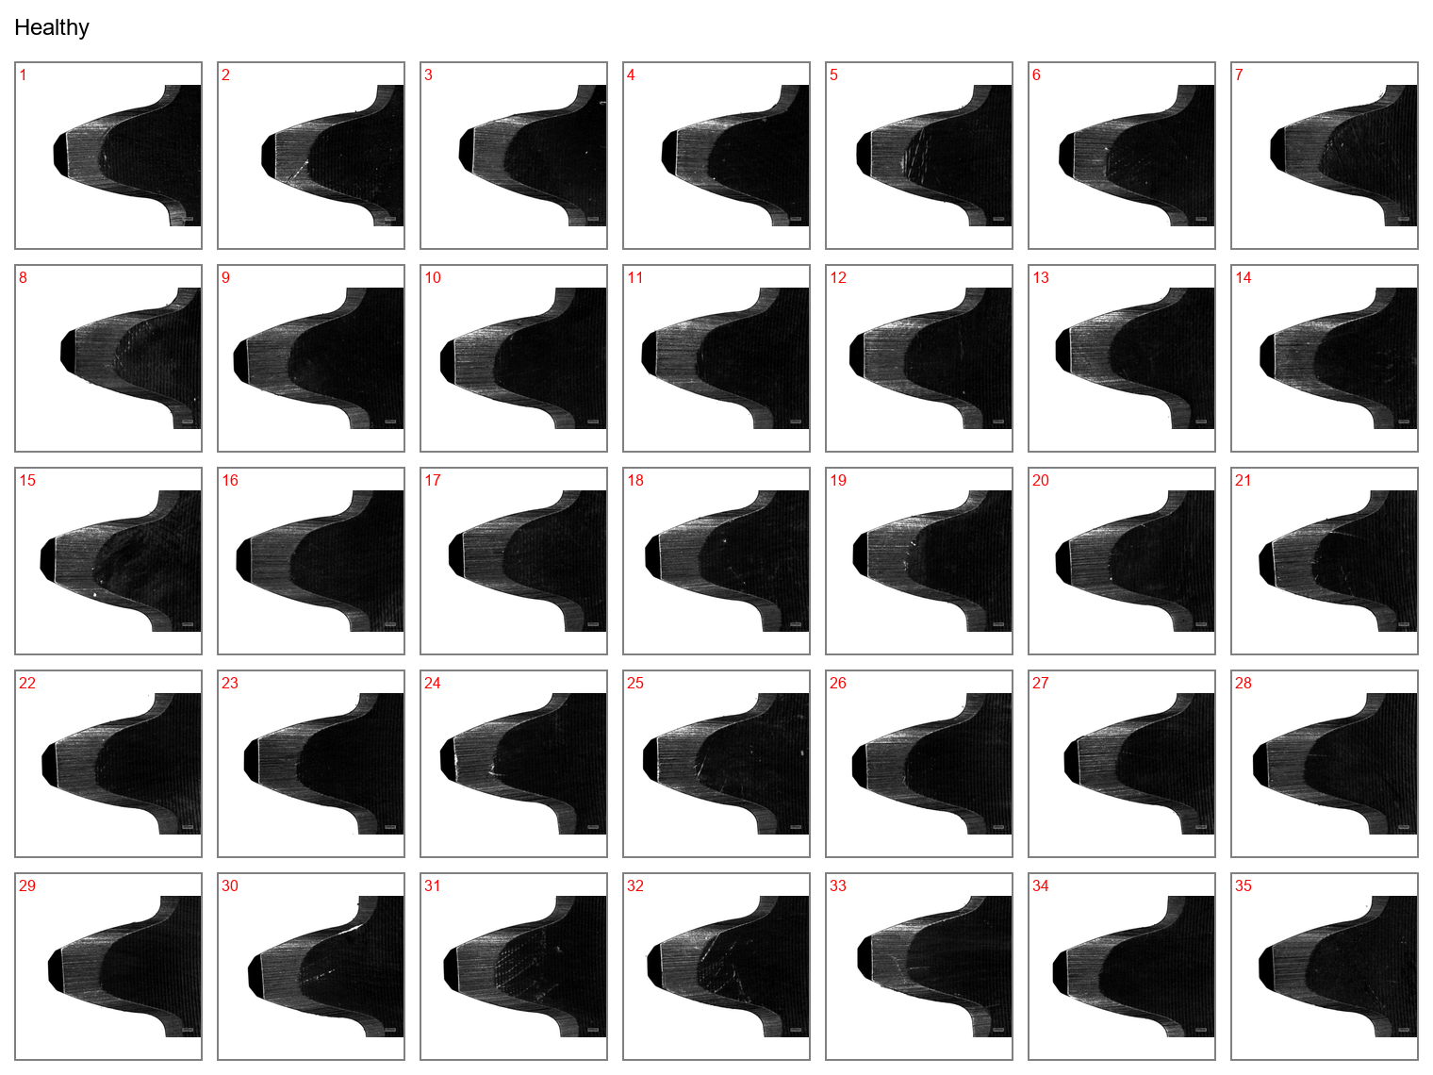

Figure 1: Face view of the drive gear teeth at healthy state.

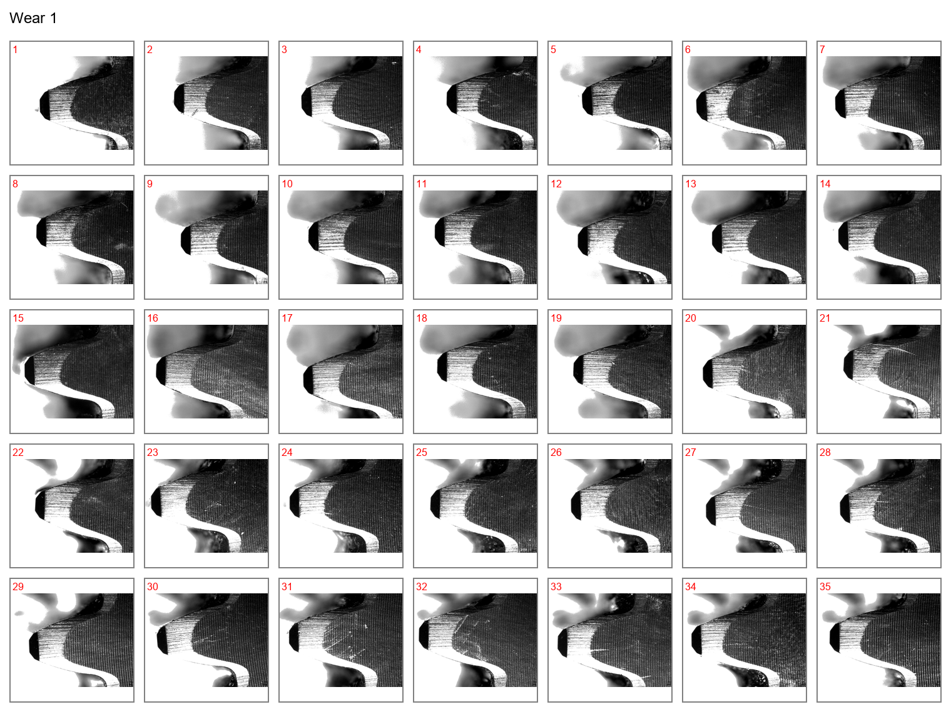

Figure 2: Face view of the drive gear teeth at wear case 1.

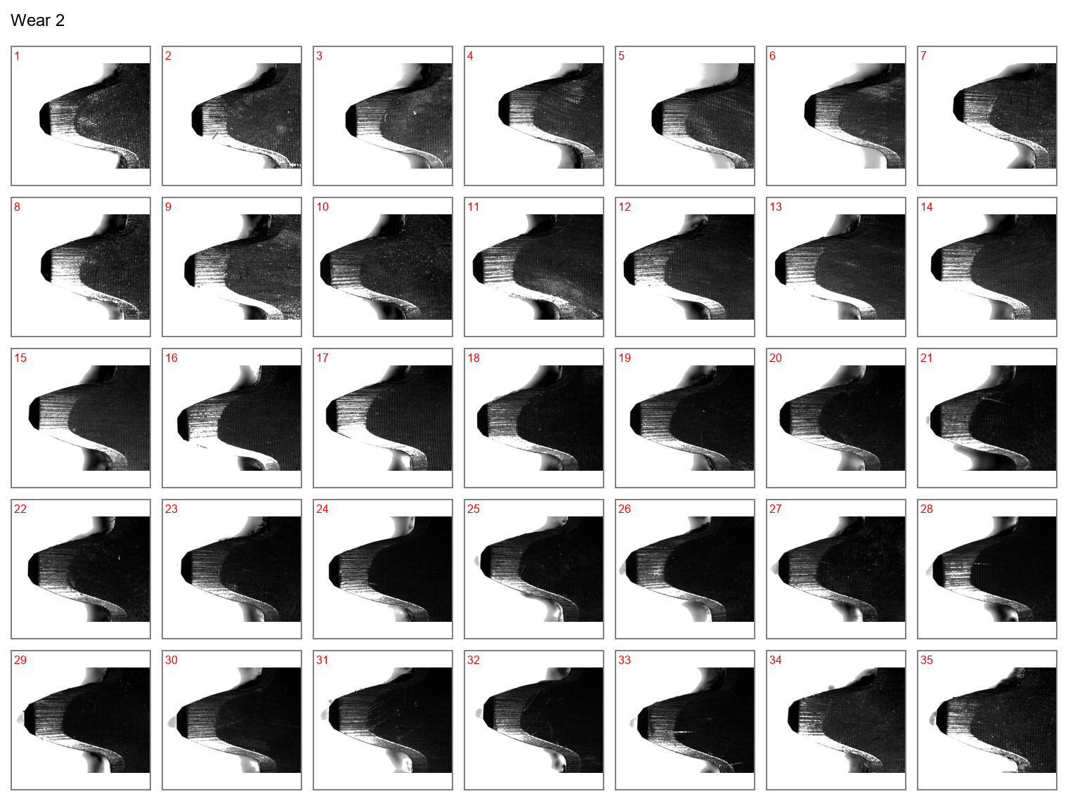

Figure 3: Face view of the drive gear teeth at wear case 2.

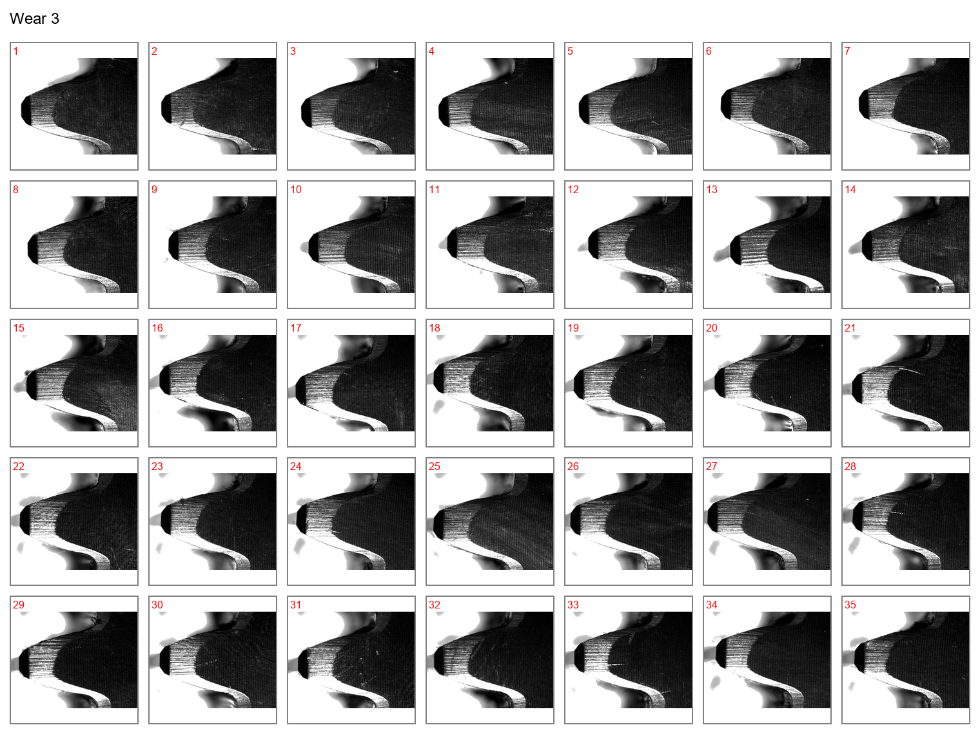

Figure 4: Face view of the drive gear teeth at wear case 3.

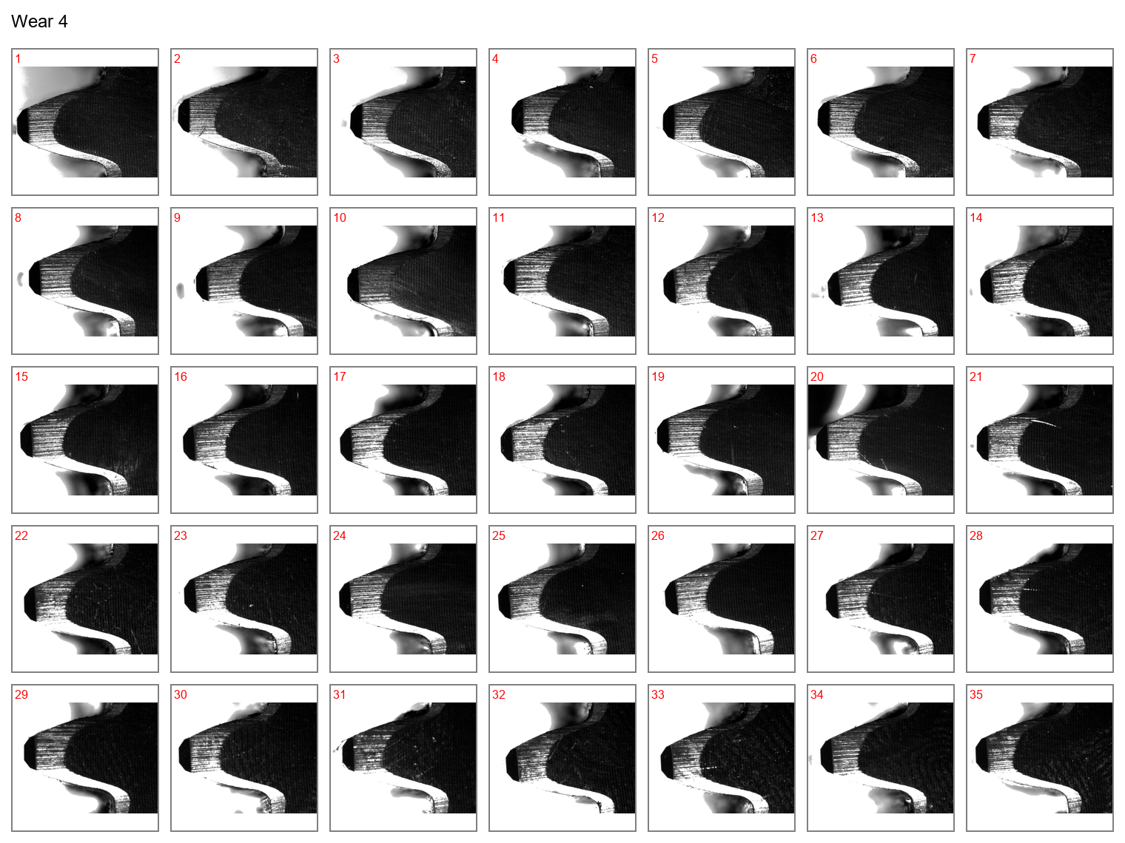

Figure 5: Face view of the drive gear teeth at wear case 4.

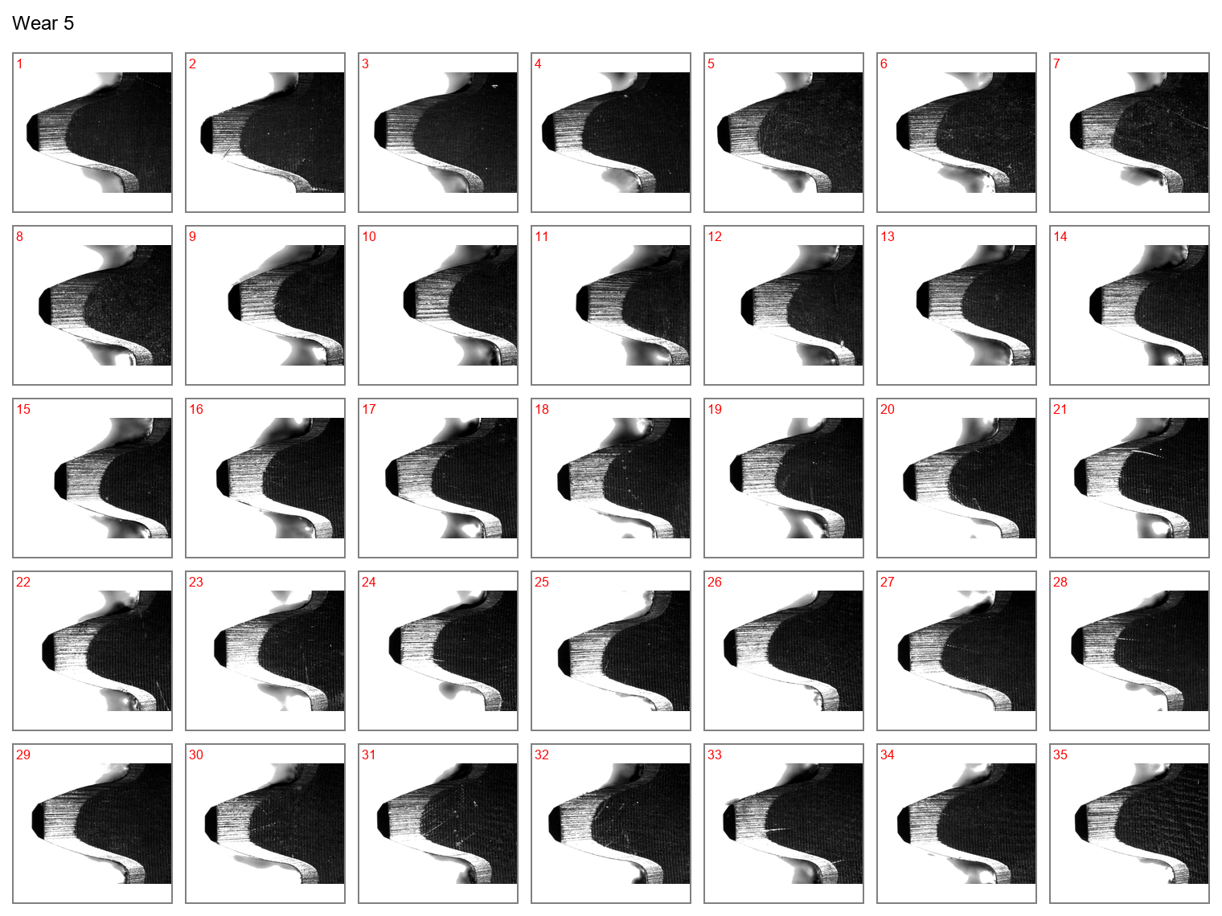

Figure 6: Face view of the drive gear teeth at wear case 5.

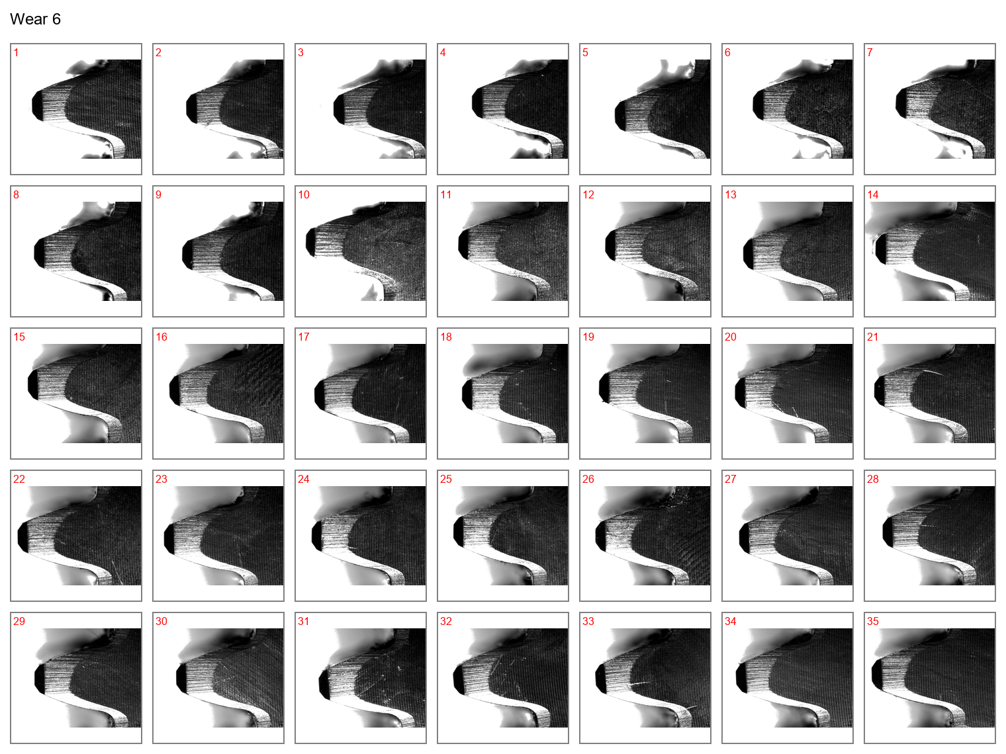

Figure 7: Face view of the drive gear teeth at wear case 6.

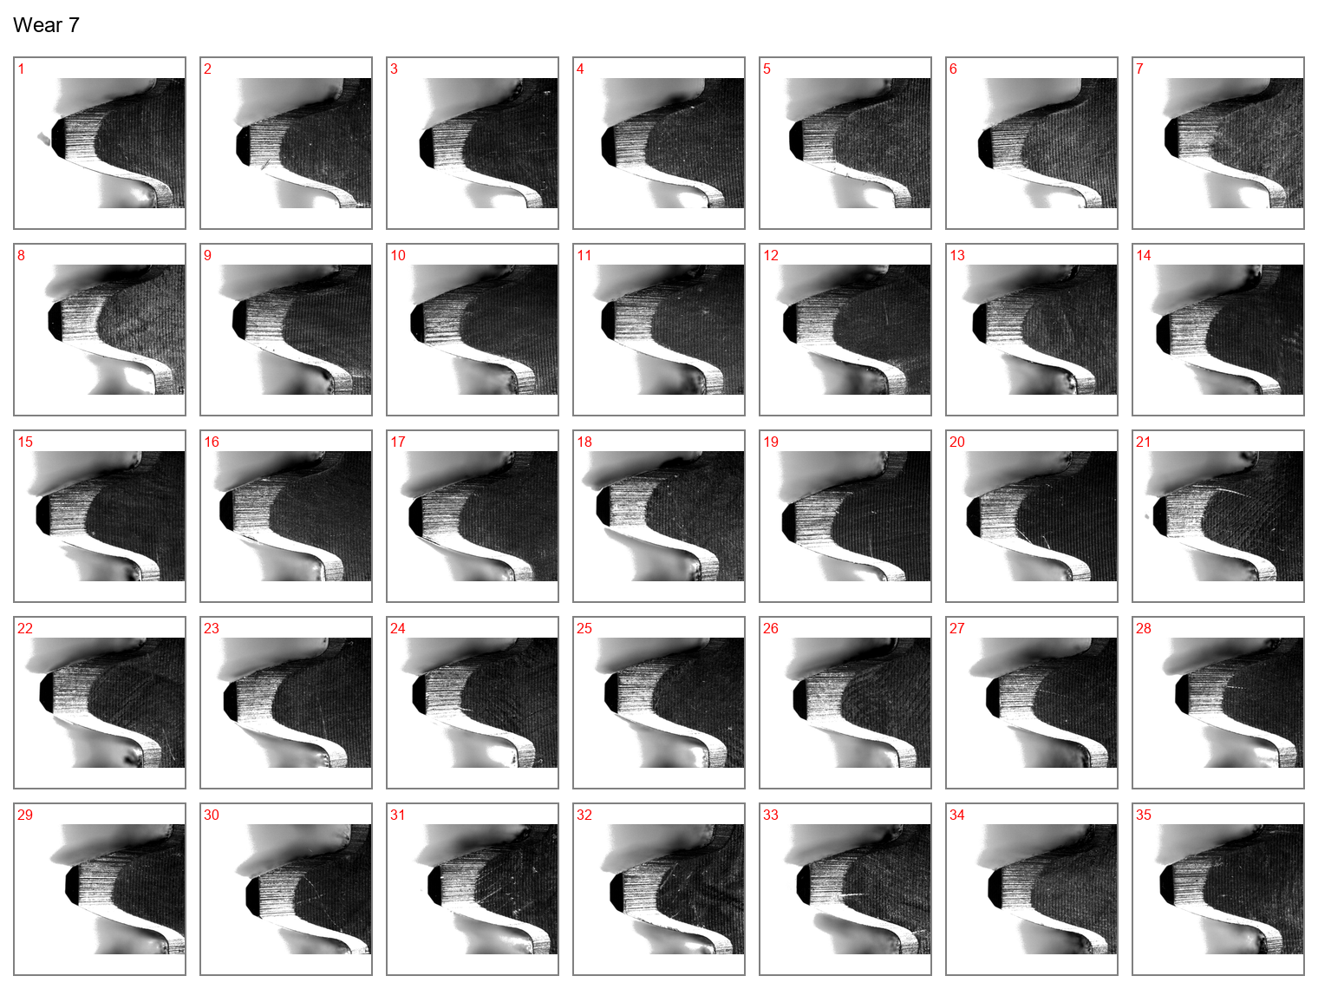

Figure 8: Face view of the drive gear teeth at wear case 7.

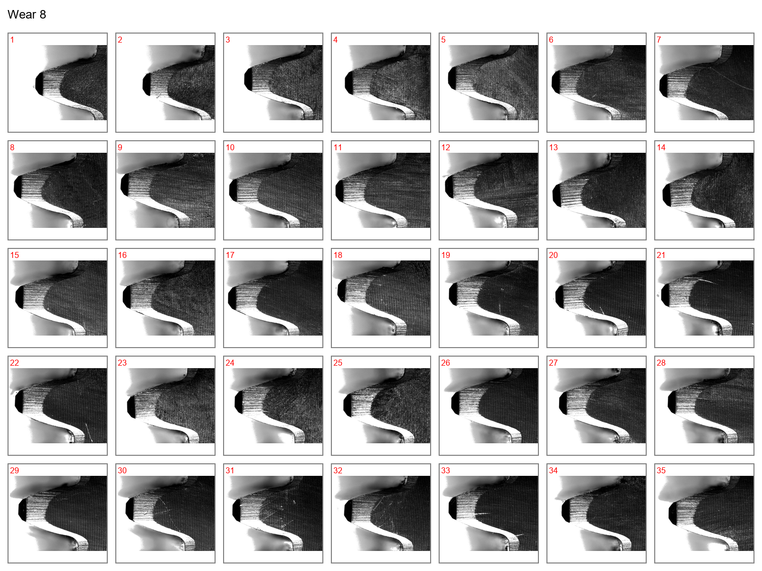

Figure 9: Face view of the drive gear teeth at wear case 8.

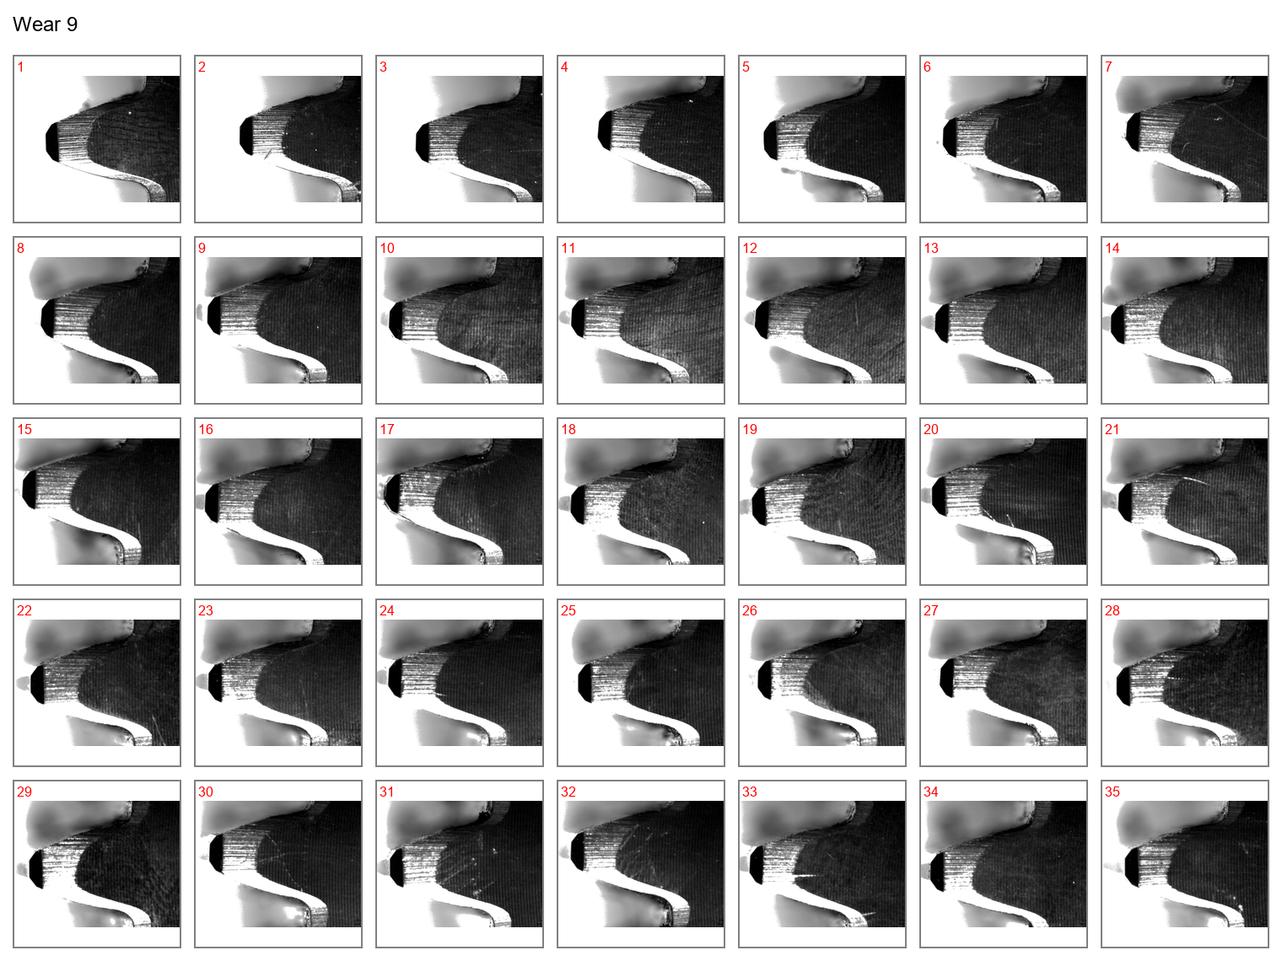

Figure 10: Face view of the drive gear teeth at wear case 9.

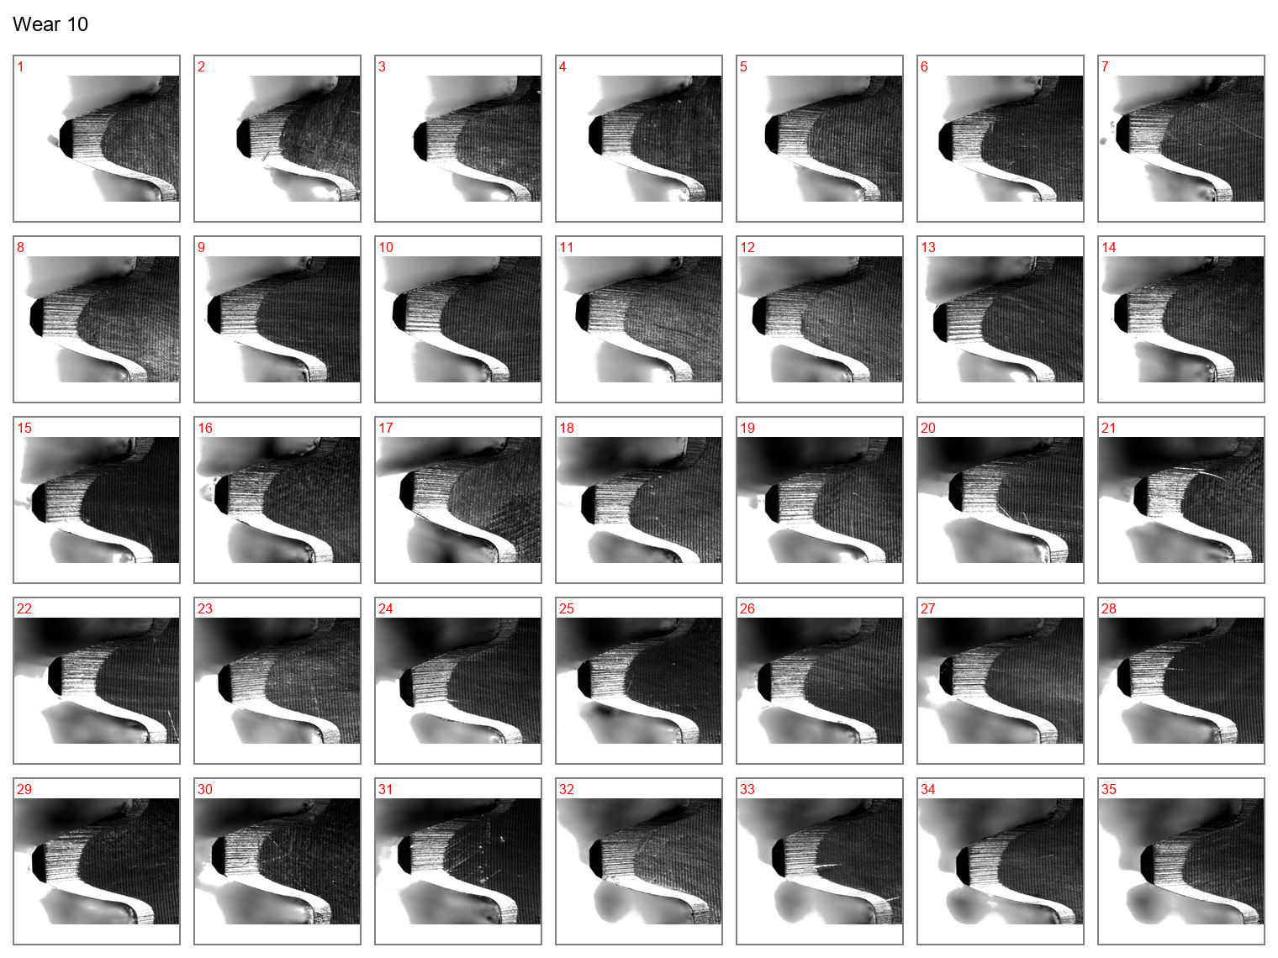

Figure 11: Face view of the drive gear teeth at wear case 10.

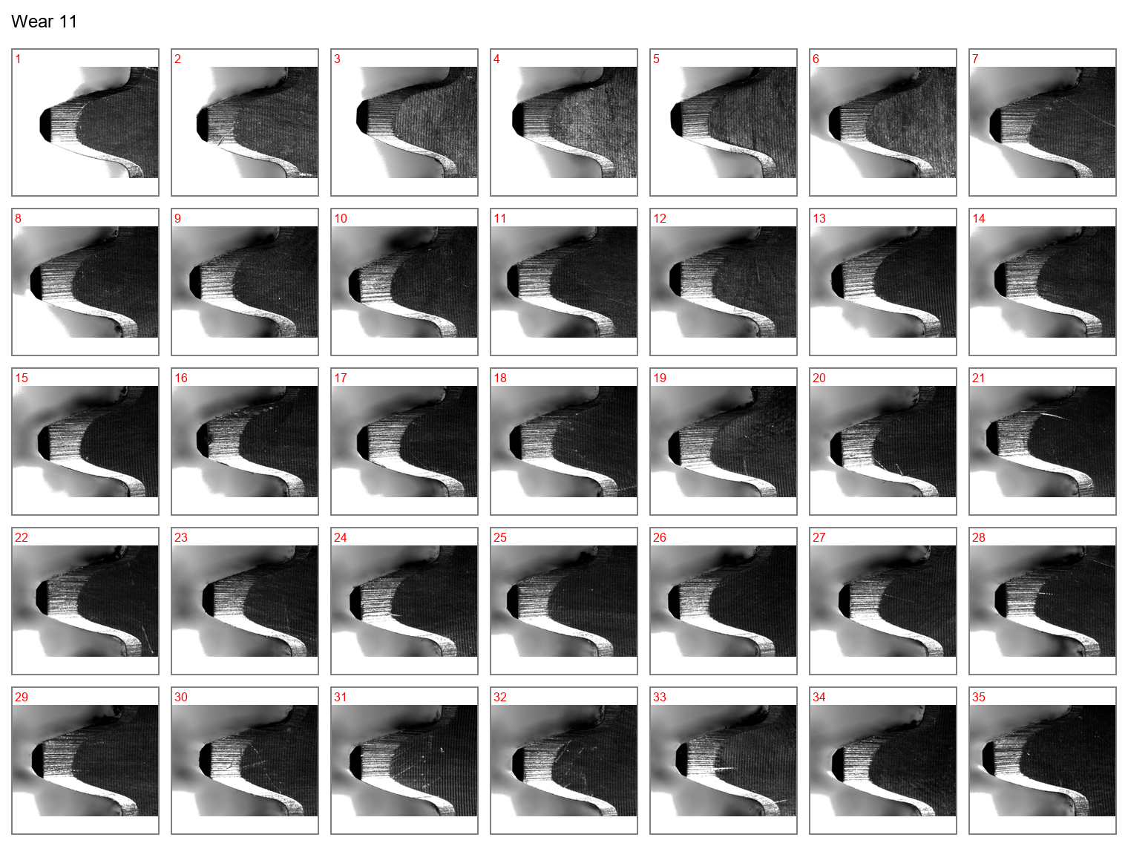

Figure 12: Face view of the drive gear teeth at wear case 11.

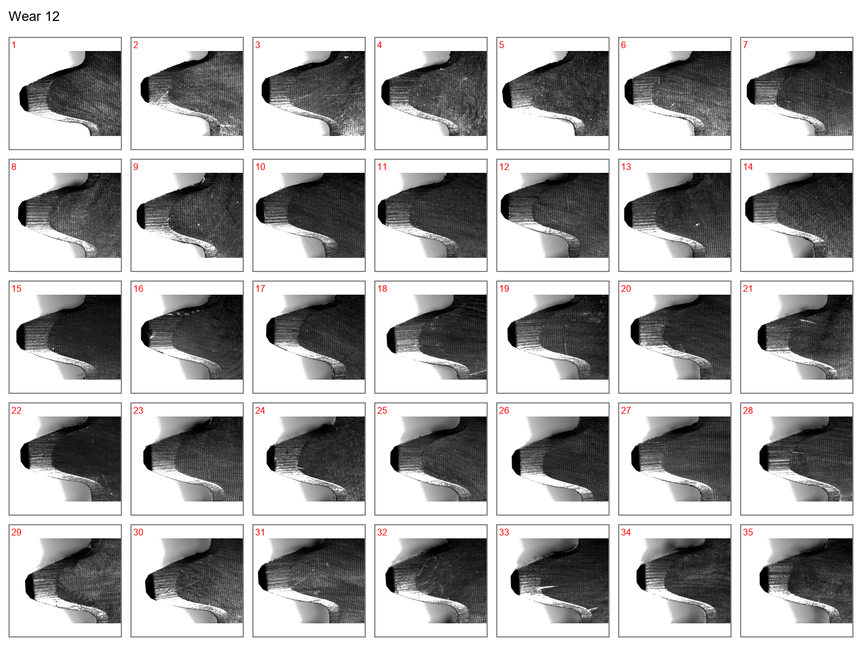

Figure 13: Face view of the drive gear teeth at wear case 12.

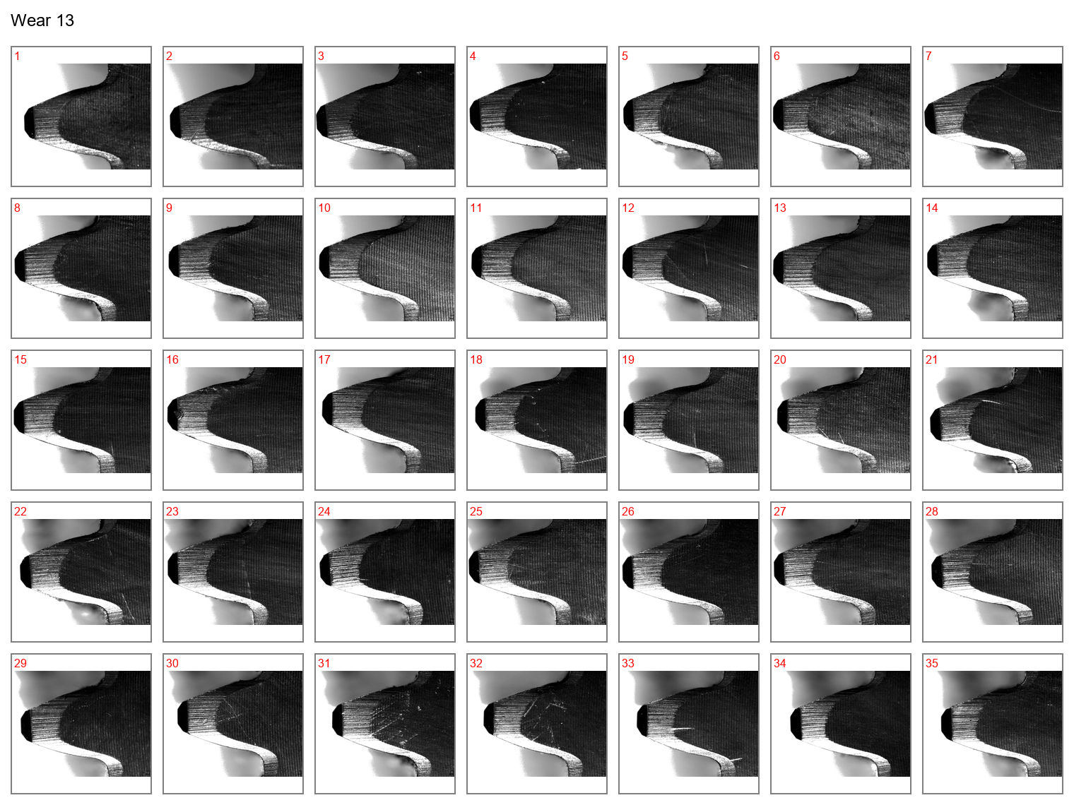

Figure 14: Face view of the drive gear teeth at wear case 13.

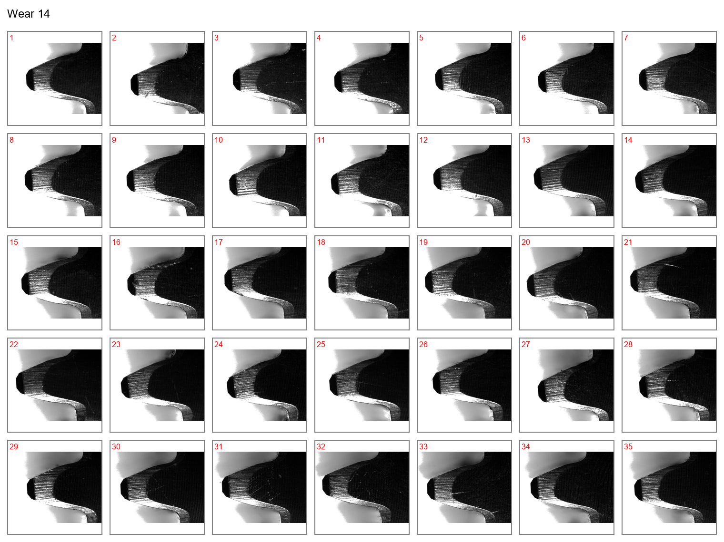

Figure 15: Face view of the drive gear teeth at wear case 14.

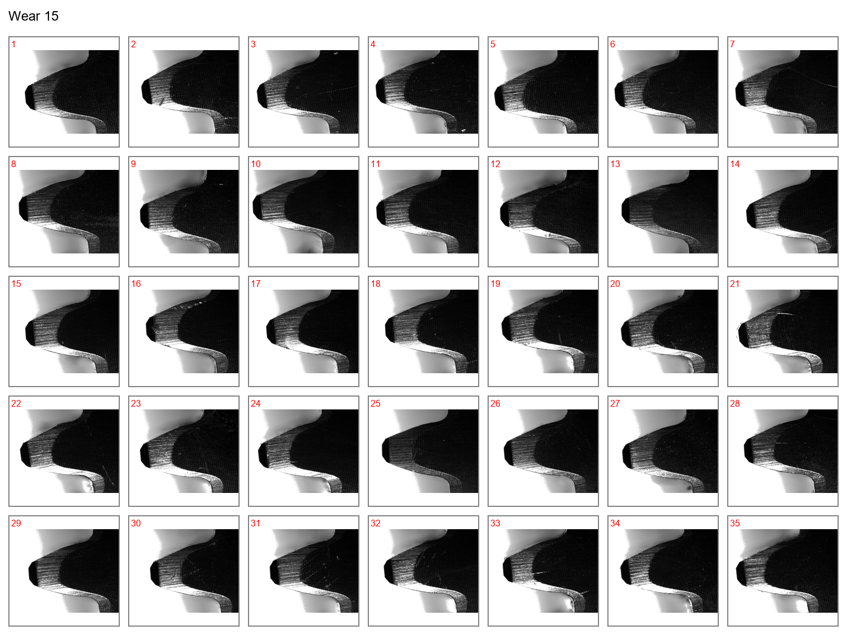

Figure 16: Face view of the drive gear teeth at wear case 15.

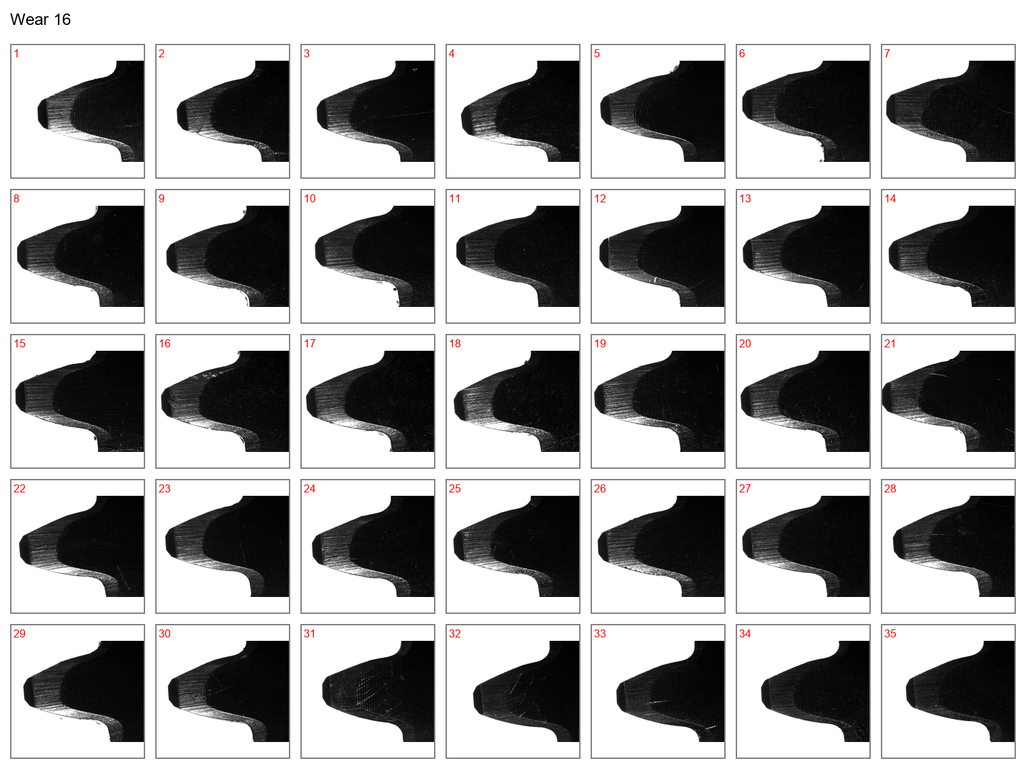

Figure 17: Face view of the drive gear teeth at wear case 16.

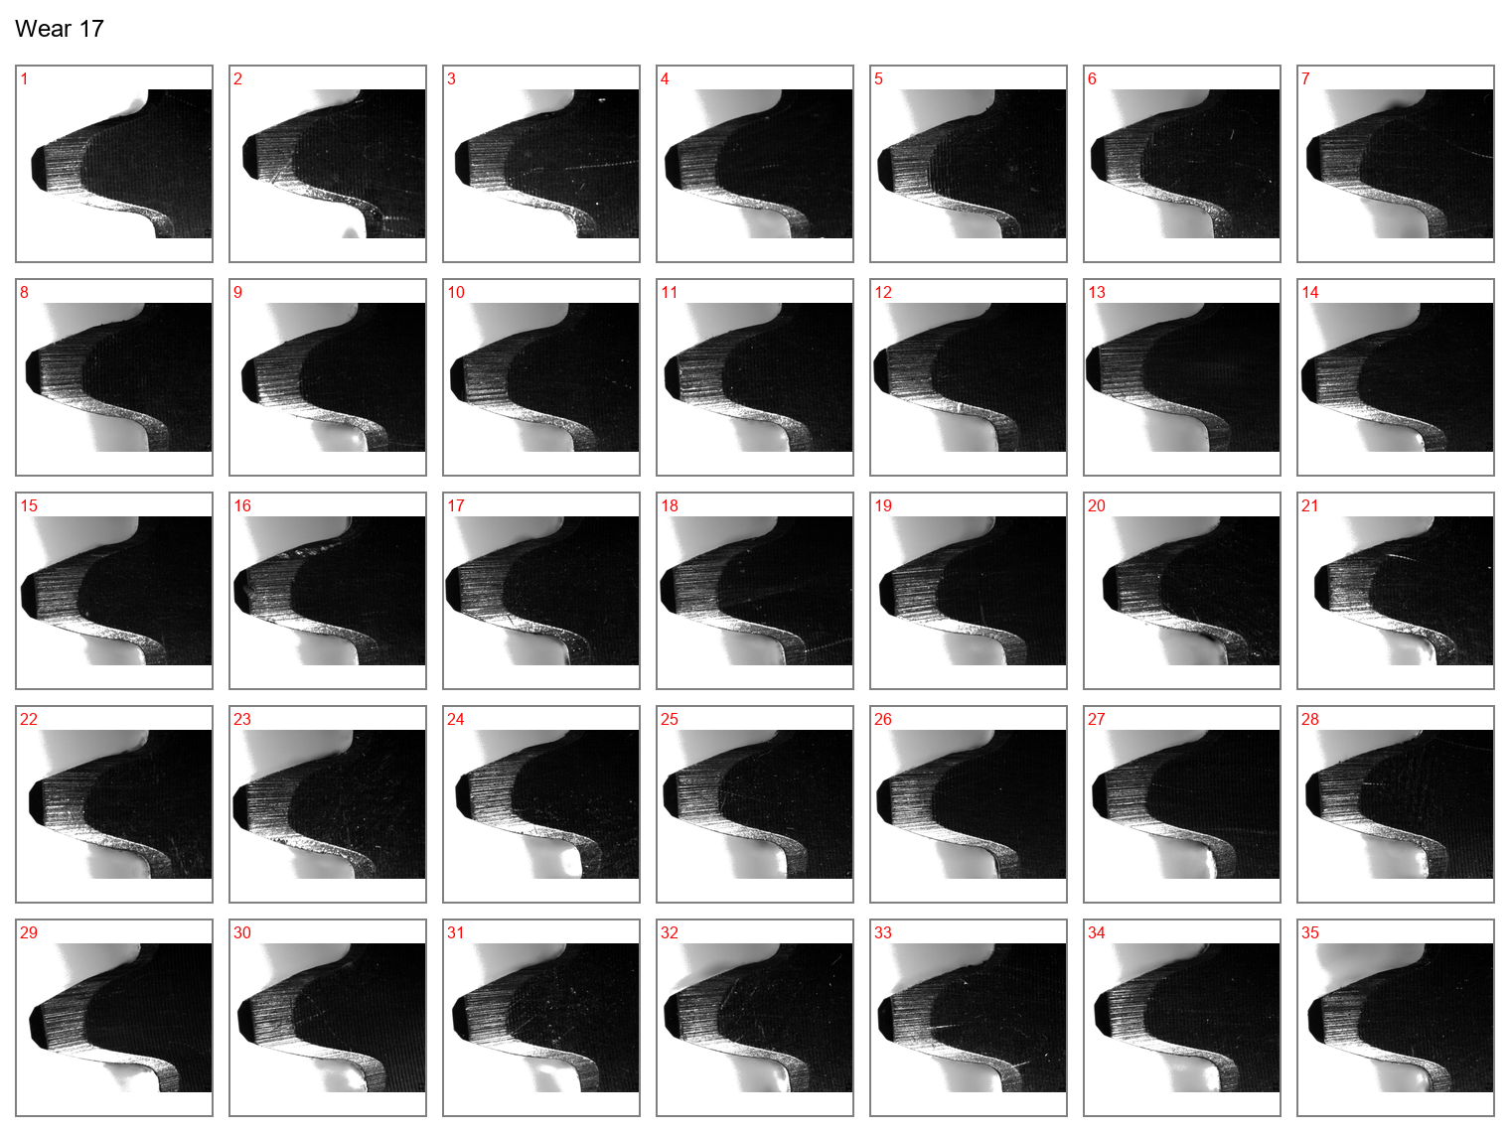

Figure 18: Face view of the drive gear teeth at wear case 17.

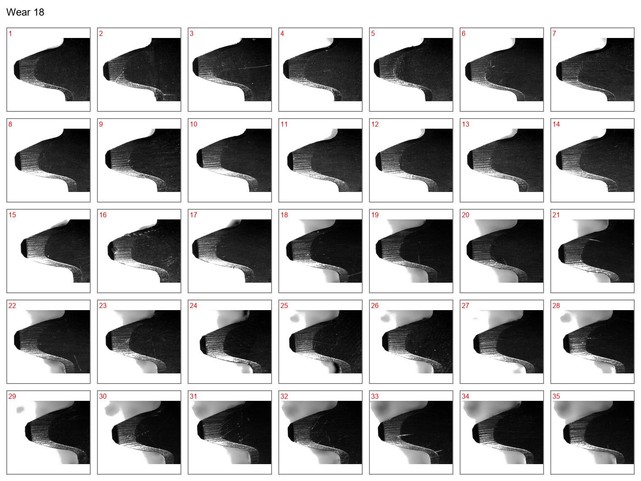

Figure 19: Face view of the drive gear teeth at wear case 18.

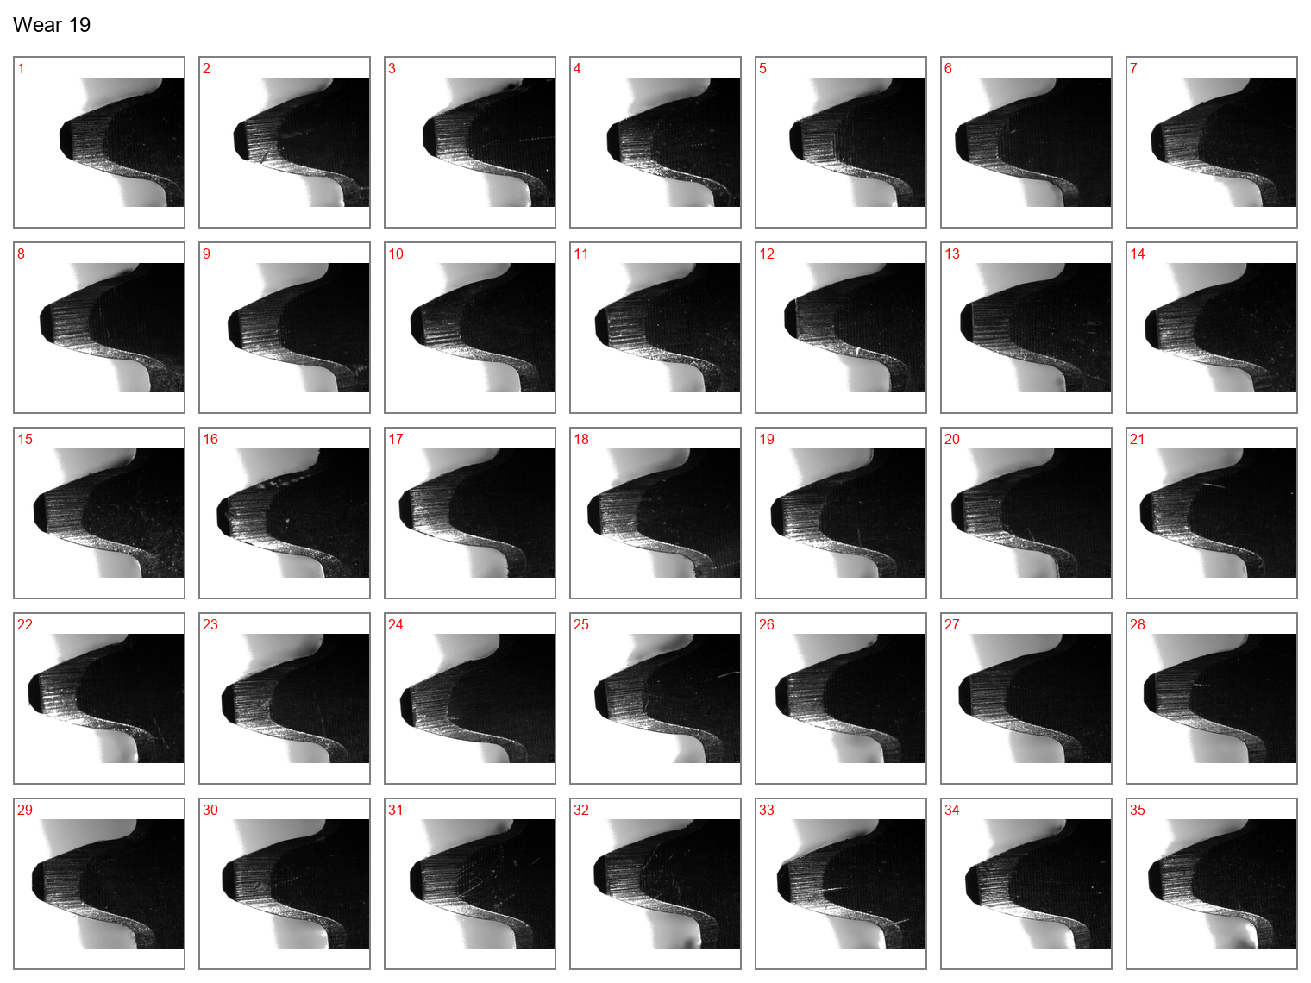

Figure 20: Face view of the drive gear teeth at wear case 19.

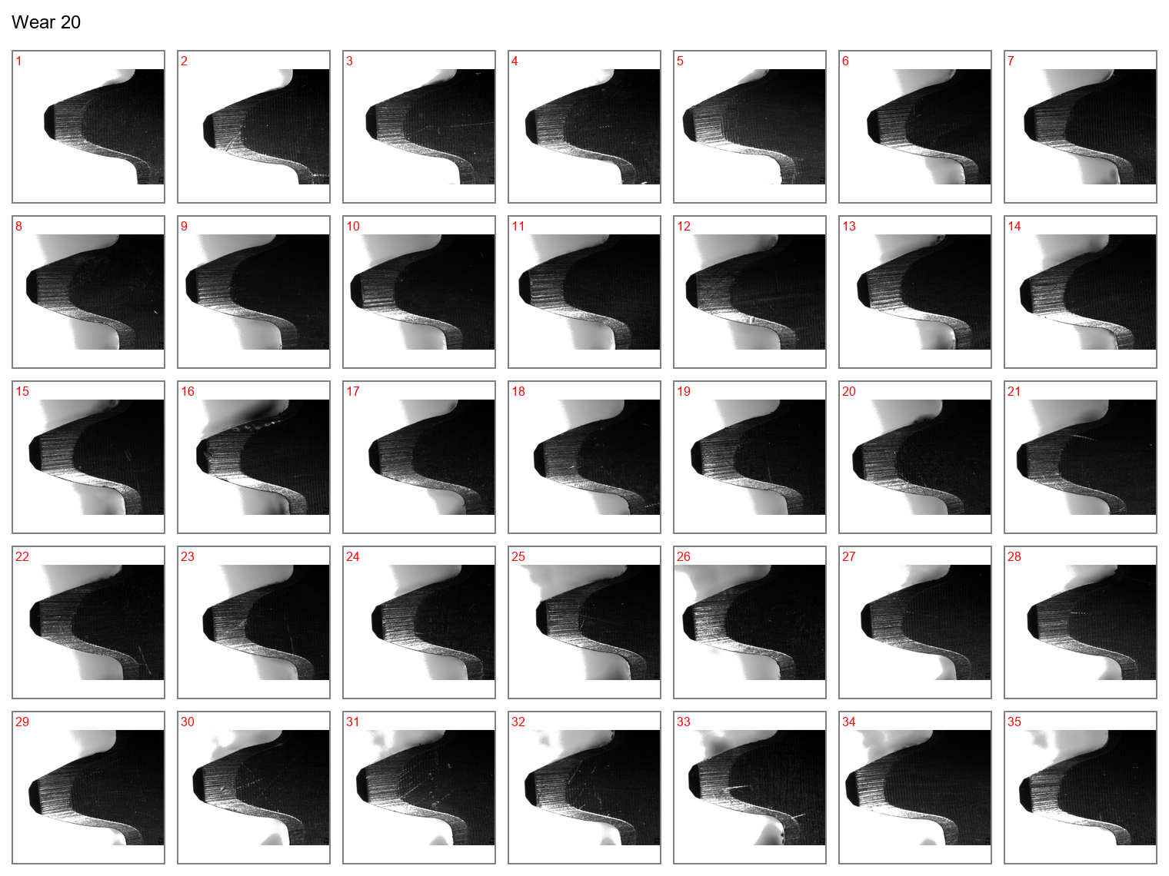

Figure 21: Face view of the drive gear teeth at wear case 20.

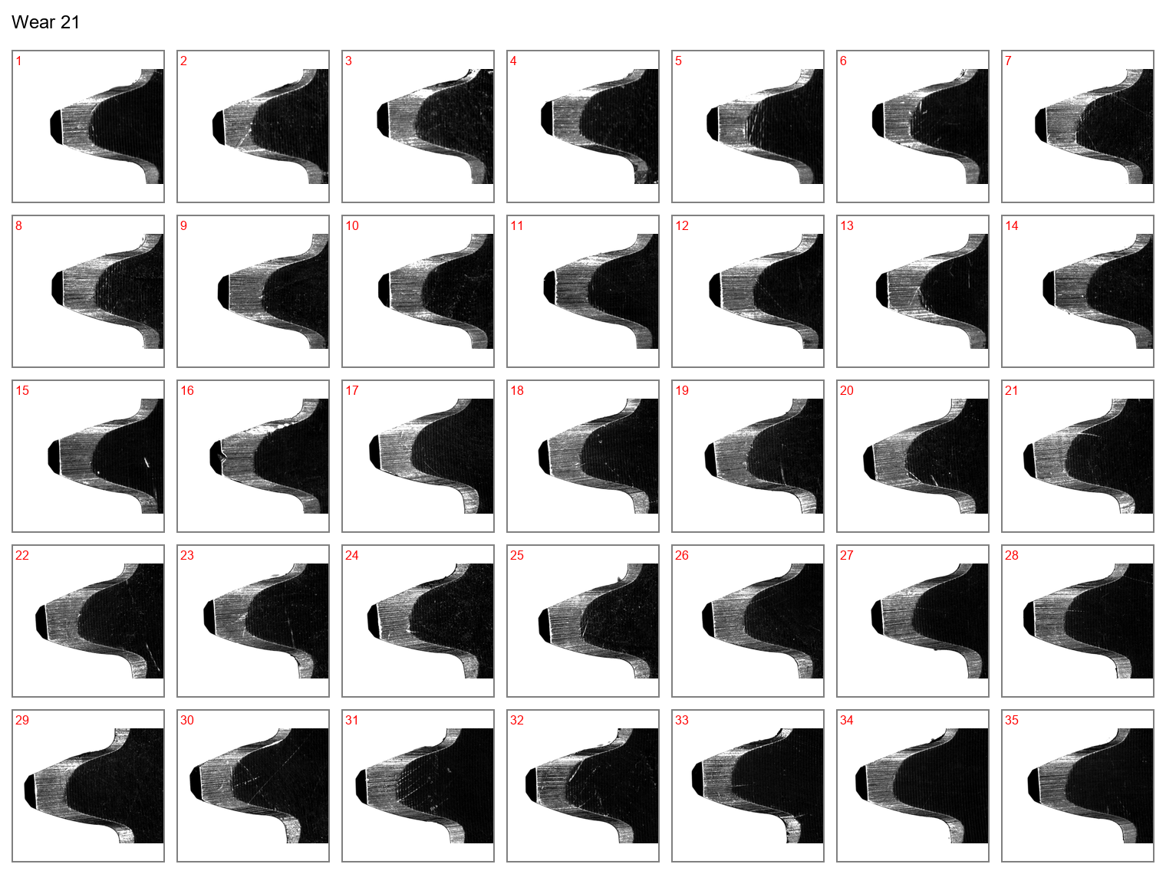

Figure 22: Face view of the drive gear teeth at wear case 21.

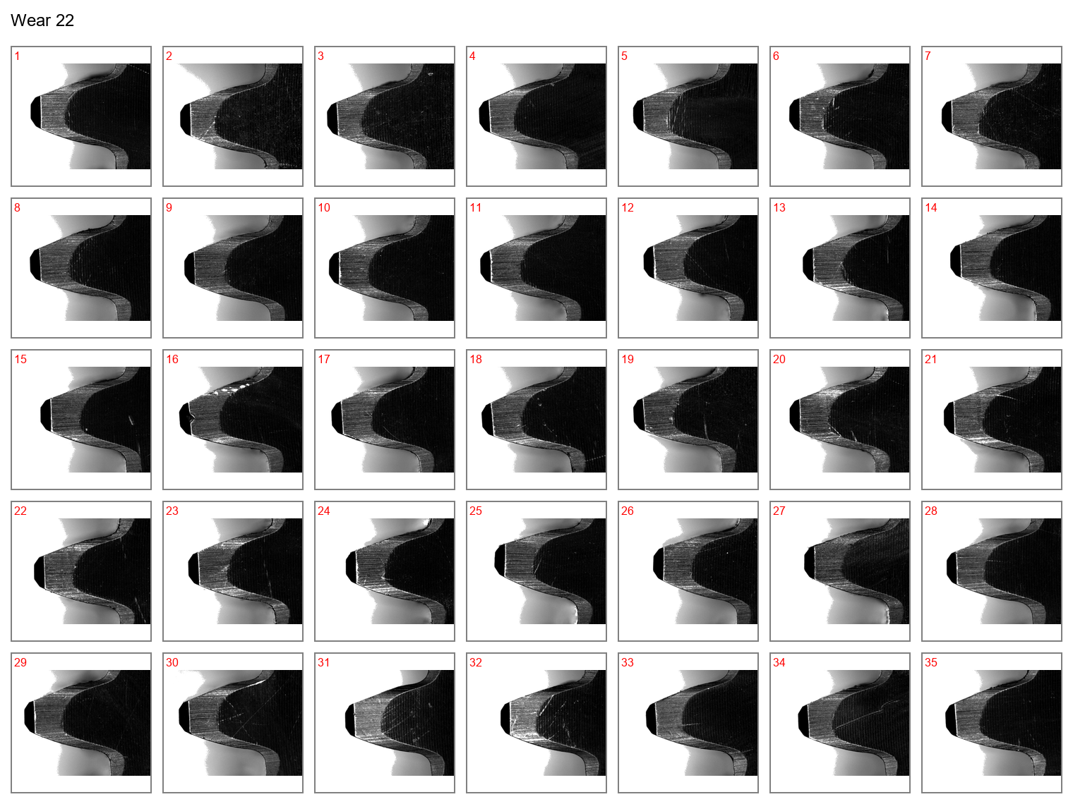

Figure 23: Face view of the drive gear teeth at wear case 22.

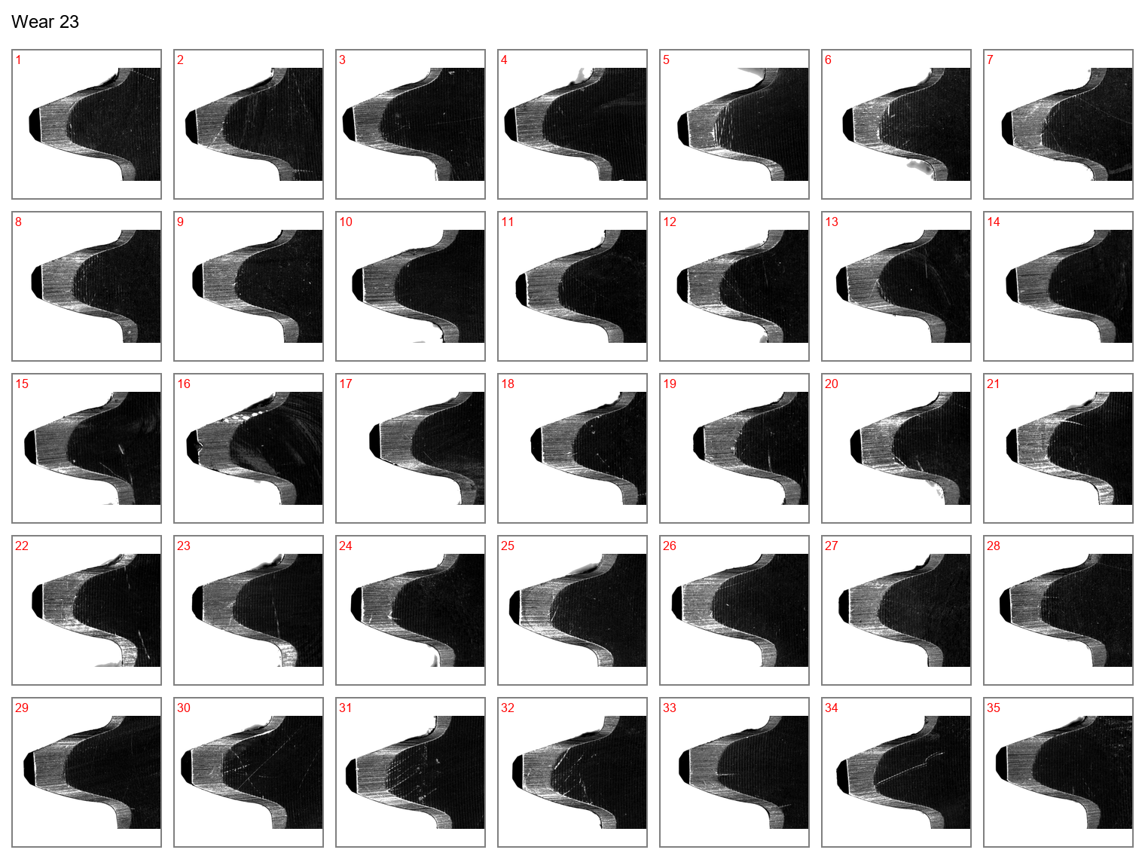

Figure 24: Face view of the drive gear teeth at wear case 23.

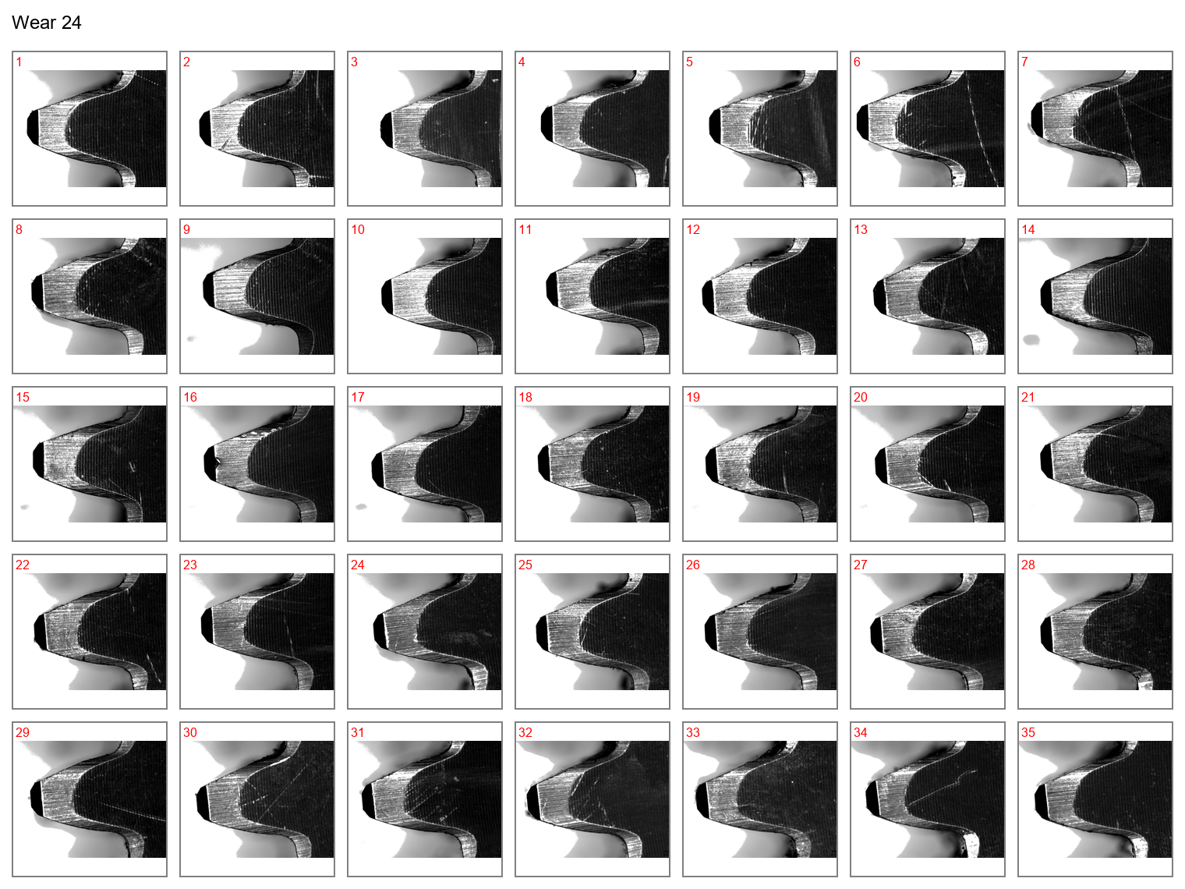

Figure 25: Face view of the drive gear teeth at wear case 24.

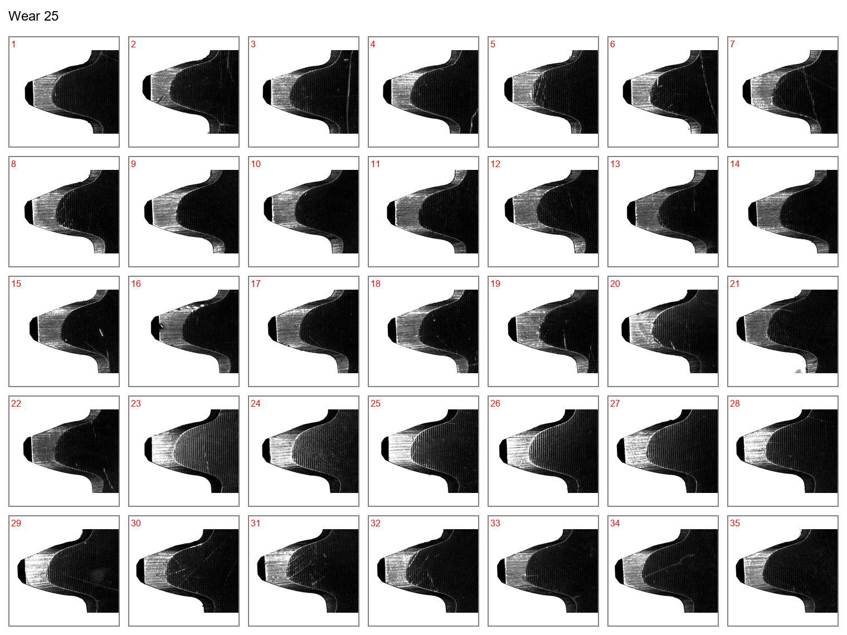

Figure 26: Face view of the drive gear teeth at wear case 25.

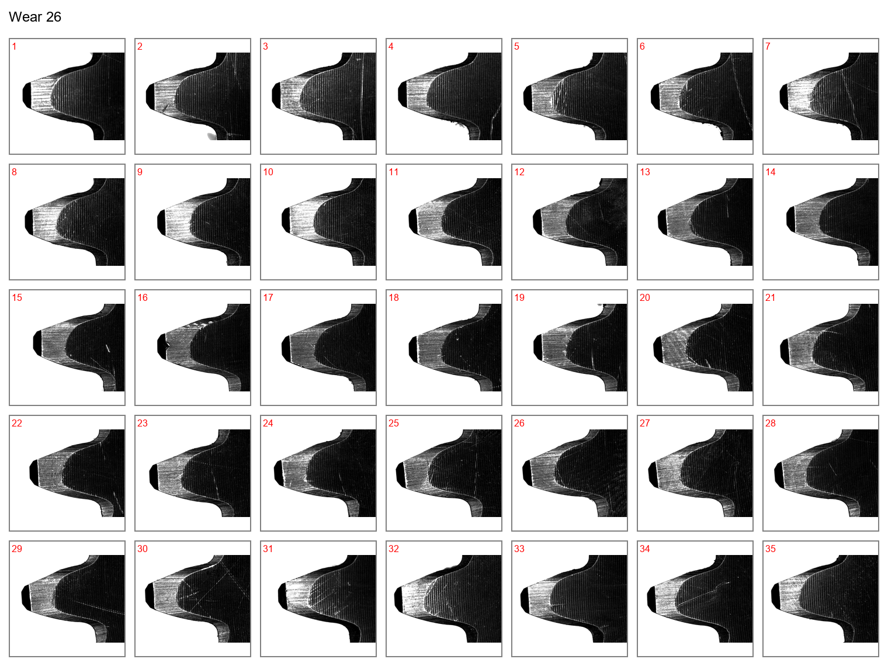

Figure 27: Face view of the drive gear teeth at wear case 26.

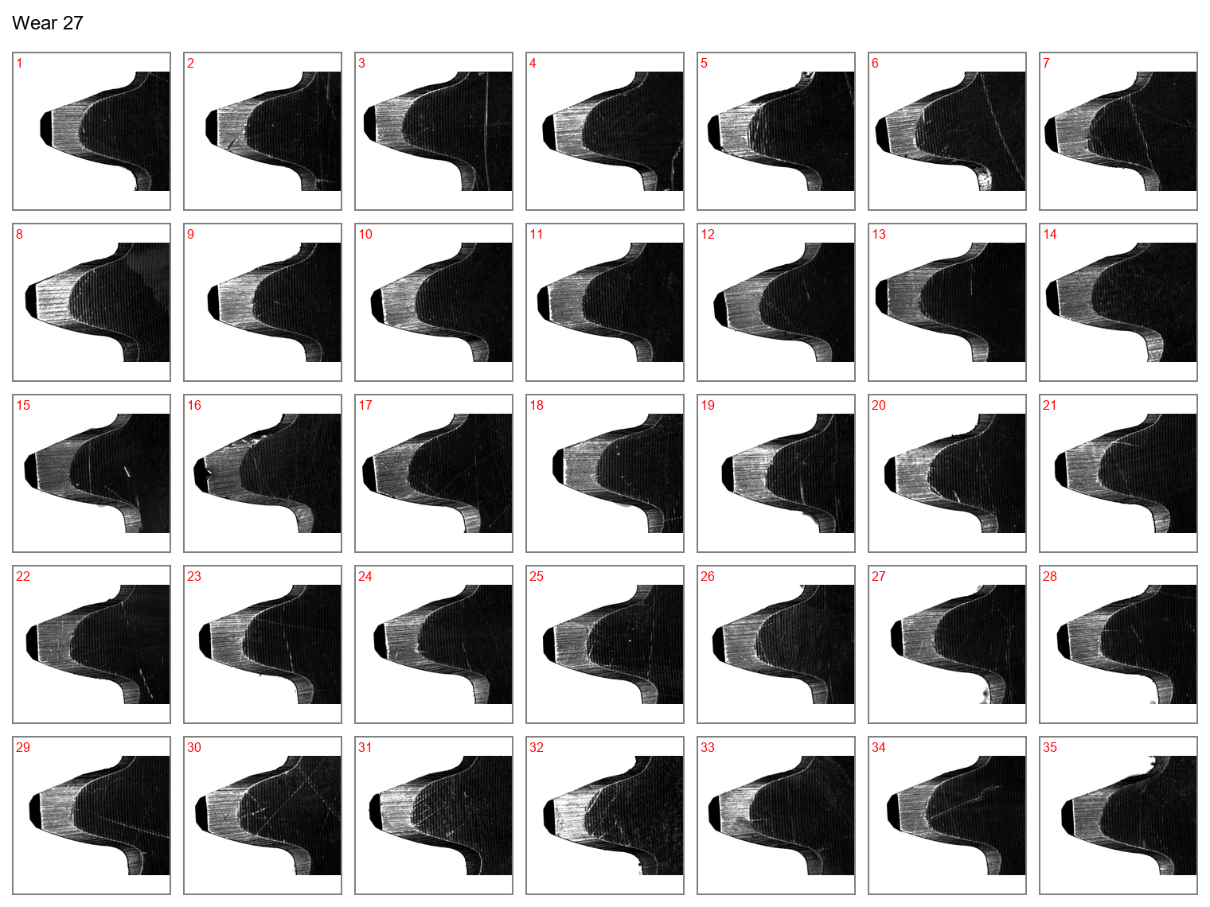

Figure 28: Face view of the drive gear teeth at wear case 27.

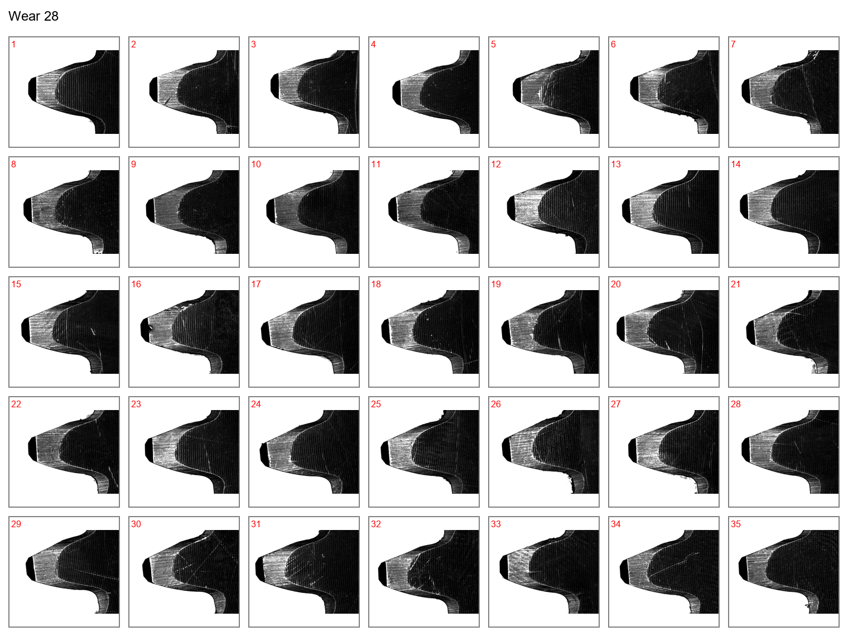

Figure 29: Face view of the drive gear teeth at wear case 28.

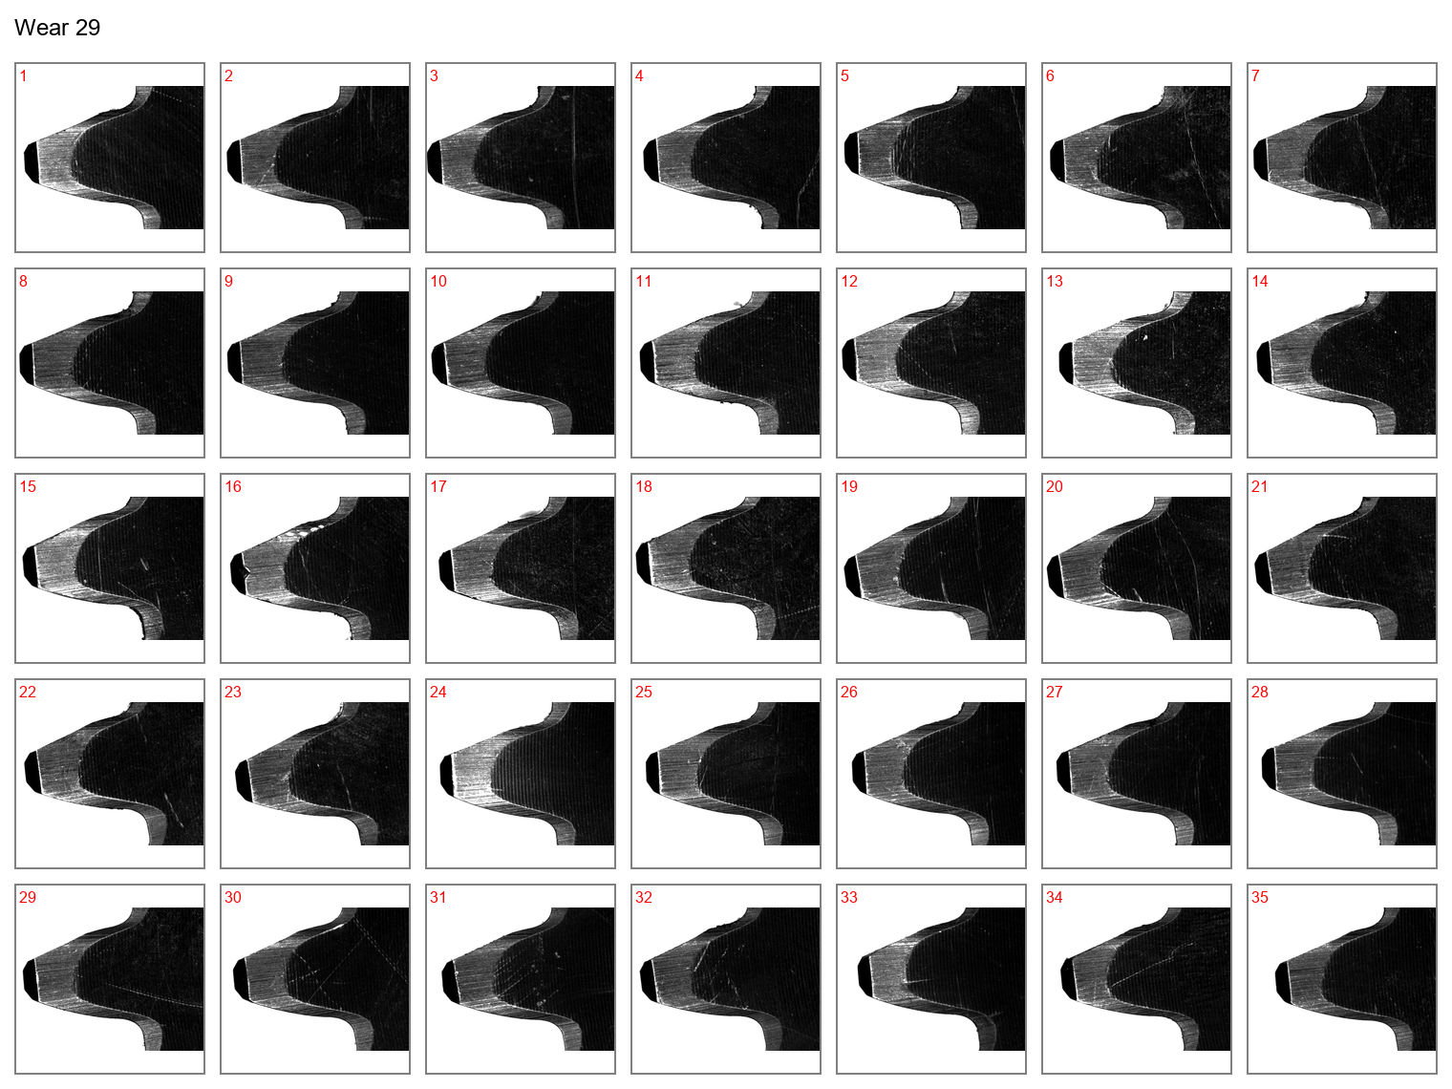

Figure 30: Face view of the drive gear teeth at wear case 29.

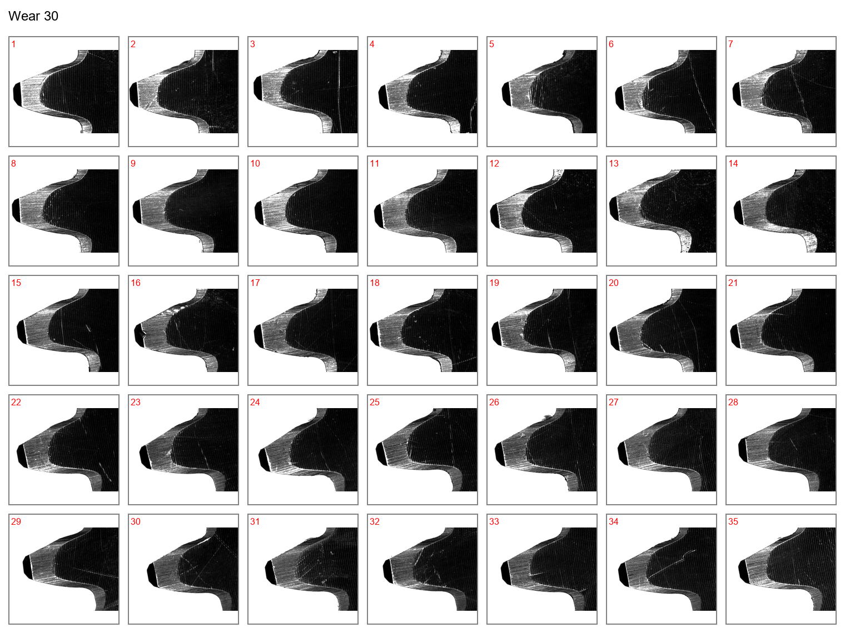

Figure 31: Face view of the drive gear teeth at wear case 30.

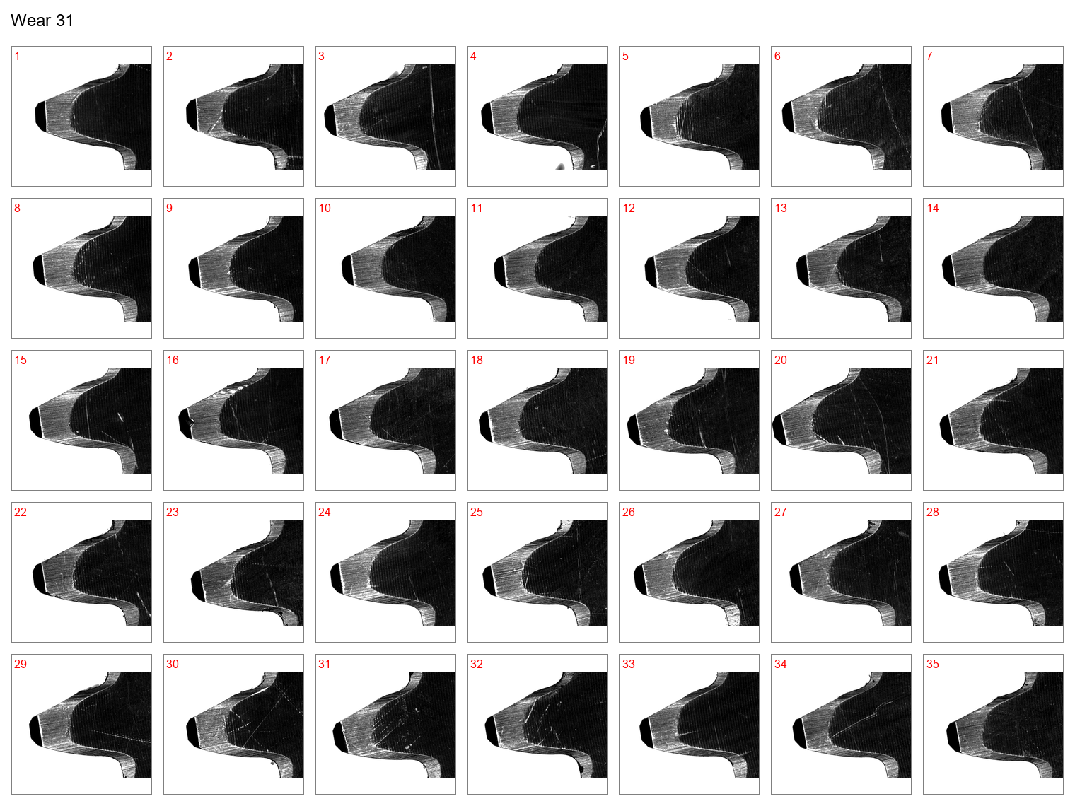

Figure 32: Face view of the drive gear teeth at wear case 31.

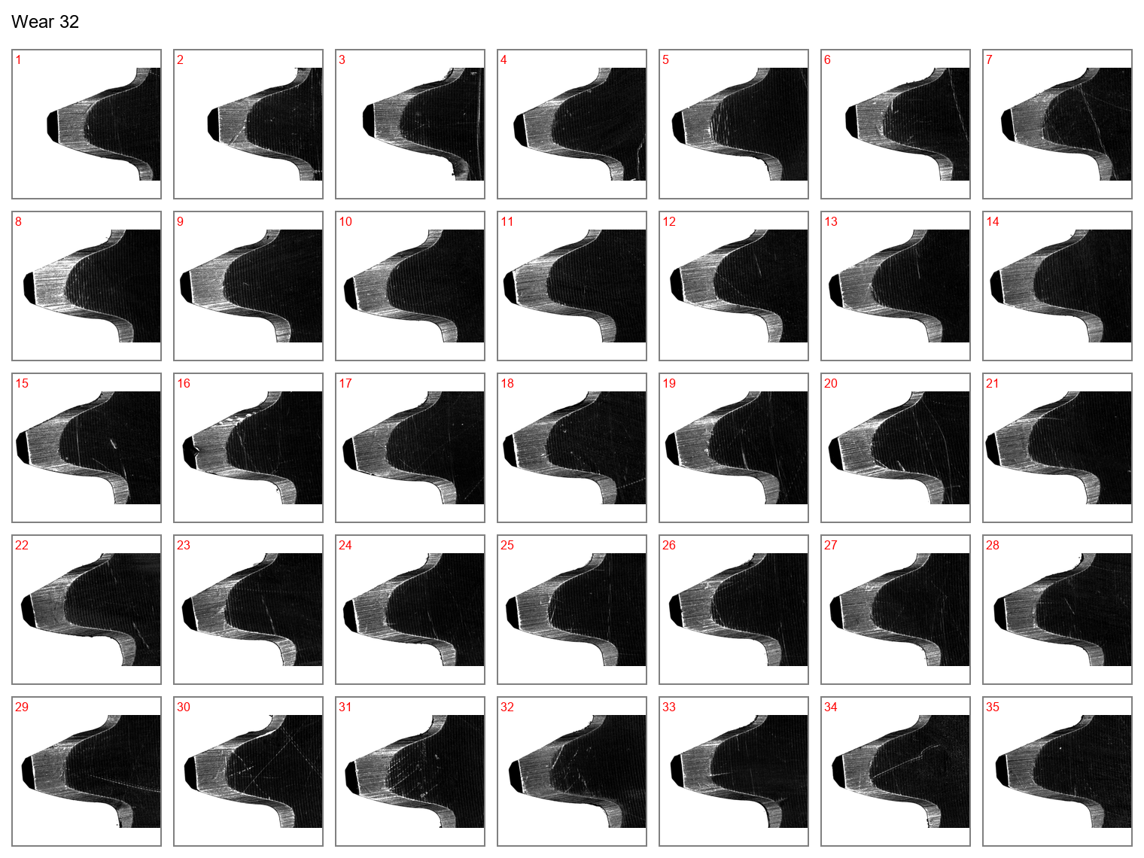

Figure 33: Face view of the drive gear teeth at wear case 32.

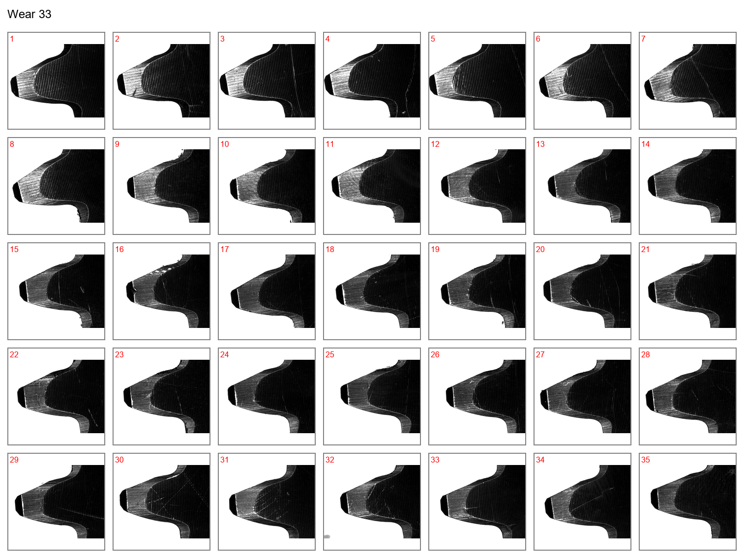

Figure 34: Face view of the drive gear teeth at wear case 33.

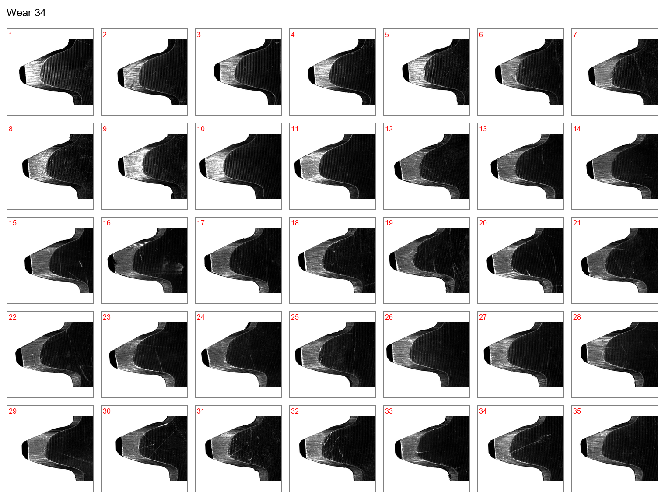

Figure 35: Face view of the drive gear teeth at wear case 34.

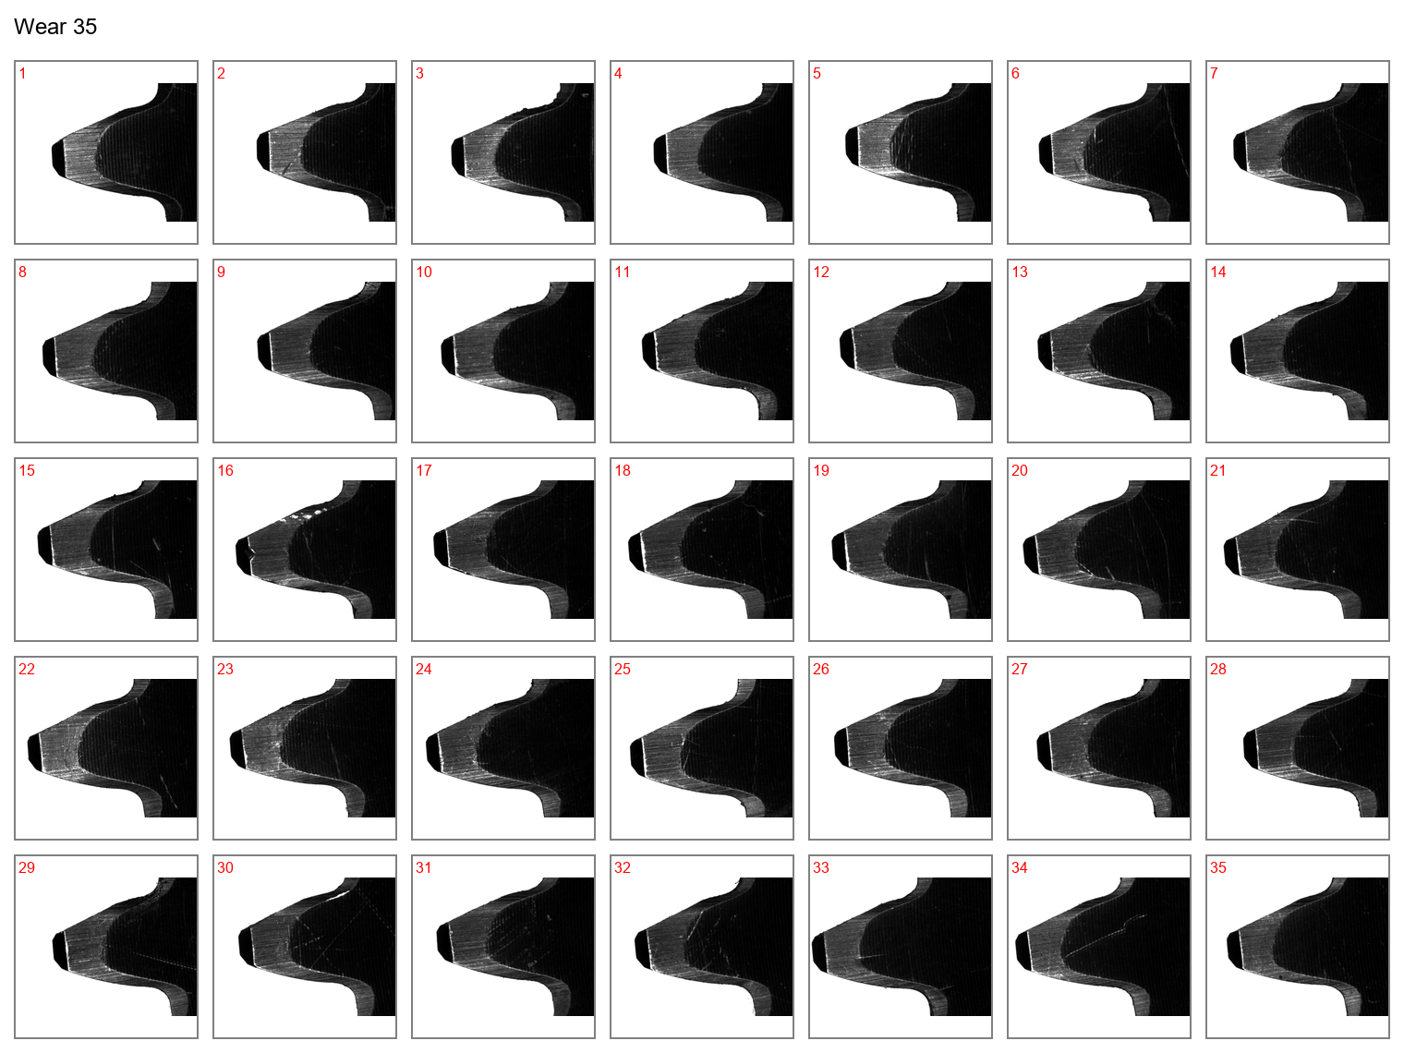

Figure 36: Face view of the drive gear teeth at wear case 35.

## Wear depths measurements

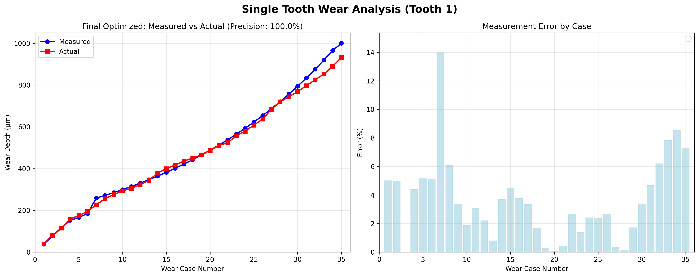

Figure 37: Comparison of wear depth from image processing and actual measurements of tooth 1.

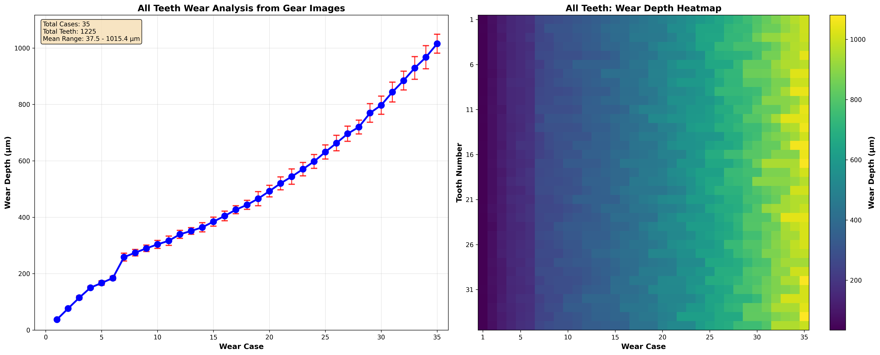

Figure 38: Mean wear depth at all wear cases and heat map for wear growth at all teeth.

## Vibrations signals

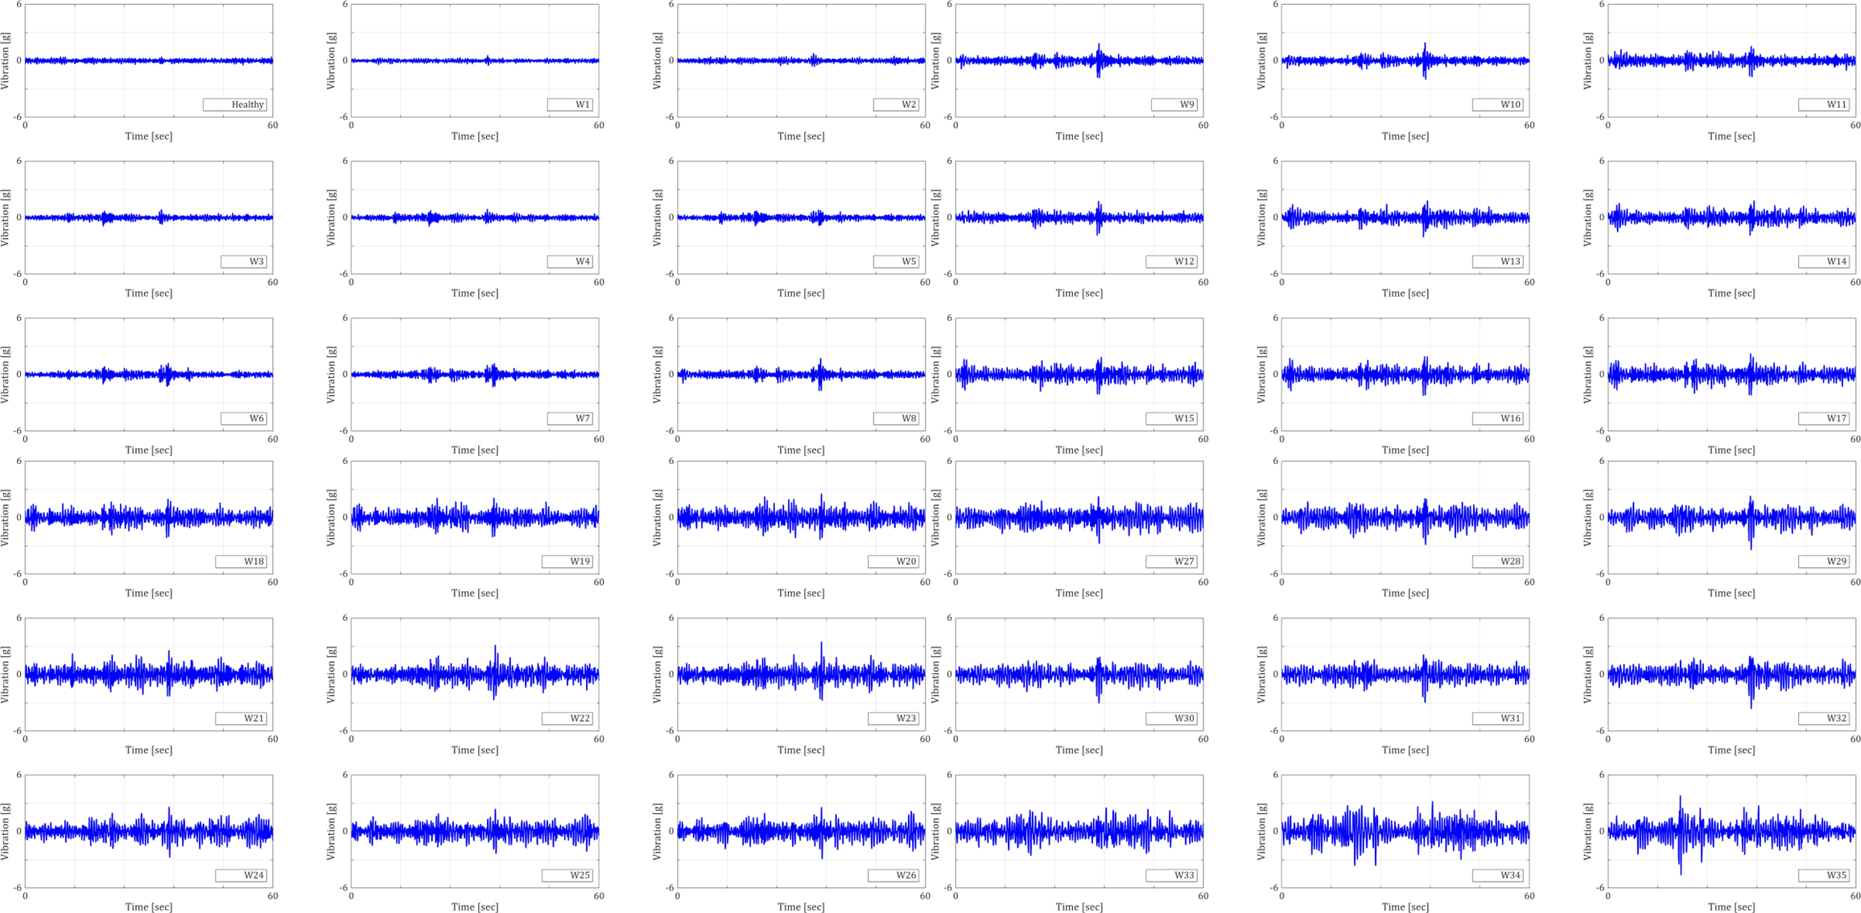

Figure 39: Examples of vibration signals at low speed, the records mentioned at Table 37 .

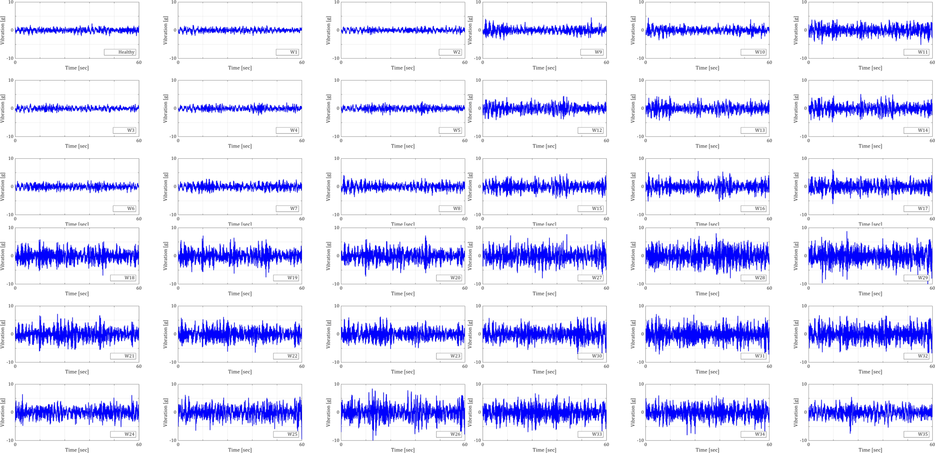

Figure 40: Examples of vibration signals at low speed, the records mentioned at Table 37.